Research Report
Sejahtra Fellowship Program
April-June

Title:

EDUCATION FOR SUSTAINABLE DEVELOPMENT (ESD) MODELS IN INDONESIAN AND KOREAN SCHOOLS
(A Comparative Study between Yogyakarta and Tongyeong city)

Written by:
Hastangka, Indonesia
The First Sejahtra Fellow
Regional Centres of Expertise (RCE) Tongyeong

TONGYEONG CITY
SOUTH KOREA
JUNE
2012

Table of Contents

Forewords ………………………………………………………………………………………. iii
Acknowledgment …………………………………………………………………………………v
Executive Summary ……………………………………………………………………………...vi
Introduction ……………………………………………………………………………………….1
The Objective of study …………………………………………………………………………... 4
Methodology ……………………………………………………………………………………...4
Literature review ………………………………………………………………………………….4
The Scope of research…………………………………………………………………………...10
Limitation of study ………………………………………………………………………………11
Significance of Study ……………………………………………………………………………11
General overview: Education system and ESD between Indonesia and South Korea ………….12
A. General overview education in Indonesia ………………………...………………………….12
1. General overview education and ESD in Yogyakarta ………...………………………..15
a. Current situation Education in Yogyakarta ………………..………………………15
b. ESD in Indonesian schools: Case study in Yogyakarta……...…………………….18
B. General overview education in South Korea…………..………………...……………………31
1. General overview education and ESD in Tongyeong city…………….…………………33
a. Current situation education and society in Tongyeong city…………...…………..…34
b. ESD in Korean schools: Case study in Tongyeong city…………………..…..……..36
ESD in schools: Case Study in Yogyakarta and Tongyeong city……………………………….57
Core Issues on ESD in Asian Schools: Lesson Learnt from Indonesia and South Korea …...….59
Conclusion and Recommendation ………………………………………………………………70
Bibliography ………………………………………………………………………………....….72
About the Author …………………………………………………………………….………….78
Attachment……………………………………………………………………………………….79

Foreword
“Education is the most powerful weapon you can use to change the world.”
*Nelson Mandela*

What the meaning and purpose of education is. This philosophical question always comes in my mind. I am really curious to know how the educators give a meaning in this issue especially educators in Korea. I do believe that every teacher have own definition and reflection about this term. There are many definition and even hundreds of definitions about education defined by scholars, scientists, and professor from university level. But it is very rarely, school teachers give definition on education. Many educators, teachers, lecturers, tutors, and mentors can teach their lesson and subject fluently and I believe a school teacher has closely relationship with the pupils because every day they meet regularly. During 6 years or 3 years, usually a pupil has favorite teacher and the best teacher in each grade.
When I ask to the pupils what is your favorite teacher they will mention one teacher who he/she think the best one. I have asked to one of elementary school student in Tongyeong city, who is your favorite teacher? And this pupil mention, one of her teacher name. I see that in giving a meaning of education it is not always explicitly in a word, a sentence or a paragraph. The teacher can give a meaning about education in the whole of his/her life because education is a hope for every human being to be someone, to be a valuable person, to be a better person, and to be useful person. Education for Sustainable Development is a hope and a dream for every people to gain sustainable future. In this foreword, I would like to stress that the role of educators in school and classroom is very important to transform knowledge, universal values, and family values continuity because in the classroom teacher and student can communicate each other from heart to heart.
Principally, the process of education is to humanize of human. In education human will be processed learn to know, learn to understand something, learn to give meaning in this life, learn to socialize, and learn to work together with other people. Education is not in the ivory tower, through the Sejahtra fellowship on Education for Sustainable Development (ESD) organized by Regional Centre of Expertise of Tongyeong, I have many valuable lessons to learn about the development and issue on ESD in Korean Schools. During my fellowship in Tongyeong city South Korea, I found many interesting things in Korean schools. As an Indonesian scholar, I observe and learn some schools in Tongyeong city. I reflected that education for sustainable development in Korean schools especially in Tongyeong city could not be meant as education to enter to higher education and to get a prestigious university or job. But, how does to return and bring back local values and cultural identity in the era of generation transition from localize to globalize society. Many teachers realize that there are many family values and cultural values lost because of industry and communication era progress in South Korea. That why, it is important to teach the student about local culture and its values. Even though, many pupils, especially in Middle to High school students they study hard to reach and get their dream and hope to pass the national examination and get the best university in Korea. The school teachers here have a burden to motivate the pupils to study and study in number of subjects to preparing them enter to the university. It is a pride of the school too if their student can accept to prestigious university in Korea and become a record for the parents to send their children in that school because the school trusted to deliver their son/daughter into prestigious higher education. The schools also feel “guilty” if their pupils cannot get a prestigious university. Regarding to the need of Education for Sustainable Development, research, study, and sharing experiences is important among us to fight common enemies on this earth such as hunger, poverty, crime, energy crisis, food crisis, and air pollution, and water pollution. Save our planet is our main agenda that need to discuss in one plate and one table and take an action together. Asian countries have important role to drive all resources and concern to save this planet from destruction. We do believe that every day we need fresh water, fresh air, and hygienic food. Comparative study on ESD between Indonesia and Korea is a key point to make a change and re-oriented the vision and mission of ESD in Asian countries. The role of Education is also important to bring long carriage for sustainable future.
Furthermore, this research paper prepared to highlight and describe the practice of ESD in the schools between two nations, Indonesia and Korea. I do hope from this comparative study between Indonesia and Korea, it will bring a new insight to accommodate local need and education need in the framework of ESD. I would states that the role of teacher and the participation of school student on ESD in Asian countries schools are most fundamental for the future generation and the healthier of this planet because the future of planet will be determined by youth in Asian countries. As we seen that Asian countries give a huge contribution on world youth population. Hopefully, this comparative research can give a meaning and focal point to develop ESD in the schools better and I would welcome for any new ideas, comments, and suggestions in future for the improvement of this research paper. To change the world for sustainable future we need to be able to change the school and classroom first because in the school there are many young people grow and learn about life and how to live together in this planet. I sincerely hope that there are many young generations can give a meaning about life, education, and its nature. Nature and human should be centered in the point of view of humanity; it is not just merely emphasis on eco-centrism but more concern on human-existence. Finally as Nelson Mandela pointed out that education is the most powerful weapon you can use to change the world need to be realized in positive way for ESD.
Tongyeong city, June 2012

Hastangka
Acknowledgements
I would like to express my deepest gratitude to RCE Tongyeong, which give me fully funding for my research on ESD in Tongyeong city South Korea. I also indebted to many of the RCE Tongyeong staffs, Ms. Won J. Byun, Ms.Choi, Ms. Lee, Mrs. Hong, Mr.Kim, Mr. Jo, Mrs. Park Su Yeon, Mrs. Kim, and Yu Jin Hong, from them I get many lessons and great experiences during I live in Tongyeong city. They are part of family in Tongyeong city as well. I would also express my great gratitude to Mrs. Jung Seok Ryuh, who always accompanied me when interview with the school teachers. My great appreciation also goes to my partner at the Gyeongsang National University, Prof. Choi Byeong-Dae, Prof. Choi Kwang-Soo, and Kim Deok-gil, Lee hyo-jin, Lee Eun-kyeong, Yu-lee Jang, and the students. My special thanks also go to Mr. Ji seong-hyon for proof-read on my research paper draft. I would also to say thank you Puji Astuti (RCE Yogyakarta’s manager), Azril Fauzan (RCE Staff), the Center for Pancasila Studies-Gadjah Mada University and many school teachers and students in Tongyeong city that I could not mention one by one here who are help me with kindly. I do hope this research and fellowship can develop friendship, brotherhood, and family-hood among us. Thank you!

Non schole, sed vitae discimus; "Kita belajar bukan untuk sekolah melainkan untuk hidup" (“We learn not for school but for life”)

June 22, 2012

Hastangka

Executive summary
This research report describes and analysis on the process and practice of current Education for sustainable development (ESD) implementation between Indonesian schools and Korean schools through case study that carried out in Yogyakarta and Tongyeong city. This study is based on field study and empirical observation in two countries, Indonesia (Yogyakarta) and Korea (Tongyeong city), with subject of research is school. The scope of this research focuses on the ESD implementation within school which is consisting of curricular design, extracurricular program, and learning and teaching process on ESD in classroom. Four elementary schools have been chosen as subjects of research in Yogyakarta as a role model and best process and its practice on ESD implementation in Indonesian school. Meanwhile, there are 5 (five) schools have been elected as case study in Tongyeong city. They are 2 elementary schools; 1 Middle school; and 2 high schools. The method of analysis in this research includes the process and teaching strategy on ESD in schools. Other analysis includes extracurricular activities and school programs.
The result of this research shows that ESD values in Korean schools has shown from the Korean educational philosophy “hongik ingan” (being beneficial to all people), this education philosophy bring moral foundation in teaching and learning in school. Moreover, the ESD issues in Korean schools have strongly focused on 8 areas, they are (1) improve basic quality of education,(2) children right protection,(3)sustainable lifestyle and healthily life style,(4) sustainable environment,(5)sustainable consumption and production,(6) sustainable democracy and equity,(7) sustainable energy, (8) sustainable culture. Specially, this research finds that Korean schools has concern in clean plate movement, environmental awareness, energy saving, and recycle. Meanwhile, in Indonesian schools has emphasis on environmental awareness and cultural preservation and protection. Axillaries programs related to ESD implementation is found in extracurricular activities such as field trips, cultural preservation activities and club activities on environmental protection. Basically, both school in two countries has been implemented ESD in various activities before ESD term itself declared. It is clear that ESD could develop and increase student’s awareness about environment, life, and future of the earth.
This report also provides the challenges and its obstacles in implementation of ESD in both schools. The major challenges and obstacles on ESD implementation in schools are (1) after DESD ended in 2015 who shall continue this paradigm because ESD need global communities and agencies commitment,(2) limited budgets for teacher training for ESD,(3) lack public awareness of ESD,(4) minimum and superficial awareness, knowledge, and understanding of ESD by educators, and (5) Education itself has internal problem which need to be solved. Core issues on ESD in Asian schools have been formulated in this report as reflected ESD practices in Indonesian and Korean schools. The core issues consisting of 8 elements as follow cultural identity strengthening, sustainable economy, sustainable life style and healthily lifestyle, environmental education, sustainable democracy, equity, and sustainable consumption and production and sustainable energy. An indicator for ESD evaluation also provided in this report in the form of question guidance. Finally, this research recommended developing ESD aspects based on school need because it already showed in this study that ESD has huge contribution to develop student’s awareness on global issues.

Introduction

The Rio declaration (1992), principle 1 is clearly states that human beings are the centre of concerns for sustainable development. They are entitled to a healthy and productive life in harmony with nature. Environmental problems and human problems have caused ecological and human instability on this earth. Save the Earth for today, tomorrow and future. The need to seek holistic and comprehensive solutions is urgent to conduct. In this case, education has a key role to develop the formula of solutions for sustainable future. Since the UNU-IAS launched the need of Education for Sustainable Development in 2002. There are many programs and activities emphasis on this issue. The study and research on climate change, environmental awareness, gender equity, health promotion, sustainable development, biodiversity, and sustainable consumption and production are increased during the last five years. As on the earth charter preamble states that “… we are one human family and one earth community with a common destiny. We must join together to bring forth a sustainable global society funded on respect for nature, universal human rights, economic justice and a culture of peace…” . Those global problems need global solution and it is important to develop and strength education system into practice to seek solution for sustainable future.
Furthermore, many studies and conferences show that the implementation of Education for Sustainable Development (ESD) in every country are diverse and various. In addition, there are many Regional Centres of Expertise on Education for Sustainable Development grows up in the country. The UN itself targeted that there will be 200 RCEs in the world in 2015. Since the issues on sustainable development involving education both formal and informal, the global educational paradigm has changes into practice and concrete one. There are many programs for teachers, students, stakeholders, government officials, and NGO’s activists who have concern on ESD are provided. The most popular ESD program in school is teacher’s training on ESD and curriculum development on ESD for schools. For example, the RCE Tongyeong city, South Korea, has open the Sejahtra fellowship to give an opportunity for young scholars, RCE’s members, researchers, and students from Asia Pacific region to conduct a research in Tongyeong city South Korea. The purpose of this fellowship is to exchange knowledge and practical experience about ESD practices between Tongyeong city and Yogyakarta.
The Tongyeong city is well known as historical city where this city has great memory in patriotism, cultural and heroism values. This city has a vision as the center of the South coast, environmental-friendly, Green city. Numbers of policies and initiatives have been developed in within this city to realize its vision.The historical values bring Korean nation to improve and develop their capacity and competence for the next generation. The moral value within society is the one of ESD spirit. Education without moral values is empty and nothing. Moral is the foundation of education. The ideas of ESD develop based on moral values which grow up within society and Education for sustainable development is the minor core of sustainable living on this earth. Meanwhile, Yogyakarta Special region (Daerah Istimewa Yogyakarta-DIY) is well known as city of student and city of tolerance. This town has characteristic and uniqueness on cultural in diversity because history of Yogyakarta has long root history from Islamic kingdom era (Mataram kingdom). This city has two cultural icons. They are Yogyakarta palace (Keraton Yogyakarta) and Sultan. The Sultan is a symbol of happiness and prosperity in Yogyakarta because beside as a Sultan (king of Yogyakarta palace) he is also as Yogyakarta’s governor. Education dynamic in Yogyakarta is driven by students from different areas in Indonesia. There are many students that representative from 33 provinces and more than 300 districts in Indonesia. study in Yogyakarta.
Meanwhile, the essences of sustainable development here are a better life, good welfare, and sustainable world. Many years ago and now human being activities are centered to search source of life for today, tomorrow, and future. As Brij Lal underlines that education is very important asset in building a society or nation (Lal, 2011, p.7) and school as centres of education have to tackle environmental issuesin a positive way (see Hens, Luc et.al,2011,p.70). This thesis shows that the important of sustainable development and education should be realized by human being. Shohel and Howes (2011,p.132) also stresses that Education for sustainable development is about practical and contextualized learning, about how to live a better life and care for the present and future of the earth. Moreover, the critical issues on ESD are how to educate the citizens understand about living in harmony with nature, balance, and sustainable world on this earth and how every citizen gives meaning about their life for future generations? So what kind of education is needed for our future generation can be able to live on this earth? The debate going shape when we discuss about sustainability and unsustainability, in which way and what aspects we make a bridge of this issue.
In facts, our world will face the same main problems such as environmental destruction, climate change, food scarcity, energy scarcity, overload population and clean water. On one hand, the need of human being is getting increase from time to time. On the other hand, the sources of food and life is getting diminish. As Luc Hens, et.al(2011,p.70) pointed out on his introduction of his research that “…if the present trends of population growth, pollution and ecological instability will continue, the planet earth’s life support system will be prone to collapse…”. In other words, we need to take actions through empowering young generation to take care this earth is urgent. This research will explore and cultivate on development of ESD that has been implemented in the school in Yogyakarta and Tongyeong city. Furthermore, this research paper will highlight on ESD models between Indonesian and Korean schools and will seek ways in which way education can contribute to the sustainable development. Generally, the system of education in Asian schools especially between Indonesia and Korea is not far different. The key points on this research will focus on the model of ESD in the schools. This study will emphasis on the learning process based than evidence based.
The objective of study
- To identify and know the implementation of Education for Sustainable Development in Tongyeong city and Yogyakarta.
- To explore and exchange knowledge regarding with theory, policy, and good process and practice on Education for Sustainable Development between Indonesia and Korea.
- To learn a new ways of developing programs on ESD in the schools.
- To build mutual understanding, friendship, and brotherhood between two nations related to Sustainable Development.
- To disseminate research on ESD between RCE Yogyakarta Indonesia and RCE Tongyeong South Korea.

Methodology

This research conducted through field study and empirical observation. The data collection through document reports review (books, newsletter, Journal online, website which considered to be public document) and various information to get complete and comprehensive picture on ESD. Observation and in-depth interview with students and teachers in Korean Schools in Tongyeong city South Korea are conducted. Specifically, the location of this research will focus on elementary school, Middle school, and High school in Tongyeong city. Those schools will be selected first for field study based on documents review and pre-observation. This research use purposive sampling method, the aim of this method is to determine which schools most appropriate with the research topic and ESD principles. The duration of this research is conducted in 3 months (April-June) 2012. Meanwhile, in Yogyakarta, the research was focus on elementary school level and the duration of the research during 6 months (July-December) in 2010.

Literature review
Shohel and Howes (2011) distinguish terminology on Education about Sustainable development, Education for Sustainable Development, and Education toward Sustainable Development. This study shows that Education about sustainable development emphasis on following steps namely transmitting information, changes attitudes, and changes behaviours. Education for Sustainable Development focus on taking action in contexts, building awareness and practical understanding, and as result is practical commitment to sustainable living, meanwhile, Education toward sustainable development stressed on generating knowledge through critical action and reflection, change policy and practice, finally, develops active and critical citizens. According to Bonn declaration (2009) also underlines that Education for sustainable development (ESD) is setting a new direction for education and learning for all. It promotes quality education, and is inclusive of all people. It is based on values principles and practices necessary to respond effectively to current and future challenges. ESD helps societies to address different priorities and issues inter-alia water, energy, climate change, disaster and risk reduction, loss of biodiversity, food crises, health risks, social vulnerability and insecurity. Meanwhile on Gothenburg recommendation (2008) also states that the purposes of ESD is reorient education in order to contribute to a sustainable future for the common good of present and future generations. ESD recognizes the interdependence of environmental, social, and economic perspectives and the dependence of humanity on a healthy biosphere.
Hens, Luc, Torsten Widemann,Schalk Raath,et.al (2011) conducted a research in primary schools in South Africa related with Environmental Management System (EMS) the research and survey conducted in 2006 ( 38 schools); in 2007 (32 schools) and in 2008 (25 schools), it is consist of 7 urban schools are located in cities and villages;19 rural schools are located near (remote) farms and in rural areas;13 Township schools are located in former settlements of the apartheid regime. This research as part of capacity building for environmental learning programmes was advocated by the Plan of Implementation of the WSSD in Johannesburg in 2002, this research showed that after EMS implemented and environment was integrated the curriculum, activities in the monitored school were measured and based on the questionnaires result showed that at the beginning project, 50% of the schools performed well on water related environmental actions. Two years later this figure was raised to 76 % for waste-related activities the improvement was even stronger: from 50%-100%. This study also figures out that the environmental performances of the schools also improved for greening related actions from 50% at the start of the project to 64% two years later. This study also noted that only energy-related activities did not improve significantly, with only 24% of all schools performing well at the end of the survey period. These questionnaires focus on four environmental aspects: water, waste, energy, and greening and three managerial aspects: environmental management, integration of environment in the curriculum; and attitude of learners, teachers, and staff-members (p.69-102).
Liu, Yunhua & Constable, Alicia (2010) study showed that there is a relationship between the Earth Charter and Education for Sustainable Development (ESD) and Chinese Philosophies. Liu and Constable Analysis on the relationship the Earth Charter and ESD in the frame work of Chinese philosophy (Confucianism, Daoism, and Buddhism), this research showed that the vision of ESD is symmetries with the Earth charter principles and Chinese philosophies. This study stressed that ancient Chinese philosophy has a framework to emphasis on respect for others, social harmony, interconnectedness with nature and the earth (p.193-195). These philosophies give core values on ESD paradigm in the context of individual, society, and institution. Finally, this study has concluded that Earth charter and Sustainable Development as a global framework which are linked with local context and traditional values will contribute to more a sustainable, just, and peaceful world (p.201). It believes that the applications of global values to local context need a bridge and the bridge is local values that already inherent in every nation like in Chinese philosophies. The Rio Declaration on Environment and Development and Agenda 21, in Chapter 36 of the Agenda 21(1992) stated that education, including formal education, public awareness and training should be recognized as a process by which human beings and societies can reach their fullest potential. Furthermore, this declaration stressed that education is critical for promoting sustainable development and improving the capacity of the people address environment and development issues (see Economic and Social Council, Second regional meeting on education for sustainable development, Rome, 15-16 July 2004, p.2).
The Costa Rican government translated Education for Sustainable Development into practice in an integral way. This government has commitment on environmental education under framework of the Earth charter since 2006. In addition, the government has commitment by adapting multiple international declarations on sustainable development and become a long life education on environmental education in the school. The national design on environmental education referred to national strategy for environmental education (decree 32001-MEP), emphasis on four main themes. They are 1).Conservation, protection and environmental recovery (social, cultural and natural),2). Prevention and mitigation on the impacts of human actions on the environment,3). Respect to all forms of life,4). Sustainable human development (see Elizondo,Alicia Jimenez,2010,p228-234). The action of the ESD through developing teacher training course on environmental education called as CREADS. The main purpose of CREADS is to implement continuous training on education for sustainable development in order to sensitive, generate awareness and empower participants to make decisions to solve problems and work towards the improvement of quality of life in their institution, community or region (see MEP 2008:1 quoted in Elizondo,Alicia,2010,p.228). As a result of this program, the teacher in high school become active person to initiate environmental education in their school such as started environment club, manage recycling project, developing themselves as environmental envy and leader and invite the student to be an active participant in environmental education. The participants wish to have longer session for each topic and based on the participants feedback showed that the courses content are appropriate. The difficulty is about funding resources and how to put the commitment into action. Meanwhile, according to Elizando’s noted that the result from recycling process used for scholarships for other mentally ill teenagers whose families can’t afford the tuition (see Elizando, Alicia, 2010, p.232).
According to the Kim.E, Rakhyun on book review of Klaus Bosselmann’s book title The Principle of Sustainability: Transforming Law and Governance,2008(2010,p.309) stated that the principle of Sustainability is about the true meaning of sustainability and its legal implications (p.310). He stressed that according to the Bosselmann thesis the principle of sustainability should be universally recognized as a fundamental principle of law (most fundamental environmental principle) like justice, equity, and freedom. Furthermore, Kim explained that this book described the important connection between ecology and jurisprudence. As on the Bosselmann’s theory underlines that theory of global sustainability law is grounded in the simple, fundamental and well-established ecological reality (but one that is often forgotten and ignored) that humans are an integral part of the community of life and that there are ecological boundaries to be respected at the a planetary scale (Kim,2010,p.310). Woonsun (2010) also review on middle school environment textbooks through content analysis on education for sustainable development. According his study and analysis showed that all text books were related to education for sustainable development principles. It means that ESD is not to be sought and find but it need to be cultivate and developed within existing relevance materials. Woonsun finding has described that the themes on all textbooks explicitly about ESD such as natural resources, energy, climate change, environmental problems, sustainable production, sustainable consumption, and healthy food.
Podger et.al (2010) underlines that the Earth charter International (ECI) and other Civil Society Organizations (CSOs) have an approach on sustainable development, need to emphasis on ethical values. The values in this case are respect, equity, justice and participation throughout the Charter and its Earth Charter-based initiatives. Podger noted that the ECI organized by civil society organizations is aware to accommodate a values based approach and conscious of the influence of this approach on sustainable development goal (p.298). According to Podger study that there are many indicators to evaluate and measure the effectiveness of national and international sustainable development and education for sustainable development such as traditional approach to measure the effectiveness and successes on environment, social, and economic phenomena for sustainable development. But few holistic sustainable development indicator and assessment tool that have been developed to assess progress towards sustainable development. Podger study found that sustainable development index and indicators for ESD do not provide significant inspiration or methodological help for the development of indicators that measure the ethical values associated with CSO sustainable development and ESD projects, whether at individual, project, organizational or community level (p.299).
Mathar, Reiner study (2010) reported that the implementation of sustainable development in Germany schools is integrated to the Earth Charter principles. There were two states of Germany started this process by organizing in-service training for primary and secondary teachers (p.280). Since 2007, group of educators involved in implementation of the DESD as senior advisors to developing teacher training program in education for sustainable development for Germany schools. They attempt to integrate Earth Charter values and its holistic framework into the school system of the two German states: Hessen and Rheinland-Plaflz. According to Mathar’s records, there are three steps in developing a systematic program to integrate Earth Charter related with school activities. Firstly, organize teacher training seminar to inform about Earth Charter text, its principles and philosophy and introduce the methodological possibilities of integrating the Earth Charter in teaching different subjects at school. Secondly, develop consortium partners to translate the Earth Charter Guidebook for ESD and its adaptation to the German realities of non-centralised school systems. Thirdly, to expand the integration of the Earth charter in school systems and finally, the effort in implementation of the ESD in Germany is through cross-curricular framework development for global development in the context of Education for Sustainable development. Matsuura (2005, p.1) on UNESCO and Sustainable Development also stressed that sustainable development is a moral precept as well as scientific concept. It is closely linked to peace, human rights and equity as much as to ecology or global warming.
Gadotti, Moacir(2010) noted that in reorienting education practices towards sustainability especially in curriculum need a special effort. As Jean Piaget underlines in Gadotti (2010, p.205) that “a curriculum should include things that are meaningful to students” Gadotti added it was incomplete statement, moreover, he stresses that the content are present in the curriculum should be meaningful to the student, and can only meaningful to them if these contents are also meaningful to the health of the planet (p.205). His report shows that the strategies to reorient current formal education curricular related with sustainable development based on the final conference report on environmental education, held from 24-28 November 2007 at the Center of Environmental Education (CEE) in Ahmedabad, India, it need transformative education which includes elements of insight, reflection, learning in the outdoors, and learning through sustainability themes, furthermore in implementing ESD in schools through a series of regional hub with cluster of schools and partnership with existing tertiary institutions, government and non-governmental organizations (p.206). Wals(2007) in Gadotti(2010,p.206) emphasis that to reorient current formal education curricular on ESD framework, it need to promote experiential and participatory ‘social learning’, in other word, it means in the process we need to take action existing programs such as Eco-schools, green schools, Environmental schools, sustainable schools and citizen Schools (p.206). Gadotti noted that without fruitful dialogue among community, developing a curriculum of clean technologies is impractical (p.207). As O’ Sullivan (2004) in Gadotti (2010,p.207) stressed that it must integrate the local economy (sustainable consumption);energy efficiency (green technologies, renewable resources, responsible consumption);human interactions (human rights, shared principles, power relations);and biodiversity (ecological interactions), Finally, these elements are gathered into a systematized knowledge and into new habits for sustainable living.
SEAMEO Innotech Regional education program (2010) has developed a toolkit for integrating Education for Sustainable Development into Secondary education Social Studies curriculum in Southeast Asia. This toolkit divided into six chapters. Chapter one discuss about the learning objective and a brief overview on ESD, chapter two discuss about dimension of curriculum, the role of teacher, the importance of Social studies and the status of social studies in Southeast Asia countries. Chapter three discuss about the status of ESD in secondary education in Southeast Asia and issues and concern, Chapter four discuss about how to integrate ESD into school curricular, chapter five discuss about pedagogy and system of evaluation, lesson plan design, and its outcome. Chapter six discuss about suggestion for sustainable development topics for curriculum integration. This toolkit use in social studies lessons. ESD could be inserted in one or two lessons in school curriculum system.
Wals(2009) study showed that there are 10 key findings on DESD review as shown on his paper entitle “A Mid-DESD Review: Key Findings and Ways Forward”, Wals explained that (1)there are a wide range of interpretations of ESD, it depends on the regional, national, and local need. They may interpret in many different ways. As an example, a country might adopt a more pedagogical orientation toward ESD, emphasizing (social) learning, participation and capacity building or a more instrumental one emphasizing changing people’s behavior. Other findings are (2)UN contribution to the DESD through establishing thematic programs and facilitate across sectors. (3)There are many ESD national coordination bodies established. According to Wals, 97 countries that responded to the 2008 survey, 79 reported creation of a national ESD coordinating body. (4) Notable presence of ESD in national policy documents, the majority of documents address broadening participation in ESD and integrating it into the curricular especially in primary and secondary education.(5)Little interdepartmental governmental cooperation on ESD, Wals reported that in most parts of the world, a structure for interdepartmental governmental cooperation on ESD is still lacking. (6) ESD mainly found in formal education. Wals pointed out that most governments from the responding countries have committed to supporting the inclusion of ESD in formal education, most notably in primary and secondary education. (7) ESD in non-formal education and informal learning is on everyone’s agenda, (8) Need for more ESD research, development and dissemination, (9) remarkable ESD networking at the international level,(10) minimal availability of public budgets and/or economic incentives for ESD, this study showed that in most responding countries, the availability of public budgets and/or economic incentives for ESD is minimal or nonexistent (p.195-204). It is clear that ESD without financial support could hamper the process of ESD implementation. Those key findings can give an overview on the need of political leader commitment to continue the DESD longer.
Ginkel,Hans Van(2006) on his paper presentation title “Global Efforts on Education for Sustainable Development and UNU Regional Centres of Expertise on ESD” underlines that the DESD vision is to create a world where everyone has the opportunity to benefits from quality education and learn the values, behavior and lifestyles required for a sustainable future and for positive societal transition. He added that ESD is not just about environmental education but it includes globalization, trade and development, poverty alleviation, sustainable consumption and production, social equity, gender perspectives, and understanding of different cultures (p.215). Sun-kyung Lee (2010) in her studied on the integration of ESD within school curriculum showed that in integrating the ESD it could be inserted and developed through traditional or innovative approach. In addition, she added that to integrate ESD into school curriculum, it is important to understand the main elements of ESD such as knowledge, issues, skills, perspectives and values. It may also necessary to make evaluation for student’s understanding on ESD or SD. She also noted that the role of the teacher is important and the teacher should need to understand about the importance of effective ESD programs. Furthermore, Lee stressed that to implement the ESD principles is not need changing the existing curriculum, it just connecting the issues and themes with community, extracurricular, school subjects. Her studied showed that ESD within school curriculum can be performed and integrated in various ways.
According to Elias,Nakayama and Hargreaves (2005,p.13) showed that the development of ESD in Korea give understanding to some people about the important of sustainable development. Meanwhile, the challenge of ESD in Korea is how to connect between education, in general, and sustainable development is not easy made; especially in term of the connections between values education and sustainable development. Kim Ransoo(1984) emphasis that the common issues on Korean Education was how students can adapt and survive on the social and global context. According to his research finding showed that Korean education need considering on social change in society and global context. The complexity of administration, management, and education system become obstacles, it is important to concern on how education can contribute to the social change for future and have reform strategy. Furthermore he stressed that the educational institution are not isolated from Society (1984, 97-130).
The issues on ESD much stronger stresses on environmental issues, especially environmental education within schools. Zolho (2005) give critical opinion about environmental education in society on his paper title “Is there A Global Environmental Crisis? Environmental Education in Northern Europe and Africa”, According to his views through case study on environmental education in Northern Europe and Africa especially, in early western interpretation the term ‘environment’ from enlightenment tradition. He draw that there are serious debate and interpretation on environmental education, it as mean merely concerned with education for the environment, as we seen that every day we bring student and teacher in field trips, and field study, works as volunteers to take a trash from the street, seashore, and public attractions or it is fundamental education in school. He give example, case in Africa, the causes of environmental problems is symmetries with the majority of local population are primary the result of the long-term unfavorable economic and political situation. Furthermore, his study shows that the debate on environmental education in school curricular is on contain of environmental education should be taught for students. Followed with what constitute the main focus for environmental education is continuing in South Africa, as it elsewhere. Finally his study concludes that environmental education best addresses local environmental problems through critical analysis of its causes and the identification of viable local solutions, whilst recognizing the wider context of the need for global sustainability (p,76).
The Declaration of Thessaloniki (1997) states that in order to achieve sustainability, an enormous co-ordination and integration of efforts is required in a number of crucial sectors and rapid and radical change of behaviours and lifestyles, including changing consumption and production patterns. For this, appropriate education and public awareness should be recognized as one the pillars of sustainability together with legislation, economy and technology. In addition, in this declaration stresses that the reorientation of education as a whole towards sustainability involves all levels of formal, non-formal and informal education in all countries. The concept of sustainability encompasses not only environment but also poverty, population, health, food security, democracy, human rights and peace. Sustainability is in the final analysis, a moral and ethical imperative in which cultural diversity and traditional knowledge need to be respected. This declaration has strengthened to the previous recommendations and study such as on Belgrade conference Environmental Education (1975), The Tbilisi Intergovernmental Conference on Environmental Education (1977), the Moscow Conference on Environmental Education and Training (1987), and the Toronto World Congress for Education and Communication on Environment and Development (1992) and Rio Summit (1992).
The Scope of the research
The scope of this research is only focus on the process and good practice of ESD in Korean schools and Indonesian schools such as (1) the process of transforming ESD values in the schools (2), the activities (extracurricular) of the students related to ESD, (3) the role of teacher in socialization of ESD, (4) how the school stakeholders makes evaluation on ESD in the school, (5) the challenges and obstacles on the implementation of ESD in the schools. Furthermore, ESD in this research mean as taking action in contexts, build awareness and practical understanding, and as a result is practical commitment to sustainable living (Shohel &Howes,2011) and ESD is not just mean as environmental education but includes globalization, climate change, food crisis, and energy crisis, trade and development, poverty alleviation, sustainable consumption and production, social equity, gender perspectives, and understanding different culture, cultural preservation, environmental preservation and protection (Ginkel,2006,p.215).
Meanwhile, I would like to define Sustainable development (SD) in my research based on International workshop on the UN decade of ESD on 28-29 November 2006 in Bonn, which said that Sustainable development means living our lives today in such manner that future generations shall also inherit a world in which they can live in according to their need (Leicht, 2006, p.12). My general framework about ESD also refer to UN-DESD definition which underlines that Education for Sustainable development (ESD) is not a particular programme or project, but is rather an umbrella for many forms of education that already exist, and new ones that remain to be created. Moreover, I would like to stress that ESD as an umbrella for any kind of activities and lesson plans in school. It is in line with education vision.
Limitation of Study
- This research is a baseline research on ESD between Indonesian and Korean Schools. The result of this research is only give comprehensive and holistic point of view on ESD based on analysis and interpretation of researcher from field study and observation during staying in Tongyeong city.
- Korean language boundaries of researcher would cause the result of this research paper are not fully reflected to the Korean education culture and society, especially related with the history of education, sociology of education, educational policy, and philosophy of education of South Korea, in general.
- The limited of time and fund caused this research only focus in some particularly issues on ESD such as emphasis on exploring and identifying the process of ESD practices in Korean schools through case study in Tongyeong city.

Significant of Study
There are many researches on curriculum, environmental education, school textbook and school administration and ESD programs for schools. But, research and study on ESD in schools is very rarely. Many researchers and scientists and even experts focus on ESD to respond global issues. Development of programs and curricular re-orientation on ESD has been suggested by many scholars. My concern in this study is on how schools and teachers organized themselves in responding about ESD issues. In addition, this study differs from other study that already appears. My research is comparative research between Indonesian schools and Korean schools on ESD practices through two case studies. One case study took place in Yogyakarta region and another case study in Tongyeong city. Furthermore, contextualization and empirical observation is the main focal point in this study in formulating core values on ESD in Asian school systems. Of course, this research is not perfect. There may be many elements not included here. I do hope this research can give basis for further study and research for better understanding and establishing of ESD practices in the schools in Asia-Pacific region. Moreover this study would give valuable contribution and understanding on what key elements are vital in designing ESD programs and its evaluation system for schools in Asia-Pacific region.
General overview Education system and ESD between Indonesia and South Korea

A. General overview education in Indonesia

Today, education is play important role for behavioral changing in sustainable future. First of all, in this section I will give general point of view about education system in Indonesia in a brief and then I will discusses on the implementation of ESD in Indonesian education system and the ESD practices in Indonesian schools through case study in Yogyakarta. Education system in Indonesia is centralized system. Indonesian government through Ministry of Education and culture has main authority to develop and distribute national curricular to all level of education institution and Provincial and district office of education will distribute and deliver any kind information about curriculum changing and information about education progress to the schools. Since 2004 to present, Indonesia’s national curriculum has changed into two times. The first revolutionary curriculum changed in 2004, this national curriculum called as Kurikulum Berbasis Kompetensi (Competence Based Curriculum). The second curriculum changed in 2006 called as Kurikulum Tingkat Satuan Pendidikan (KTSP). The different of those curriculums are the first curriculum has purposes to improve and empower basic competence and standard competence of students in learning and studying of the lesson in the school. The second curriculum is emphasis on the school autonomy to develop local curricular, and lesson plan based on the school need refers to national education goal. In this case, the teacher and school have autonomy to design their lesson plan with the assistant of office of education, school committee, and headmaster/mistress. In the decentralization era and local autonomy, there are many great changing in Indonesian education system. The revolutionary changing is on curriculum development as showed above. Moreover, the structures of education in Indonesia are nine years compulsory education. It is consists of 6 years of Elementary schooland 3 years of Middle School and continue to 3 years of High School.
Education for Sustainable Development (ESD) is starting point of view on new education paradigm in globalize society. The ESD values are very fundamental to be considered in every place and anytime for sustainable world. Every nation has responsible to educate their citizens on this issue. In addition, ESD has a vision to develop and empower people to avoid from sufferingon this earth. Since the United Nations declare Education for Sustainable Development (2005-2014), stressing on the critical role of education in achieving sustainable development. Related with ESD, the previous study of Badan Penelitian dan Pengembangan, research and development section, Ministry of Education Republic of Indonesia (2010) showed that Education for Sustainable Development (ESD) values has been implemented in Indonesian schools. Meanwhile, Indonesia started to implement ESD since 2008. According to Badan Penelitian dan Pengembangan study found that the implementation of ESD in Indonesia is not explicitly inserted in school curricular. There are some indicators showed why ESD is not yet explicitly inserted in school curricular. Firstly, there are no regulation, policy, and programs on ESD which stressed in implementing ESD from central to districts, and to educational institution. Secondly, the authority in district office of education, headmaster, and the teacher is not yet understand about the meaning and the essence of ESD. It caused by limitation of socialization on ESD. Thirdly, material, learning sources and information on ESD in mother tongue language and local language is limited. Fourthly, the teacher does not understand about how to integrate the principles, values, and practices of ESD in learning process. The conclusions of the study are recommendation for Indonesian educational office to design strategic plan in 2010-2014 on ESD. Secondly, it needs national strategy to implement ESD in order to have coordination and synergy between central and district office of education. Thirdly, it needs to arrange reference standard on ESD implementation throughout extracurricular activities and intra-curricular.
According to the global commitment scheme in reducing human suffering and improving quality of life and basic education through ESD, the ESD paradigm has closely relationship with that Millennium Development Goal such as Millennium Development Goal 2 (on primary school) and Millennium Development Goal 7(on environmental sustainability). At the level of policy of education, the issues on ESD in Indonesia has develops two mainstreams. Firstly, ambitious mainstream underlines that ESD suggested being a compulsory subject in every Indonesian school from basic to higher education and inserted into national curriculum and should be inserted in all lessons. Secondly, ESD does not need being compulsory subject but as an optional subject in Indonesian school because the important point on ESD is how to transfer ESD’s valuesto student and how teacher understand what kind of values they will deliver and transform it and it is not how to give material about ESD to students. As result, after student hear and understand about ESD, there is a behavioral changing.

Although, these mainstreams perspectives is incompatible as well as too much ambition will cause ambiguity and unreasonable on ESD itself. An alternative solution in this issue offered that ESD can be inserted as an optional-compulsory subject (compulsory local content-muatan lokal wajib) in schools. It means, school has authority to organize and design their own curricular especially curricular that related with ESD under local content subject. The schools can emphasis one or two or more in ESD (social-cultural approach, environmental approach, and economic approach) it based on the need of students and school’s capacity. ESD could be integrated to school’s lessons such as physics, chemistry, biology, botany, economic, sociology, and the like but it is not as knowledge and discourse based. It needs action based activities. For example, the Higher education, like Gadjah Mada University offer number of grant deal with ESD programs. In addition,

1. General overview education and ESD in Yogyakarta

a. Current Situation Education in Yogyakarta

Yogyakarta Special Regionhas commitment to support the ideas of Sustainable development in the school, government, and private institution. Specifically, this section will describe and explain about the ESD models in the elementary school in Yogyakarta. This document was taken from field research that carried out in Yogyakarta by young scholar from Gadjah Mada University in 2010through research and community services division research grant.Generally, Yogyakarta Special’s Region is very well known as city of students. As city of student there are many students from outside of the city and even others provinces are studying in Yogyakarta. Based on the Yogyakarta’s office of Education statistic 2010/2011, there are 19 public kindergarten schools; 2.036 private kindergarten schools; 1.471 public elementary schools, 387 private elementary schools; 8 public school for special need, 59 private school with special need; 214 public Junior High schools, 421 private Junior High School; 70 Public high schools, 95 private schools and 52 public vocational high schools, 143 private vocation high schools. In addition, in Yogyakarta there are many schools built by religious institution, Madrasah. They are 120 private kindergarten schools (RA); 21 public elementary schools (MI),130 private elementary schools(MI); 35 public junior high schools (MTs),51 private Junior schools (MTs); 15 public High schools(MA);24 private high schools (MA). As shown on the table below.
Table 1.1a Number of schools in Yogyakarta’s Special Region
 | District | Kindergarten |  | Elementary school |  | School for special need
 |  | Public | Private | Public | Private | Public | Private
 | Kulon Progo | 3 | 308 | 289 | 62 | 1 | 6
 | Bantul | 1 | 491 | 274 | 75 | 2 | 13
 | Gunung Kidul | 7 | 561 | 431 | 55 | 1 | 7
 | Sleman | 6 | 476 | 378 | 121 | 1 | 27
 | Kota Yogyakarta | 2 | 200 | 99 | 74 | 3 | 6
 | Sub total | 19 | 2.036 | 1.471 | 387 | 8 | 59
 | Total | 2.055 |  | 1.858 |  | 67
Table 1.1b Number of schools in Yogyakarta’s Special Region
 | District | Junior High School |  | High School |  | Vocational School
 |  | Public | Private | Public | Private | Public | Private
 | Kulon Progo | 38 | 31 | 11 | 5 | 10 | 26
 | Bantul | 47 | 38 | 19 | 14 | 13 | 23
 | Gunung Kidul | 59 | 47 | 11 | 13 | 13 | 29
 | Sleman | 54 | 51 | 18 | 27 | 8 | 45
 | Kota Yogyakarta | 16 | 40 | 11 | 36 | 8 | 20
 | Sub-total | 214 | 207 | 70 | 95 | 52 | 143
 | Total | 421 |  | 165 |  | 195
Table 1.1c Number of schools in Yogyakarta’s Special Region
 | District | Kindergarten  (RA) | Elementary school  (MI) |  | Junior High School  (MTs) |  | High school  (MA)
 |  | Private | Public | Private | Public | Private | Public | Private
 | Kulon Progo | 12 | 4 | 23 | 6 | 5 | 3 | 1
 | Bantul | 23 | 3 | 24 | 9 | 13 | 4 | 7
 | Gunung Kidul | 50 | 11 | 64 | 9 | 20 | 1 | 5
 | Sleman | 32 | 2 | 18 | 10 | 7 | 5 | 7
 | Kota Yogyakarta | 3 | 1 | 1 | 1 | 6 | 2 | 4
 | Sub-total | - | 21 | 130 | 35 | 51 | 15 | 24
 | Total | 120 | 151 |  | 86 |  | 39
Taken from Yogyakarta’s Provincial office of Education, 2011/2012.
Based on the table above total number of school categorized by educational level, kindergarten is 1.175 schools; Elementary school is 2.009 schools; Junior high school is 507 schools; High school is 204 schools and added 195 vocational high schoolsand 67 schools for special need. All of these schools have number of activities and extracurricular related with ESD. Since the Ministry of Education, Republic of Indonesia declares about the important of Character Education and national identity in 2010, many schools has developed some extracurricular activities related with cultural preservation, values education, and character building. Basically, the pillars of this character education have closely meaning with ESD values for sustainable future. This paper will describe the ESD models that have been practicing in elementary schools. This research carried out in Yogyakarta through case study in 4 elementary schools in Yogyakarta. They were 1 public school and 3 private schools. They are Sekolah Dasar Percobaan II (Public school), Sekolah Dasar IT ALAM, Sekolah Dasar Tumbuh, and Sekolah Dasar BIAS. The reasons of these schools were chosen for case study is based on our preliminary observation and assessment on these schools showed most representatives with the ESD framework. Although, there are many schools in Yogyakarta has developed ESD programs by their own creativity. We only focus on four schools to explore the ESD practices as an exemplary model based on our priority scale. This research started from July to December 2010. The scopes of this research are emphasis on innovative aspects on ESD programs done by the school, after school programs, learning methods done by the teacher, and learning process in the classroom.
In addition, this research is a part of a process in creating innovative learning and teaching in school related with ESD. The term of ESD here mean to develop the creativity, spirituality, self-reliance, entrepreneurship skills, and environmental awareness to the students in responding to global issues. The core values of ESD in Indonesia based on the Pancasila values; they are spirituality, humanity, unity, community-self-help, and social justice. Rachman also stress that the role of ESD is to help people develop the attitudes, skills, and knowledge to make informed decisions for the benefit of themselves and others, now and for the future, and to act upon those decisions (see Rachman, 2011, p.25).
b. ESD in Indonesian Schools: Case study in Yogyakarta
This section will describe on the model of ESD in Indonesian Primary schools through case study in Yogyakarta. In this case I would like to define Education for Sustainable Development (ESD) as an education to improve student’s consciousness about their life, environment, and considering for future generation. The framework in this study is ESD based on local need such as Education for sustainable development in cultural preservation, cultural diversity, environmental awareness, and economic development. This framework has same meaning with global ESD framework. In this study there will be 4 primary schools as an example and have closely meaning with the ESD vision.
Generally, this study showed that four (4) primary schools have been doing ESD in various models and styles. The implementation of ESD is not just merely in responding global agenda, but it is related with the vision and the commitment of the schools to make and design alternative schools. Alternative schools in Yogyakarta become trends since the problem on school tuition fee getting higher from time to time.Usually, these alternative schools initiated by private institution or individual. This research found that alternative school becomes a good model and best practice of ESD implementation rather than public school because alternative schools have diverse and various method of learning. So these schools have more authority to design what kind of lesson and learning method they like.
The challenges education in Indonesia is about how education institution can give space and opportunity for learners to explore their talents, creativity, and interest. The role of education institution is not for schooling and emphasis on cognitive side but educating and empowering the learners to be themselves and care for the environment. This research showed that 3 primary schools (SD IT ALAM, SD BIAS, and SD Tumbuh) have been implemented the ESD values in the frame of cultural preservation, indigenous knowledge learning, entrepreneurship skills and environmental consciousness. In addition 1 school (SD Percobaan 2, Yogyakarta) have implemented ESD in the areas of environmental consciousness and cultural awareness to the students. All these schools develop their own programs in environmental awareness and preservation, entrepreneurship skills development, and cultural preservation that they have concern. It is because the vision and mission of the school that already determined since they built the school. In the next section, I would like to give an overview of school profiles and then I will describe the models of ESD in each school.
1. SD IT ALAM (IT ALAM Elementary School)
SD ITALAM was established on 25 March 2002. At the beginning, the numbers of student in this school were 25 students. This school divided into 3 classes. They are class I and class III and number of teacher were 6 teachers. When this school started in learning and teaching in 2002, this school used Al-Ikhsan boarding school located in Pundong, Nogotirto, Yogyakarta. There were 3 rooms for students and 2 rooms for teacher and administrative issue. In the new academic year in 2006/2007, number of student had increased dramatically. This school has 200 students with the number of teachers and staffs are 30. The historical background of this school is developed in different way because it is as anti-thesis and concern toward today education which assessed that education today has not been able to develop the potential of students optimally. It has not been able to organize a fun learning activity and has not been able to produce graduates who have the moral integrity.
Meanwhile, disoriented education caused creating human as industrial machine and worker. In addition, hedonistic patterns cause transfer of responsibility from parents to schools. In internal issues, education also faces some problems. They are (1) secularization of education, distinguish between religion and science,(2) Education is fail to develop positive attitude,(3) the school is not pleasant place anymore, (4)school only teach science in dry so that children cannot deal with life problem,(5) teacher centered learning. This school has basic concept in order to restore human to the basic purposes of human creation. In short, this school has principles that education is directed to the role of the children in future, education is to develop student’s potentiality and its creativity, it is not create student as a school want. Education has a purpose to help the children, and the important thing is how can children do what they want to do, and it is not how the teacher teaches what?
This school has vision and mission to put forward religiosity aspect first. The vision of this school is to become school which can guide and assist the pupils in developing his/her potentiality to come forward closely with Islamic personality through Quran and Tafakur alam guidance. The mission of this school are developing faithfulness and obedience to Allah; attitude and think scientifically; and developing leadership spirit. The basic moral of this school based on the Islamic values. The main purposes of this school is to assist the student to mastering spiritual values, intellectual values, emotional values through direct interaction with nature. The method of learning in this school use thematic learning, experiential learning, and learning by doing. These methods are part of the implementation of the school’s vision and mission. This school designed as full day school, the school begins at 7.15 am to 15.15 pm for first grade and 15.45 pm for second to sixth grade. The curriculum in this school designed and developed under coordination and supervision of Nurul Islam foundation and district office of education. Meanwhile, the Kurikulum Tingkat Satuan Pendidikan (KTSP) in this elementary school arranged based on content standard, basic standard of graduation of BSNP.
Related with system of education in SD IT ALAM, this school has a unique education system. The philosophy of school in this school is school is my home. Being one with nature, the classroom in this school is designed without a wall and as part of commitment to sustainability. This school is not an exclusive place belonging to a company and strange for learners. This school wants to portraits a school as a place to play, second home, and place to express student’s feeling to other. The learning model in this school based on learning by doing, thematic learning and experiential learning which are give a huge opportunity to the students learning more actively. The uniqueness of this school makes the learners feel comfort, for example the borders of the classroom is not too high in order to develop the student’s interaction each other and they can observing other friend while studying.
The implementation of experiential learning method in learning and teaching activities, can be shown through involving the student in each lesson which are need experience and practical tools, for example, mathematic lesson for first grade student, the student invite to go to outside of the class and practice to count a certain number through small stones and leaves media. The student can experience learning from their own environment. As well as, in social science lesson or geography, the teacher introduce to the student to know about map or region where they live. The student taught how to make a basic map about their schools and teach how to read a map which teaches at outside of the classroom, in scout lesson, or outbound activity. These activities showed to the student that to understand a map is not only on the text book or picture, they can learn and practices it how to make a map, search a track, and how to read a map.
Meanwhile, the implementation of learning by dong in SD IT ALAM, they invite student to be active learners. It means learning by playing some games. In studying, the teacher invite to student in an activity. In addition, this school has number of extracurricular and programs such as scout, outbound, swimming, gardening, raising, and outing. The purpose of these programs is to introduce student to the nature. It would develop self-confident of the student after they graduated from this school and fit with the vision and mission of the school. The implementation of curriculum for grade 6 emphases on scientific activities such as they teach how to make minor thesis paper, group discussion, proposal research presentation, and class presentation. They teach to practice group discussion to build leadership character and cooperation.
Basically, the main characters in this school are to teach responsible, self-reliance, leadership, and entrepreneurship skills. The character of responsibility can be shown on the process when they have to wash their own plate after lunch in the school, take a line when they have lunch, doing home work. Self-reliance and leadership character can be shown in the activities such as outbound, scout, group discussion, become a leader in a classroom, lead in a group discussion, and make cooperation with other students. The entrepreneurship skill is implemented through market day program. This program offered to the student in order they can learn how to sell a food, goods, buy a food, goods, and sell a goods from their mother. This research found that there are three main activities in this school that related with ESD values. Please see on the table 1.2 below.
Table 1.2 Main extracurricular in the School
Activity/program | Purpose
Scout/outbound  (Engagement of Leader) | - To build leadership character  - To build cooperation and team work  - To build harmony between nature, human, and other living creators.  - To build critical thinking  - To build discipline attitude
Outing  (Environmental education and Cultural diversity learning) | - To train scientific thinking  - To give technology knowledge and science environment  - Media of learning in outside of the classroom  - To give practical experience based on reality (problem based learning)  - To learn the process of life (visit to the university laboratory, village to learn culture and villagers life, beach to learn biodiversity).
Entrepreneurship  (Sustainable Economy) | - To train entrepreneurship skills through market day.  - To train self-reliance and visionry thinking on finnancial management.  - As a media to implementing creativity based on sustainable production and consumtion.

According to the table above showed that the learning and method that implemented in this school emphasis on nature or environment as laboratory of learning. My research found that the main values of ESD such as environmental awareness, environmental education, sustainable consumption and production, leadership, and health promotion already inserted in system of education in this school holistically and comprehensively. The condition of this school and its environment bring to the student more closely to the nature. As an example, in outbound activity, student can study about water quality in the river near of the school and do many activities around the schools for scientific experiments. Since the implement of ESD within this school, it gives a huge impact to the student that student become confident with themselves, more aware with environment, more critical and self-reliance. Of course, networking and cooperation with parents and school teachers is important to build relationship and communication two ways to think about future education. So that, sometimes and even periodically, this school make gathering and meeting with parents to share about education and school development for students.
2. SD Tumbuh (Tumbuh Elementary School)
SD Tumbuh established in 2005. This school has 6 classrooms. It is consist of first grade to sixth grade. Each class only has 22 students and 2 chairs give for special need students. The philosophy of this school is “a child is a unique individual”. Every child has a need, interest, and various learning styles. The children have the right to develop their talents and potentiality without see sex different, economy background, cultural background, and religion. The child should be seen as fully individual so in education it need to be considered all aspect of their developments such as physical, language, emotion, and cognitive. The mission of this school is we are; learning community, work together with parent and society in the spirit of education which respected Yogyakarta cultures, and its diversity, develop for the best our child. This school also has local content such as environmental education, multi-cultural education, Information technology, and local art and language, and English (English is refer to Cambridge primary program). In addition, this school develops excursion, resource person, multiage, parent participation, reading journal, library visit, family collection, and saving money. The extracurricular in this school called as Club Tumbuh such as playing gamelan, green club, batik writing, traditional dance, and soccer.
According to the cultural and historical context in Yogyakarta, this school has commitment to develop and empower the student based on cultural diversity. Regarding to this situation, this school has learning strategy which takes place a student as a subject of learning. They believe that children as resource person who are searching a knowledge on this earth. The teacher positioned as facilitator. There are many teaching and learning models that modified by this school. They are active learning, mini trip, resource person, Assemble, kid’s market, Mind mapping, and green club. The modification of those learning will describe as follow. Firstly, active learning, this method is use to invite the student to be more active learner. This method develops to improve intelligent, develop habit to ask a question, and express their opinion in a class. In this point, teacher has important role in giving the lesson and engaging the student to ask questions because their curiosity. Secondly, mini-trip, the purpose of this method to give an opportunity to the student to explore about their environment and knowledge outside of the school, it is a bridge of the student to learn from inside to outside of the school. It is a compulsory lesson, each month this school makes mini trip programs. The theme in this mini-trip varies and diverse, it based on the lesson in each grade, for example, fifth grade has a theme about “banking”, all students in this class will invite to the bank of Indonesia to learn about the banking system, the money, rate exchange, and so on. In this bank they can ask a question to the teller or Bank staff directly.
Thirdly, resource person, in this section, it emphasis on people who has direct connection with the theme that discussed, student can learn about waste management system from the cleaner staff, and street janitor. They are not learn about knowledge how important to keep clean the environment, but also involving affective(emotive)aspect, how hard to take care the environment keep clean and neat on the street and school. In this way, student can respect other people how important they are for them and the city without them the school and street will keep dirty. They can learn to be responsible for their environment. This school also invites their parent who has various professions such as doctor, police officers, government officers, lecturer, teacher, and trader to share their experiences in the school.
Fourthly, Assembli. In this part they will have flag ceremony. In this assembli every student stand in front of the school and give a hand to the Indonesian flag and sing national anthem, Indonesia Raya,after they have flag ceremony they will have a dialogue with the spokeman, the lesson usually from news or current issues such as about nationalism, about Malaysia claiming to Indonesian culture and about global issues. After question and answer finish, the student do traditional dance performance. Fifth, kid’s market, this is a montly program, in this program the student ask to make a product by themselves. In this section, they try to pretend as a businessman/woman,seller and buyer. Each month the product in this market are diverses because it depend on the theme, for example, in the independent day (in August), student are asked to make a product under theme red and white. In other chance, the theme about waste, so the product should be from rycle things.
Sixth, Mind mapping, this method developed by this school to engage to the students to think logically, to make roadmap of ideas clearly, and to explore a knowledge, then visualized their mind through a chart. The benefits of this mind mapping are to accelarate process of learning, to identify the connection among different topic, to help brainstroming, to see a great picture in the mind, to make concrete of ideas structure. Seventh, green club, this club is a media to develop student’s awareness in environment, the activities of this club emphasis on love environment activities. This research identified that this school emphasis on ESD values under framework environmental awereness, cultural preservation, cross-cultural understanding, democratic learning and equity in education. In short, this school uses inquiry learning aproaches, it is a learning process which driven by questions and curiosity of the students to the process of discovery that enhance level of student’s understanding. Number of international activities has been participated by teacher and student in this school too such as Environmental teacher’s convention (ETIC) in 2008 (Pasuruan), ETIC 2012 (Malang). My observation showed that this school is also very active in promoting ESD.
3. SD BIAS (BIAS Elementary School)
SD IT BIAS has a vision to educate and assist school age-child based on islamic values. At the begining, this school only has 2 students in 1980s. Now, this school has number of branches and students in Indonesia. It initiated by Mrs. Lilik Indriati. The school started from homeschooling model and the first student is her own son. Then, her neighbour was interested with her teaching and then send their child to go to Mrs. Lilik Indriati’s school. At the first time, this school only emphasis on elementary school level and grow up until college level. This school has vision to educate the student is not just emphasis on life skills but considering in leadership life skills too. The effort of this school is to make this school has internationally environment and global competitiveness. This school use two method of learnings. They are conventional and modern. The first method is learning by doing, this model as the same as SD IT Alam system. This method is quite familiar and common in Indonesia system of education especially at the level of kindergarten and Elementary school level. In this school student are invited to be an active learner.
The student is taught how to listen, see, and practices their lessons. Secondly, habit forming, the school invites to the student to do a good thing as a habit. Each student is taught how to have a good conduct based on the islam rules. They taught to give greeting, shaking hand, and smile to people. Thirdly, human approach, this humanity approach is developed by this school to teach the student not as a robot. They taught to be a responsible existance (people). This school give a moral sanction through deliberation or agreement between each other. The decision take from class discussion which is involving the student. They invite to make decision what kind of punishement should be given if their break the school rules. There is no rank system in this school, it is to avoid exlusivity (minder) of the student. To engage the student’s competitiveness this school make competition outside of the academic activities. Fourthly, Small group classroom, this method is implemented in the school to keep the quality and learning process in the school. My study found that ESD values already inserted in the system of education in this school which emphasis on green schools,enterepreneurship skills, environmental awerness, and environmental education.
4. SD IKIP Percobaan 2 (Percobaan 2 Elementary school)
SD Negeri Percobaan 2 Depok established in 1963. This is a public school which located in Catur Tunggal, Depok, Sleman Yogyakarta. The number of students are 520 and the teachers are 17 teachers and 6 honorary teachers. This school is very well known in Yogyakarta because has number of academic achievement from time to time. Generally the teaching method in this school is similar with common school in Indonesia. The different of this school and other school is because of this school has many academic achievements both the student and the teacher.In sixth grade level, the classroom divided into three categories, Class A for clever, Class B for avarage, Class C for lower. Since in first grade they have to do competition to get class A when they in sixth grade. This school give supports and facilities to the student and the teacher.
the teacher has important role to bring the student in a good learning environment. The teacher in this school is trying to be open-minded. They are open with the critic, and corection, and even clarification from the student. Student has freedom to ask and feel free to speak in front of the teacher. Some teachers make innovation when they are in classroom, for example provide class corner which content of exercises. In this class corner student can do exercises and discuss with their friends. Compare to other schools, this school is not give burden with too many homeworks, the student can have fun, play with other friend, and leisure time. They usually go to academy to learn music,martial art, swimming, and extra-study. Regarding with extracurricular activities, this school has number of extracurricular activities such as dancing, theater, drumband, scout,swimming, angklung,soccer, and dokter kecil.
This school also introduce humanity and social values. They have religous study for student first to fourth grade. My study found that this school has been developing the ESD values through cultural values, democratic values, and student’s empowerment. This school does not have spesific method of learning related with sustainable future. But this school develops number of extracuricular activities which has sinergy with the ESD values. My observation found that this school also develop go green school since the implementation of Decade Education for Sustainable Development in Indonesia (2008). They develop green schoolparadigm as part of environmental education. Here is the summary on ESD practices in Indonesian schools.
Table. 1.3 The Summary the implementation of ESD values in Primary Schools
Name of the School | Sustainable Economy | Sustainable Culture  (Key words: Cultural Awereness, protection, and preservation) | Sustainable Environment (Key words: Env awareness, protection, and conservation)
SD IT ALAM | - Market day | - Trip to the cultural events, cultural museum (regularly). | - School rule to throw the trash into the trash can.  - School provide three models of the trash can (plastic, paper, and metal)  - School provide garden.  - Sekolah hijau (Green school) program.
SD TUMBUH | - Kid’s market  - Resource person (traders, businessman, business motivator, and etc). | - Extracuricular on batik writing, traditional dance, traditional music, gamelan,etc.  - Mini trip to batik museum, and cultural events.  - Cultural performance: traditional dance, and cultural discussion. | - Green club  - Invite the key person in environmental education. Experintial learning with the expert in waste management, environmental education.  - Sekolah hijau (Green school) program.
SD BIAS | - International trade day organized by the student. | - Provide ektracuricular on angklung, traditional dance, and drama. | - This school emphasis on green school.  - Student’s give responsiblity to take care their own class keep clean and neat.  - School provide three models of the trash can (plastic, paper, and metal)  - Sekolah hijau (Green school) program.
SD PERCOBAAN 2 | - There is no activity related with this topic. | - Traditional dance, poem, batik writing and angklung. | - Student are engagging to take action in environmental awareness through field trip  - Sekolah hijau (Green school) program.
According to the table 1.3 above, it shows that the implication of ESD promotion is to enhance the quality of human life through environmental awareness. My research found that education for Sustainable development within primary school level is the process of learning and practicing about how to take care of the environment in a good manner. There are three main core issues of ESD practices in Indonesian schools especially in primary school level as showed on the table above. Firstly, sustainable economy, since education insitution failed to produce job opportunity and high qualified manpower because employement opportunity is become limited followed by the overpupulation and technology usage, as a result human lost many employement opportunity in company and industry. In responding to this case, enterprenuership become an alternative way to reduce porverty and educated unemployement in the world. Mind set changing from worker mentality to entreprennuer mentality is needed. Number of schools in Yogyakarta and even higher education want to improve their students capability and competency in enterpreneurship skills.
Secondly, sustainable local culture, Indonesia is well known as diverse and rich country in languages, culture, and ethnic groups. There are many mother tongues,traditional knowledge, cultural values dispapear because there is no future generation understand and even speaks in those languages. Cultural preservation and protection are fundamental aspects on ESD practices in Indonesian schools from Primary schools to High Schools. To teach future generation keep preserve and continues the traditions for better future is highly appreciated for the existence of a nation. That why, local content curriculum on art, language and culture are developed as national curriculum policy. This local content curriculum has focus on local culture strengthening. Thirdly, sustainable environment, as common believed said that every human activity always produced trash or rubish. It may come from household waste, human daily activities, and industrial activities. The need to preserve and protect environment is very important. School practices environmental education through extracuricular activities and school facilitites establishment. In supporting ESD implementation, Ministry of environment also offers Adiwiyata program, the purposes of this program is to create knowledge and awareness of school community in the efforts of environmental preservation. In addition, Ministry of Education and culture, Republic of Indonesia has launched safe school program and develop book guidance for safe school. It has already school model in five provinces (West Sumatera;Padang and Padang Pariaman;West Java-Bandung city and Bandung district;Nusa Tenggara Barat, Nusa Tenggara Timur, and Central Jawa.
My study showed that every teachers does not want the environment damaged, it may caused by disaster such as flood, earthquake, pain, drought, and many disease will come. Everyday we need clean fresh air (oxygen) to live on this earth. Where the exygon produce, it is produce from green environment or plants. Indonesia is well known as lungs of the world because there are many dense forests still preserve in Indonesia region. It has become main concerned by many people especially educators on the important to preserve the environment in the schools for future generation. Related to the obstacles and its challenges on ESD implementation. It is clear that my study showed that there are some challenges and obstacles on ESD practices in the schools as follows; the challenges are (a) less commitment from local government and school for ESD programs in schools, (b) lack of innovation related with relevant methods to develop ESD frameworks in schools, (c) missing link between schools and society related with sustainable development. In one hand, schools emphasis on the important of sustainable future and educate to students about these issues.
On the other hand, society environment does not support or not conducive to live and to study,(d) lack of experts and scholars on ESD, so the development of ESD in schools just running in place. (e)Many school policies do not accommodate the ESD principles to include in school’s program. Moreover issues on overloaded population and urbanization give an impact to inequality of education in Indonesia. Meanwhile the Obstacles are(a) resources of ESD texts in local language and mother tongue is limited or none, (b)low access for resources, (c) deficient facilities, (d)low standard and achievements on ESD, inappropriate assessment systems, (e)there is no evaluation and monitoring system on ESD, (f)school curriculum is too overloaded, (g)lack of budget to spread out the ESD promotion in schools, and (h) many teachers still do not understand about the important of ESD, education and school itself has own problems which need to be solved first, the ESD principles is just interpreted as commodity not as way of life. In addition, the challenges on ESD practices faced in Southeast Asia has been identified and documented on the SEAMEO Innotech (2010) as follows 1). Lack of awareness and understanding and sustainability problems, 2).Lack of knowledge about sustainable development,3).confusion over the proper implementation of ESD, 4) Fitting ESD within broader national development priorities (see SEAMEO Innotech, 2010, p.12).

Specifically there are also some challenges faces in integrated ESD in Social studies. Some of these challenges are a).minimal and superficial awareness, knowledge, and understanding of ESD by educators and curriculum developers, b).social studies curriculum developers have very little or zero involvement in actual ESD curriculum integration initiatives. Involvement is mostly assigned to science experts, c). Overloaded curriculum, confusion as to how and where to integrate ESD principles, d). Environmental education not fully integrated in formal curricula, e). Teachers themselves do not fully imbibe the holistic and interdisciplinary scope of the ESD framework and often focus only on the environment aspect of sustainable development, f). Shortage of teachers to adequately support ESD advocacy in countries, especially in remote areas, g). Limited budgets for teacher training for ESD, h). Lack of public awareness of ESD (see SEAMEO Innotech,2010,p.34). I would notes that there is a steep road toward ESD. It is important to find the best solution to solve and to face this steep road and reach the goal.

Conlusion
Principally, world problems such as environmental issues, poverty, climate change, loss biodiversity, food crisis, and health risks need to be solved. It is clear that ESD has importance role to accommodate and develop student’s awareness in all aspect of life especially related with sustainable future. It could be emphasis on responding both global and local issues. It also showed in this study that school’s policy and commitment has fundamental elements to succeed ESD at all levels. The role of teacher and their commitment will become most determinant factors on implementation of ESD in school system especially in classroom level. Of course, parent’s participation and good education environment and conducive social environment become supporting system to succeed of ESD implementation.

B. General overview education in South Korea
In this part, I would like to describe about Korean education system in general and its issues. After I describe the Korean education dynamics, then I will go to inside about the ESD design and its policy in Korea and the model of ESD in Korean schools through case study in Tongyeong city. Generally, Korean education system is centralized. The Korean government through Ministry of Education, Science and Technology develop, distribute and evaluate the national curriculum for the school. This national curriculumis revised every 6 years to 10 years by ministry of education, science and technology. The aim of this curriculum is to develop democratic citizens who have strong moral and civic conviction.Korea also develops a STEAM initiative program which is consisting of Science, Technology, Engineering, Art and Mathematic. The paradigm of Korean education has also changed from teacher centered learning to practice based learning and student centered learning. In order to support that learning method, Korean Ministry of Education is engages school autonomy. The purposes of this initiative is to give an opportunity to the school to develop school curricular based on school need and its environment as well as to reduce overload study, emphasizing practical skills and student’s competencies.
Meanwhile, formal education structure in Korea divided into three levels. They are 6 years of elementary school, 3 years of Middle school and then followed 3 years of High school. The primary curriculum in Korean elementary schoolconsists of 8 basic subjects. They are moral education, Korean language, social studies, mathematics, science, physical education, fine arts, and practical arts. In Middle school level, the curriculum consists of 9 main subjects. In High school level, it is consist of 10 primary subjectsand elective courses. Since the sustainable development need to be transformed into education, followed with Decade on ESD 2002, education paradigm in Korea dramatically changing, according to Korean National Commission for UNESCO the role of ESD in Korea related with sustainability issues is centered on the survival and prosperity of Korean Peninsula. Recent policy in education shows that Korean government has also released guidebook for Middle school student and teacher on the importance of green growth education in the school in 2012. It means environmental education is not enough to accommodate sustainable development; it is also need to consider about green growth dimensions.
Compare to the green growth’s policy and ESD in Korea. Green growth is consisting of three major items. They are 1). Mitigation of Climate change and energy independence,2).Creating new engines for economic growth,3). Improving quality of education and enhanced international standing. Moreover, this green growth has more long term period (government plan on green growth and policy set up for 2050). Meanwhile, ESD program focus on mindset changing and behavior changing in practical life mainly in education level. According to the Global Green Growth Summit, on 10-11 May 2012 in Seoul South Korea, this Summit stresses specific dimensions on green growth. They are water and green growth, ocean and fisheries cooperation, agriculture and land use, financing sustainable energy, sustainable energy trade, policy and capacity building support for developing countries, green growth knowledge platform, technological innovation and diffusion, journalism and green growth. In this case, South Korea has become a role model of Green Growth in the context of in setting up of political leadership and commitment to put Green Growth as the first priority in Korea.
Korean government gives a way on ESD into many aspects of life such as economy, social change, environmental education, and innovation of curriculum. Historically, there are three points of view about ESD in Korea as follows First, According to Ministry of Environment perspective ESD could be approached as environmental education. Second, based on Ministry of Education, Science and Technology view, ESD is included in the national education curriculum. Third, according to PCSD ESD is a comprehensive approach (See Lee, 2008, p.137). Since 2003, ESD status and development in South Korea shows remarkable progress. It could be explained in a brief as follow; in 2003 PCSD established an expert committee on ESD to discuss on the significance of ESD for Korean society. In 2004, PCSD initiated discussion on ESD beyond the purview of environmental education. In addition, PCSD also developed a comprehensive policy and its strategy on ESD. In 2005, President of Korea announced “national vision for sustainable development” on environmental day.
Since 2005, the action plan draft on ESD has been improved through deliberation and conference among related ministries, specialists, teachers, and activist. In 2006, national strategy for sustainable development has been approved during the cabinet meeting and the action plan has been implemented for 2006-2010.Meanwhile, the vision of ESD at national level is “sustainable development and sustainable society through education” and there are four target to be achieved (1) sharing with high level awareness and vision of SD,(2)equipped with capacity for learning and doing for SD,(3) enforcing communication and strong networking among the stakeholders of SD,(4)participating in the process of establishing SD and creating a sustainable society. Starting 2009, freshman in teachers’ college and college of education are advised to take ESD course. At local governments level such as Incheon city and Tongyeong city Gyeongsangnamdo established and operated RCE (see Kitae,Hyekyung, Lee, 2008, p.60-66).The basic questions need to be asked to reflect this global agenda are what kind of school system do we want or need in order to achieve ESD programs? Specifically, this study focuses on the role of ESD in the school and its characteristic of ESD in Tongyeong city.
1. General overview education and ESD in Tongyeong city
Tongyeong city is located in South Gyeongsang province area. In fact, South Korea is divided into nine provinces and six metropolitan cities and a Seoul metropolitan government. The Governors of the provinces and mayors of the seven provincial cities are elected by the people every four years. According to the office of South Gyeongsang province state that education in south Gyeongsang province has a vision that school that change a dream into reality; education by everyone. There are four basic policies to translate this vision into practice. They are developing talents, creative education to create good personality in the future, healthy and safe educational environment, trustworthy educational administration. Regarding with education in Tongyeong city, this city have number of schools as follow 19 public elementary schools, 10 public Middle schools, 2 private Middle Schools and 3 public High schools, and 2 private High schools. This study will take place in number of schools in Tongyeong city that already chosen at the beginning. They are 2 High Schools, 1 Middle School and 2 Elementary Schools.
a. Current situation Education and society in Tongyeong city
Generally, issues on sustainable development in Tongyeong city strong emphasis on environmental issues and ecological inequality such as sea pollution, water pollution caused by marine industry and ship building company and other particularly issues. In addition, the sources of marine litter could be divided into two categories: land based(storm water discharges, run-off by heavy rain or flood, absence of waste services and people’s littering, littering of recreational beach users and shoreline residents).Sea based(commercial and recreational fishing, cruse, merchant and recreational ships, offshore platforms, and other facilities (see Lee,J.M,Hong,S,W,Ko,SS.H,2008,p.106). Local problems need local solutions. It is important to stress that to solve local problems need local resources and its commitment. Furthermore, the characteristic of Tongyeong society are different with characteristics of society in rural or urban area. I would stress that academic achievement and social development of students in marine area are very different and sometime uneven. Demographic condition and its topographic have influence society condition and way of life on viewing environment and culture. Tongyeong city is the place of fishery workers both local and international. Practically, Tongyeong society dynamics is driven by fishery workers, visitors, students, and tourists from outside of the city.The impact of this social dynamic in education is education used as springboard for people to works and get higher education in other city. Moreover, current issue in Korean education is violence in the schools such as bullying, school brutality, crime by teenagers, and suicide attempt. It is become one of biggest concerns for educators and parents in Korea.
My study also shows that education in Tongyeong city itself faces both internal and external problems. The internal problems are about violence as mention before, and then teachers is not focus on the student but sometimes focus on how to get promotion for higher position in the school, student’s disobedience to school’s rule and teacher’s role, student’s does not pay attention with the lesson because too tired and bored in the classroom and some cases, many students does not respect to the teacher’s teaching, while in the classroom many students sleep when teachers give the lessons, education is just emphasis on memorizing rather than an understanding. In addition, teacher has a burden to push the students to get higher score or grade for a ticket to prestigious university in South Korea. Meanwhile, the external problems are parent sue school to provide better teaching and good facilities but schools has a burden to provide it because of the school has limited financial from government, and there are many forces from government to increase quality of education. It is reasonable that to give a good quality of education it need financial support too. In international context, globalization and modernization bring Korean society into different lifestyles and many pressures, especially political issue on ideological conflict between North Korea and South Korea. Finally, many parents, educators, and teachers want to pursue the alternative education system especially in teaching and learning for student to avoid and prevent student’s problems like suicide attempt, violence, and stress.
b. ESD in Korean schools: Case Study in Tongyeong city
Focusing on ESD in Tongyeong city, education has important role in responding critical issues in this marine area especially on environmental issues and sustainable marine city. As Joong (2008,p.41-56) underlines that the current status of fishing industry in Tongyeong are in decline, less competitiveness, over-production of oysters, and many sea squirts are dead, and followed by costal environment pollution. According to the Office of Education of Tongyeong city, the goal of this institution is to achieve pupil’s talents and creativity in order to strengthening character building in Tongyeong city. The institution support to the school to develop pupil’s vision for future through school based management. There are five core values of Tongyeong office of Education which become main concern, they are (1) fostering pupils to be proud with his/her own self by developing their talents,(2) shaping the future through strengthening pupil’s character and developing creativity,(3) making the environment of education healthy and safety for learning and teaching activities,(4) equality of education for the poor through welfare education, (5) develop trusted of education administration.
Related with ESD vision, Tongyeong office of Education strives to promote ESD into the schools. The purport of ESD in this city is behavior changing on consumption life styles followed strengthening cultural identity of Tongyeong city. To implement its policy, Tongyeong office of Education has developed 4 elements policies which inserted to the Office of Education programs. These four elements consist of (a) making students to be successor of the spirit of Tongyeong,(b) Improving the quality of class and student’s academic ability,(c) activating experience-oriented education for mapping student’s career and its achievement,(d) tightening precaution-oriented student guidance. Number of programs on ESD has been established since 2007, for example, in 2011 Tongyeong office of education held education contest for ESD and teaching material for creative learning experiences; in 2012 held ESD English camp in cooperated with RCE Tongyeong. As Kim Gum Yong, Tongyeong Office of Education (2012) has said in the interview, he says that:
“The vision and mission of office of Education related with ESD programs emphasis on the creativity of student and school extracurricular (after school activities). In the past, Korean education system was just emphasis on knowledge based and study oriented. But today, we would like to focus on creativity development and extracurricular which engaging student to participate in club member, working group, and environmental education activities. Moreover, this institution wants to focus to two main policies. Firstly, emphasis on academic achievement and secondly, stressed on creativity to develop student’s talent and its potentiality”.
According to the statement above I would to figure out that ESD is part of policy of Tongyeong office of education and become concern of this office in future to develop student’s awareness and its responsibility for sustainable living. Kim Gum Yong also has personal hopes how to help education in Tongyeong city through developing the quality of education into two aspects, academic and creativity of the student. In other words, how schools could provide the rights of students to get opportunities to develop their talents and potentialities in communities as early as possible and can participate in smoke and alcohol prevention, violence prevention, suicide attempt prevention. The investment in these aspects is necessary for students and club activities in future. I would like to stress that ESD is not an ambitious vision and program to force the schools as what international interest, but how to help school and the students find a way to solve local and global problems in practical and real action under ESD framework.
My research through my empirical observation shows that there are some positives activities and impacts on ESD practices in the schools. I conducted field study in two elementary schools, one middle school, and two high schools and I would like describe my fact finding during my observation mission on ESD in Korean schools. As follows;
1. Inpyeong Elementary school
Inpyeong elementary school was established in 1971.This school is located in Gyeongsangnamdo Tongyeong city pyeongiginiljuro 91-1 and now this school has number of students 310 students (2012). This school has vision create children who has good personality and creativity to rule the 21 century. To reach the vision, this school has four goals. They are (1)Challenge, which mean to challenge the pupil to have a dream or dare to dream,(2) Creative, it mean develop pupil’s creativity who can rule the future society,(3) Humanity, develop children who has right personality and morality,(4) health, it means healthy body and mind. There are many club activities offered to the students in this school such as animation, drawing, English, basketball, soccer, art, cooking, paper craft, science, music, and reading books. This club activity is an optional program for students. In every Wednesday, student can choose one of this club activity based on their interest and talents.
Inpyeong Elementary school also has developed various programs to promote sustainable development within the school. As a model school for ESD, this school has integrated ESD into existing school curriculum and extracurricular activities (see also Heekyung).The main goal of this school is to foster student to be a person to lead future Korean society. In organizing ESD programs, this school uses following steps, firstly, identify local issues such as environment, economic, and culture. Secondly, design the objective of the program with the purposes to systematize knowledge, value and objective of conduct. Thirdly, organize the content and finally, develop assessment to identify in what level of understanding of student and teacher mastering the contents and value, and to measure on the achievement related with study objective and its goal. Here are the summary of activities related ESD in Inpyeong elementary school
Table 1.4 Summary of ESD program in Inpyeong elementary school
Grade | Name of Program | Topic | Purposes
1 | Toyeong’s school Tour | Diversity in organism, natural resources, environmental issues, energy source, sustainable production and consumption | - To draw on the connection between ecological system and organism in school area.  - To introduce better school of the future.  - To introduce empty plate campaign.  - To inform how to reduce waste.  - To inform how to save energy.
2 | Green village Inpyeong Tour | Diversity in organism, natural resources, environmental issues, energy source, sustainable production and consumption | - To introduce forest as our village (Mt. Cheonham).  - To introduce sea of our village (fishing farming).  - To introduce Inpyongdong office.  - To map problems and solution for our village.  - To give understanding on necessary efforts to make a livable village.
3 | Toyeong’s personal experience of a traditional craft | Diversity in culture, natural resources and international responsibilities, sustainable production | - To experience how to make Tongyeong’s traditional craft.  - To experience how to make Tongyeong kites and traditional craft.  - To understand different cultures in the world.
4 | Toyeong’s Traditional culture Tour | Diversity in culture, human right, social justice, moderation of the gap between rich and poor, global and international responsibilities | - To know the beauty and characteristic of Tongyeong Ohgwangdae Mask.  - To experience how to make traditional mask.  - To know the characteristics of Tongyeong mask dance and experiencing the dancing.  - To inform of socio-cultural justice dimensions of Tongyeong.  - To understand the different culture of the world.
5 | Toyeong’s Trip to the Sea | Market economy, diversity in organism, natural resource, civil participations | - To identify problems and future of Tongyeong fisheries industry.  - To experience a sandbank and ways to preserve it.  - To present condition of sea contamination and its cause.  - To know condition for sustainable ocean city.  - To know the future of beautiful city, Tongyeong.
6 | How to develop Toyeong’s beautiful future city | Diversity in culture, civil participation, natural resources, sustainable city, | - To know about culture, art, and tourism in Tongyeong.  - To understand environment, economic, and social issues of Tongyeong.  - To know Sustainable future city of Tongyeong
Source: ESD international forum proceeding 2008, 209-217.
According to the table above shows that Inpyeong elementary school has thematic program for ESD with the purposes to introduce the student knowing about their environment and culture. I also would note that when schools trying to increase student’s ESD engagement, school have to be selective about what curriculum or program they adopt. The teacher in this school also said that they have three kinds of selective ESD programs. They are program for teacher, student, and parent. ESD for teacher emphasis on mastering material on ESD and training to improve competency and capability building of the teacher about ESD. Program for student is focuses on after school programs and classroom programs called as club activities. For parents, it is focus on training and sharing experience with parents and teachers in the school. In 2011, this school has received grand prize as a good and best model school for ESD in Tongyeong city. In particular, Inpyeong elementary school has enhanced either indoor or outdoor programs for preserving the culture and history of Tongyeong. For example, a traditional kite making program for 3rd grade students and a field trip to recognize the importance of mudflat for 5th grade students.
Short reviewing on curriculum development in this school, Yong and Nam (2010, p.150) studied describe about core contents of ESD each grades in Inpyeong elementary school. The core content of ESD divided in three categories. First, social aspect is consisting of human right, peace safety, unity, cultural diversity, social justice, healthily food, participation in governance, equality, globalization and international affair. Second, environmental aspect such as natural resources, energy, climate change, biodiversity, environmental problem, sustainable food stuff, sustainable town/city, prevention and decline of disaster traffic. Third, economic aspect such as sustainable production and consumption, sustainable company, market economy, reduce the gap between the poor and the have not.
In addition, this school has two main issues on ESD. They are (1) about cultural preservation and conservation through cultural program activities for students and creative activities such as music, traditional dances, and making a craft. Since 2006 this school has adopted ESD and number of programs has established within the school under theme “raise knowledge about harmonious future life in our town” (see Yong and Nam, 2010). (2) environmental awareness and preservation, for example, camping and exploration for environmental issues in Tongyeong, separate trash which organized by RCE Tongyeong; Marine activities such as monitoring marine garbage and international coast purify organized by Korean Ocean Rescue center; ecological activities, create Tongyeong beach newspaper; education on meteorology through photo exhibition and lecturing from Tongyeong weather station and camping for love environment and water environmental conservation. As Yong and Nam studies (2010) also showed that in Inpyeong elementary school there were two kinds of ESD program were developed. First, ESD through subject centered learning which focuses on searching on environmental issues, society issues, and economic issues. Second, ESD through extracurricular activities focus on social phenomena in Tongyeong city as called “Beyond the text”. Furthermore, Yong and Nam has concluded that Inpyeong elementary school has core content related with ESD values in all grades such as citizenship participation, natural resources, biodiversity, sustainable production and consumption and market economy, sustainable food production, disaster prevention and reduction. From 2006 to 2008, Inpyeong elementary school also conducted a program called as ”research and model school for sustainable development”. Although, there are no obstacles and challenges in implementation of ESD in this school, in contrast, there are some problems in Korean education which need to be solved too. As Kim Jong Sookstates that:
“The most difficult problem is they (students) need a lot opportunity to communicate with their parents. Meanwhile, they do not have much time and opportunity to stay with their parents that why parents sometime misunderstand with the teacher and it is kind of problems. The parent does not know what happen inside of the school and sometimes, a parent does not understand what teachers are doing in the school to educate their children”.

It seems a Korean child does not get love and much attention from their own parents. They just keep on studying in the school until late of night or until evening and their parents keep busy with their own works or own business. In contrast, the parents foster and push the teacher to give much attention to their son or daughter for its education but they could not give more attention and care by themselves. In some case, the student have to stay in the school longer than other friend because they have to wait their parents pick him/her up from the school. If not, they could back home by themselves through school bus but when they arrive at home no body welcome him/her and they are feel lonely at home or after school they have to go to academy and spent their time in academy for study only. It means that education also need parent participation. Education cannot stand alone but integrated in three aspects. They are family, school and society.

In evaluating the ESD program, this school make questioner to the students and parents, they want to hear about which program are appropriate and best to do in future and which one is not good to do. Usually they do this evaluation every year. The evaluation is focus on the knowledge level and practical level. For knowledge level, student asked by teacher how far or deep they understand about ESD and also for parent. Meanwhile, in practical level, schools ask to the parent about how far you satisfied with the school activities. My studies show that there are some different before and after this school implement ESD. Before ESD, many students do not understand or care about their own culture and environment issues, but nowadays, they getting know and understand about the culture and environmental issues. The need to keep the environment clean and preserve it is important for their life and start to think what they should do in future. It proved that ESD has great influence and impact for school students and environment to develop more sustainable future both human and nature in good manner. My observation shows that today, ESD in Inpyeong elementary keep continue and mostly emphasis on extracurricular activities and club activities.
2. Yongnam Elementary School
Yongnam elementary school was established in 1932. This school located in Gyeongsangnamdo Tongyeong Yongnammyeon dongdalri dalpo mainstreet 125 and the number of student in this school is 432 students (2012). The vision of this school is Bright and healthy unfolds children's dream. There are four majors goal that developed by this school to translate the vision into education. They are (1) children who act nice,(2) children who creates new values,(3)children who leading the self directed learning,(4)children who has healthy mind and body. This school starts to implement ESD values since 2009 and became school model for ESD. There are number of activities related with ESD in this school. This school has two concerns on ESD. First, focus on ESD with main issues to preserving traditional Korean culture and environmental awareness and environmental protection. Second, it is focus on creative activities, this creative activities has also same meaning with ESD vision with the purpose to develop student’s potentiality and talents through creative activities such as playing a music, do traditional dance, leadership engagement in classroom activities.
Nam Jung Hee also said that related with ESD implementation this school emphasis on save electricity power campaign; keep our environment clean, recycling, empty plate movement and understanding other culture. Every subject in the school is connected to ESD values indirectly . Yongnam elementary school has also traditional dance group and art club. In traditional dance group, this school is preserve and keeps two Korean Intangible cultural heritage such as Seungjeonmu (the dance of victory) and Tongyeong Ogwangdae(Mask dance) Regularly student does and practice traditional dance in the school. In art club, student learns about traditional craft skills like Najeonchilgi, Mother-of –Pearl Inlaying including other important intangible art heritages such as Tongyeong gat (Top hats), Duseokjang,Timsmithing, Somokjang, Wooden furniture making. This school has guidebook on ESD, the guidebook content on environment, water, recycling, understanding culture, and developing traditional culture, and cultural preservation and particular issues is included in it.
According to my empirical observation shows that there is a different before and after this school implement ESD values in school. Before ESD, the students never care, not know, and even pay attention on traditional culture. In other words, many student does not care about traditional culture and knowledge, but after the ESD implementation through after school activities, many students is getting understand and participate in preserving traditional culture. They make a concert, do performance, and presentation. Finally they proud with they do and also the parent feel moved and touched his/her feelings when they show their son or daughter perform traditional dance in public. As Nam Jung Hee underlines that the meaning of education is a sharing, education is important for all and teacher should become a model for their students. The strategies in implementing ESD at this school is first develop core contents and values about ESD through critical reading and discussion among teachers and stakeholders. Second, developing school programs related to ESD for each grade and special activities, which are translated into annual operational plan of school programs (see also Yong and Nam, 2010). It is clear that ESD has important role to strengthen local values and contribute to global solution. The ESD values have strong implication to student’s point of view to see this world. Even though, it needs more effort and hard work to develop sustainably in Korean schools.
3. Tongyeong Girl’s Middle School
Tongyeong girl’s Middle school was established on 9 April 1943. This school located in Gyeongsangnamdo Tongyeong 1st street 45. The numbers of students in this school are 770. The vision of this school is to develop the student “to be a true student”. Moreover, the goal of this school is cultivating student’s good mentality through training. There are three kinds of core values to reach this goal. They are (1) to be wise Korean women (2) prepare creative women for future society, (3) respect elderly and parent. In addition, the objective of this school are (1) character education to enhance love and care (2) strengthening public education teaching and learning,(3) knowledge based society to prepare for future education, (4) practical education together local communities and love.
There are three focuses of activities to achieve the objective of this school. They are (1) reading of essay writing,(2) everyday English education,(3) develop talented student in Taekwondo. Since 2009, this school was practiced ESD in the areas of empty plate movement, environmental awareness and preservation, and energy saving and also become a model for ESD at Middle school level. The reason why this school becomes a model for ESD is because this school has strong commitment to improve and develop its capacities as one leader in ESD models in Tongyeong city. This school also provides facilities to support transforming ESD values to the students and to create an inclusive school environment through open school day activity. Periodically this school has open day school two times a year; this school is open to parents. The parents can come to this school and see their son/daughter study and learn how the teacher teaches them. After sit in activity in classroom, the parents have a time to discuss and dialogue with the teacher. Meanwhile, there are number of after schools activities in this school likes Korean traditional music “salmunori”, Japanese, Yoga, Tae kwon do, music, guitar, and drama.
There are four kinds of activities regarding with ESD values transformation in this school such as environmental awareness, energy saving campaign, cultural preservation and care through field trips and practical experiences. Other topics are focuses on human right and society, which discuss about relationship between human and human, relationship between human and nature, tolerance and understanding different culture and life, and then carrier development, which emphasis on the future carrier that student hope and do for future. My field study shows that there are two key processes on ESD implementation in this school. First, through teaching and learning, for example student and teacher are watching movies related to society, environment, human rights, history, and culture with the purposes to gaining sympathy from the students. Then, after watching movies student ask to make reflection about what they watch and their opinion about ESD. In this point, many students like this activity. It is very effective for values internalization on sustainable development transformation. In science class, the teacher teaches and discuss about wind energy. In Technology and home making lesson, the teacher discuss and teaches a lesson about energy, how to use less energy, energy saving, how to develop renewable energy, and the important of energy for human being. Second, extra-curricular activities, this school also set up program on ESD through extra-curricular activities such as field trips program which is focus on environmental issues as the main substance. Lee Hoe Soen also emphasis that:
“We cannot separate between ESD and education itself. There is always ESD in education at the same time. In curriculum, there is ESD values inherent in each lesson, in every activity; every our action there is always related with ESD. There is no ESD term or word itself but the idea is about ESD”.
Lee Hoe Soen statement above showed that within education there are potentialities and values needed to be cultivated for sustainable development and future. Education has implication to every human activity both internal and external. It is also can develop mindset of the students for the future. My observation shows that this school has habit on sustainable life style and healthily life style too through clean and neat school and classroom environment. My research also show that there is a behavioral changing among student after they get lesson on ESD, student become aware about how to save energy for future and not left the food after eating. In the school library, school also provides books related to ESD for self-study. ESD bookcase in the library is consisting of number of topics such as biodiversity, ecology, energy, health, climate change, literature, lifestyle, biotech, science cafe, the blue water, traditional art, philosophy, poverty and population, healthy food, living history.etc. Even though this school does not has evaluation and monitoring system on ESD, it is clear that ESD values has been inserted in the school system and environment as shown on my observation mission in this school.
My research showed that this school has practicing the ESD values as follows: Firstly, school provided foot and hand washing facilities in front of the school, after doing sport in the yard student could wash her hand. It also appears in nearby of classroom. Secondly, separate trash bin in the school. Thirdly, Clean and neat classroom, it mean student has responsible for her classroom keep clean and neat, periodically, student have to clean up their classroom every day, Fourthly, green food zone, it mean healthy life style program and empty plate campaign in school has set up and become school commitment. Fifth, sustainable democracy, it means student, teacher, and parent discuss and decide on school rules for students. The mechanism, student makes poll related to school rules such as coloring the hair, no colorful shoes, accessories, cell phone, earring, wearing a necklace and how to dress such as no too tight dress and no too short skirt. This public poll conducted by student usually two times each year. Sixth, sustainable culture, this school has after school program on Korean traditional music “salmunori” exercise every Monday, Thursday, Saturday, and Friday. In addition, this school also develops field trips program in number of historical site, cultural site and the sea in Korea for second grade and third grade students such as Dokdo Island, Kyeongbok palace and Baekje cultural museum. This program has huge implication for student’s vision and dream for future. Lee Hoe Soen also states that before ESD implementation in this school there are many students have no ideas about the poor people and many students left the food after eating. But now, student can think about other people who cannot buy food, before ESD learning, student forget to turn off the light but now, they think about energy saving.

4. Dongwon High School
Dongwon High schoolwas established on 14th February 1947 and has number of student 926. Since 2008, this school has educated students with revolutionary educational philosophy. As a private school, it has autonomy to create independent curriculum for their students by providing learners with a student-centered learning method. This method gives students an opportunity for self-growth and development of creativity by fully respecting the autonomy of the board representatives and selecting the bottom up model in an operation of the school. The school's policy also gives space to the students and teachers to develop their creativity. This school showed remarkable progress both for teachers and students. "Renaissance spirit", is the vision for the school, the aims of this vision is to develops students' humanities and cultivates future human resources to have good personalities and be creative as well as regaining the fame and prosperity of the city of Tongyeong.
The vision of this school clearly state on school guidebook which emphasis on responsible to do and act by the book and love and give services. This school has five goals to actualize the vision. They are (1) become a future oriented and achieve the goal by themselves,(2) become a person who has correct values and serve in society,(3) become a person with democratic citizenship and autonomous person,(4) become a person which can solve the problems creatively, (5) become a person who has healthy mind and body and live reasonably. The school’s policy also gives space to the student and teacher to develop their creativity. In order to support school vision, this school has four major programs. They are (1) full of intellect and virtue human resources development,(2) all education communities are implemented welfare education, (3) education communities to expand participating in education,(4) inspired school’s spirit by strengthening educational authority. The school has been implemented "1cm Education" which aims to build a strongly close relationship between teachers and students and teach them person to person based on understanding learners' personality and their learning levels. This program is designed to promote both students' good achievement in all grades and problem-solving abilities, and ultimately aims for the development of students' creativity and good personality.
The school provides students with the "pre-education program", with purposes to complete financial support information from the school board and graduates. In this program, students could learn a range of knowledge at major high school subjects and experience high school curriculum in advance during the period before they enter the school. The chairman of the school board who is one of the graduates of Dongwon high school has invested more than 46 billion won ($46million) to construct new school building which includes 30 classrooms, 21 education support room, 50 management facilities, and even a room for ESD research. After he realized that many students go to the big cities such as Seoul and Busan due to the lack of good educational infrastructure in Tongyeong, he decided to build up state-of-the art educational environment with the belief that his contribution support and attention in education will bring back those students to Tongyeong to plan their sustainable future in their home city of Tongyeong.There are many extracurricular programs developed in this school emphasize on talents and interest of students. Dohoen Lim also notes that:
“We think the best connection for ESD internalization in school is sharing our experiences. In this city there are many city groups or communities. We can get many experiences by working with them on ESD framework. In this school, we cooperate with some of them and they help us. We cooperate at the level in supporting of knowledge and sharing experiences. It is not calculate by the money. When this school need some help, we call them and they come to us by giving lecture about some topics related to ESD ”.

It is clear that networking, partnership, communication, and cooperation are the key elements to succeed ESD implementation in the school. As Doheon Lim, a teacher at Dongwon High school stressed above. Some cases, school cannot be able to give services and teaching on ESD independently to the students because school teachers are busy with their own works and teaching. In order to keep and manage the relationship among teacher and student for ESD, the school or teacher invite communities in the city to give understanding and training about ESD. The challenges and obstacles in implementing ESD in this school is lack of time to cooperate with student because student spent their time only for study and the challenges is to change the student’s mindset become a big challenges in ESD implementation because between school and society environment sometime contradiction. The school teaches good habit, revolutionary thinking and clean environment campaign to the student but when the student on the way back to home they see a lot of things that contradiction with what they get in school for example, many people throw the trash such as can, cigarette, bottle, plastic, and etc in every place and anywhere. Many students in high school and middle school have personal hopes that every people in Tongyeong city can throw the trash into trash can.
My research has found that this school doesn't have independent curriculum and materials on ESD and any evaluation and monitoring system on ESD practices in the school. However, this school has been in partnership with RCE Tongyeong since 2007, and a number of teachers have participated in training programs on ESD under RCE Tongyeong assistantship. Furthermore, my study has found that the practices of ESD in this school emphasize extracurricular activities or additional programs organized by RCE Tongyeong for teachers or school programs for students on environmental protection. Tongyeong RCE center has constantly supported many educational activities by providing performing places and promotions of the free concert for the literacy and art creation group. For example, 'The #', Dongwon high school saxophone group, has contributed to cultivating students' music talents and engraving the image of Tongyeong as the art and music city on people since its first music performance in 2005. In 2009, the student in this school has participated “Bridge to the world” program organized by RCE Tongyeong. They went to India to learn about movie making. They visited to number of places in India to learn on Indian movies making. In 2010, the student and teachers went to Egypt to learn about traditional market in Egypt in the same program. In 2011 the student and teacher went to Spain to learn traditional food. The impact of this ESD in school through cultural and historical preservation and pupil’s participation on cultural protection makes student proud and love with their city. Finally, they can know and identify their city characteristics and its Excellencies.

5. Tongyeong Girl’s High School
Tongyeong Girls’ High School was established on 31 March 1943. This school is government school. This school located in Gyeongsangnamdo Tongyeong 1st street 19. The number of student is around 1156 students. This school has a vision “to be honest and trustfully” and the main goal of this school is to raise human resources who will lead future society, with the right personality, creativity, polite and wisdom. To reach this goal, there are three kinds of programs achieved by this school. They are (1) raise creativity based on enhancing achievement,(2) activate the creative activities to foster right personality,(3) customized career guidance to make the prestigious high school.
In this case, my observation found that this school does not have materials on ESD; meanwhile, they have concern on environmental education. In each class they make separate trash can into three categories. The extracurricular activities in this school develop to engage student’s creativity. Basically, this school does not clearly states implement the ESD and has inserted in school programs or policy but this school has number of extracurricular or after school activities which is related to ESD such as Red Cross Youth (RCY), Science club, Broadcasting club, volunteer club, environmental (Mul pu re) club, reading book club, political and diplomacy club, career exploration club, and math club. The activities which are most relevance with ESD are Red Cross Youth, this activity develops student to care and help other people related to health issues and humanities issues. The member of this club is come from first grade and second grade students. Now, number of student that being involves in this club is around 160 students. There are three kinds of activities in this club, first, practice for first aids. Second, house visit for elderly people and help them to clean up the room, washing the cloth, and give massage and children care by helping children clean up his/her room, play with them, and keep their cloth clean and neat. Third, it is collecting trash in some places. This activity is due one month two times.
Volunteer club is focuses on program to develop awareness as citizen and responsibility in citizenship activities; environmental (Mul pu re) club is an activity to develop student’s awareness on environmental preservation and protection among students both inside of the school and outside of the school. Meanwhile, this school gets information on ESD from RCE Tongyeong. This school also participates in number of ESD programs organized by RCE Tongyeong. For example during 2006-2011, student participates in training for recycle bag making. This school also has developed number of program for parents and students. For parents, (1) Parents goes to school program, in this program the parents can visit to classroom to see and listen how school teachers teaches their son/daughter. (2) Parents study orientation in school, this program is to give lecture to parents related to various topics in schools. For students, there are number of programs offered by this school such as English programs, science day, art exhibition, class meeting leader, sport, school trips, health check-up services, festival, U-Learning system, environmental club, Korean traditional music performance, dream factory, reading books. For example, in 2006, number of Tongyeong girl’s high school student were participated in Eco-friendly in Yokji island this activity organized by College of Marine Gyeongsang National University, Korean Rescue Center and RCE Tongyeong. This activity has a purpose to introduce the student on the important of clean seashore for eco-friendly Island through collecting the trash around the seashore. Eco-campus club at College of Marine also provide training for eco-friendly soup for Tongyeong girl’s high school students. In cultural aspect, Tongyeong girl’s High school has a Salmunori club called as “White point”, the students sometime do exercise this Korean traditional music, “salmunori” in gums Salmunori at Yi Park Tongyeong city and they do performance when the school has event such as school festival.
In 2008, number of students participated in the “Bridge to the world” program organized by RCE Tongyeong. Soe Ji-eun, one of student who participated in this program said that from this program student can learn about different culture and dream of teenagers from another country. She explained that when she travelled in Germany under theme “To be happy”. She got chance to observing number of schools in Germany and asked to the students about their dream in future. She was very surprised because many students knows what they will do, they are convinces where they will go, they have good plan for their future, they focus is not just about their study but also about their life. Compare to students in Tongyeong city, she think that student in Tongyeong city is less happy, they have no ideas about their future and vision, they cannot develop their talents, they have little opportunity to experience other cultures, they life just focus on study, and they just thinking about how to go to another city after graduate from Middle schools or High schools. Lesson learnt from what she got in this program, to be a happier person is we must to know about ourselves, who am I. My observation showed that this program has potentiality and could support in developing ESD internalization in the school sustainably.
In addition, the main issues related to education in Tongyeong city is about violence between students to teacher and student to student, truants, failure of study, dropout, and poor quality of education compare to other provinces. In responding to ESD, my study that carried out in Tongyeong city shows that there are 8 basic characteristics of ESD in Korean Schools. I formulated these 8 characteristics based on my empirical observation and analysis. These 8 characteristics are (1)improving quality of basic education, (2) children right protection, (3) sustainable life style and healthily lifestyle,(4) sustainable environment, (5)sustainable consumption and production, (6) sustainable democracy and equity, (7) sustainable energy, (8) sustainable culture and cultural differences understanding (tolerance). Related to environmental education, some schools have a program to recruit volunteers to go to some places which has problems on trash or rubbish. My observation also showed that this city has two potentialities and has shown in factual life. This city is city of tolerance and city fit for children. In addition, to develop ESD it need to develop comfortable environment too such as green apartment, green hotel, and green city. Based on my empirical study I try to formulate the practices of ESD in Korean schools through case study carried out in Tongyeong city as follow. Please see on the table below.
Table.1.5 the Practices of ESD in Korean schools
Num | The ESD Core Principles | High School |  | Middle School | Elementary School
 |  | Tongyeong girl’s | Dongwon | Tongyeong girl’s | Inpyeong | Yongnam
1. | Improving quality of basic education/Education for all (welfare education) | √ | √ | √ | √ | √
2. | Children right protection |  |  |  | √ | √
3. | Sustainable life style and healthily lifestyle | √ | √ | √ | √ | √
4. | Sustainable environment | √ | √ | √ | √ | √
5. | Sustainable consumption and production | √ | √ | √ | √ | √
6. | Sustainable democracy and equity | √ | √ | √ | √ | √
7. | Sustainable energy | √ | √ | √ | √ | √
8. | Sustainable culture: cultural difference understanding and cultural preservation | √ | √ | √ | √ | √

Based on the table above it shows that school has common vision to solve the school problems and education problems. The categories above based on empirical study that found in the schools. Specifically, each schools has own characteristic to translate and bring issues on sustainable development (SD) to the students based on school level and capacities. Specifically, there are three main basic concerns that school and teacher deliver to the student. They are clean plate movement, save energy, and recycle. These three key concerns are not only become national agenda but also local agenda which inserted into school programs. On other words, sustainable lifestyle, sustainable consumption and production, sustainable culture, sustainable democracy, and sustainable environment as shown on the table above is most explicitly appear in the school. As Lee study notes that Elementary school, Middle school, and High School has various and diverse on ESD programs in Korea. Those schools conducted ESD programs through curricular, extracurricular, and alternative activities (2011, p.130). Even though, Lee finding need to be clarified and re-developed because my empirical observation and study in Korean schools, ESD is not clearly inserted in curriculum but ESD values inherent in every lesson in school curriculum.
Meanwhile, these 8 characteristics of ESD practices in school could be explained as follow regarding with improving access to quality of basic education, Ministry of Education, Science, and Technology set up a program title “Educational Welfare Promotion Plan” in 2008, the aim of this program is to ensure sufficient educational access for underprivileged students and to bridge the gap of education by region and income level; in 2010,Korean government expand compulsory education and support tuition fee for low income families. Meanwhile a child right protection and against violence is emphasis on safe schools program to prevent school from violence and crime also introduced by the school in 2011. Recently, schools in Tongyeong city build safety facilities (security guards and patrol around elementary school). Tongyeong city has potentiality to become city Fit for Children which focus on the overall school environment and the city need to consider the children need and children’s right protection.
Sustainable lifestyle and healthily lifestyle promotion has focus on hand washing campaign in schools, UV sterilizing storage cabinet for metal drinking cups, and green food zone program in school and society. The school is also providing facilitates to support this sustainable lifestyle. Sustainable environment or environmental ethics refer to the ideas student has responsibility with their classroom keep clean and neat; school etiquette- student and teacher must change their shoes into school slips when they are entering to the classroom or office; separate trash campaign in schools and volunteer activities to collect the trash from the street, in public events, and school environment. This school etiquette is rooted deeply in Korean traditions and culture. Sustainable consumption and production is emphasis on empty plate campaign eco-school friendly campaign and training for eco-plate soap. Sustainable democratic and equity, for example, in Tongyeong girl’s Middle school, the teacher gives an opportunity to the student freedom of expression to share their experiences, and present their self-study to other students. In the classroom, teacher also gives an optional choice at the time of reading habit every morning to choose their own book to read by themselves. Moreover, this school makes public poll to vote and decide about school rules for students. In Inpyeong elementary school and Yongnam elementary school, students are engage to express their opinion and ideas. Equity has concern in non discrimination to handicapped pupils and education for all and access of education for multiculturalism family children. The school provides facilities for disabled pupils to access the school and education.
In addition, In Inpyeong elementary school and Yongnam elementary school, the children can express their voices and opinion in the classroom when discuss about ESD and present their diary in front of the classroom, and the student also ask their opinion about process teaching and learning done by the teacher and school programs which is satisfied from them. Sustainable energy in school is focus on energy saving campaign. My research showed that Tongyeong girl’s high school, Dongwon high school, Tongyeong girl’s middle school, Inpyeong elementary school, and Yongnam elementary school teaches to the student how to use less energy in school and daily life (example, at home). This school is emphasis on how to save energy and why it is very important. At national level, government will plan to increase the electricity cost around 13.1 percent in order to reduce energy consumption next July 2012. The government also launched a national wide campaign to encourage people’s participation in driving to cut electricity use and join the campaign voluntarily. Furthermore, sustainable culture through school and City of Tolerance is focus on international and world cultural learning and respect other people from different culture, nationality. Additional activities in Korean schools have focus on cultural preservation and protection. For example, Yongnam elementary school has traditional dance club and in Tongyeong Boy’s high school has Salmunori, Korean traditional music exercise and the student do exercise around 30 minutes every day and in school festival day they do Salmunori performance. Tongyeong girl’s middle school also has Salmunori exercise.
Many Korean teachers and citizens feel that there are many traditional culture and its values lost in Korea because of development of Korean country such as industrialization and modernization. As Nam Jung Hae noted that prosperity and happiness is not just merely about material things but also spiritual matters too which could be found in indigenous knowledge and family values. But now, it was disappear, in Tongyeong city there are very rarely traditional culture performances because many traditional culture endanger and there is no next generation to continue and preserve the traditional culture. So ESD is about how to give a vision for young generations to cultivate cultural values and life by themselves for future. In traditional culture, it has been stored many moral values, values of life, and virtues. For example, in Korean traditional folk song “arirang”has been giving moral teaching about life, struggle, and how people live in harmony with nature and living creatures. It is important for Korean people to preserve and protect this intangible cultural heritage for sustainable future. In Tongyeong girl’s middle school, arirang is keeping taught by the teacher in music lesson.
It is clear that after school activities and auxiliaries programs within the schools can help students establish his/her awareness about culture, life, nature, environment, and society, and develop healthy life style and sustainable future. Moreover relationship among peers to acquire skills and knowledge not fund in the classroom which believed bored. The key point of ESD here is how to develop student’s participation actively in finding a solution of global problems through local wisdom and local action. When they grow up and marriage and become a parent for their children they can teach their son or daughter about ESD vision. It is believed that combination of classroom teaching and learning on ESD and community involvement results in teenagers and youth developing a sense of awareness and social responsibility for sustainable world. While there is no single, agreed on definition of “ESD”, but the main point to be underlined here is how ESD can contribute to behavior changing among young generation in the world to take care this planet sustainably. The Korean government has realized that there are many pressures for school and student. As consequent, many students against the law and disobey school’s rule and further negative effect has shown on survey for 9,600 students that conducted by National Youth Policy Institute (NYPI) in 2011 According to the survey, released on Monday, said that:
“58 percent of third-year high school students and 24 percent of fourth-year elementary school students said that they would move abroad if they could. About 50 percent of Middle and High school students think that Korea is not a good country to live in… about 83 percent of fourth-grade elementary school students said Korea’s political system was effective, but only 17 percent of third-year high school students thought the same… the survey also showed that many student think illegal and violent rallies are an effective way of expressing opinions on socially controversial issues…”.
Condition above reflected that education in anywhere and anyplace has face particular problems. Social and economy and its environment background will be a strong influence to the success of education in future. Education for sustainability is important to develop as a bridge between internal and external situation that school could not reach in. In this point, the role of educational policy and financial support will become determinate factors to keep education on the right track. Moreover number of ESD activities has been conducted at schools in Tongyeong city such as Chungmu Girl’s Middle school. This school has Tongyeong Sarang Club. This club is focus on environmental protection and preservation through field study in Ganggooan (2008). There were around 29 student involved in this projects. They did some activities such as take water sampling and analysis and then measure the oxygen content, temperature, and PH. They did experiments in College of Marine Science of Gyeongsang University. In the final of the program the student make poster presentation about their finding. Finally they could concluded that Ganggooan is the place of diverse living organism, it need to be preserved from pollution and in the last notes said that sustainability of Ganggooan is the key essence for Tongyeong citizen happiness (see Tongyeong Sarang Club, 2008, p.43-150).
Diaz et.al (1993;107) also noted that environmental and public health problems can be solved by preventing access by undesirable microorganism and macro-organisms during storage and transport. In the field, they can be controlled by incorporating the wastes into soil as soon as possible. Regarding with sustainable consumption, green food campaign, food safety, empty plate campaign has introduced to the schools. For instance, empty plate campaign, it was announced in September 2005 in College of Marine of Gyeongsang University and continues promoted through media. For instance, there are number of activities for empty plate campaign in the school, this promotion had conducted by providing information and training to teacher, giving training to parents, public lecture in the school under theme “clean plate movement” and “starvation and poverty experience”, and etc(see Jung,Shin Yeong,et.al, 2008). My study showed that Korean schools give many examples on ESD in daily life and school programs such as compulsory volunteer programs with various purposes. Student has participate in this programs at least 15-20 hours during a year, environment club, and number of extracurricular activities that well established, and followed with school facilitates establishment to strengthen sustainable life style in school.
Regarding with evaluation systems, the school only has basic evaluation through survey to the parents and students. The survey contents about the level of knowledge of student about ESD, and its understanding, meanwhile, for parent school provide questioner to responses school programs and ESD which one need improvement and do they satisfied with school programs or not. There is no comprehensive and holistic evaluation and its contribution of the student, school, and parent and society to succeed the ESD implementation still rarely. Even thought, RCE Tongyeong provides and published many survey about ESD which showed statistic of ESD in different activities in Tongyeong city, this survey and statistic publication is express RCE Tongyeong interest and concern. This survey also useful as basic information for the development of ESD in Tongyeong city because could illustrated and describe how ESD in Tongyeong work and develop in different way and massively. Therefore, the instrument of survey methodology content focus on the progress of the ESD programs in Tongyeong city.
My study has found that the biggest obstacles on ESD implementation in Korean schools are (1), teacher and student does not have time to do anything about ESD. ESD in Korea school only could be happened when it is implemented at outside of main Korean curricular because Korean curriculum has strong established for competition among Korean students. Furthermore, student has only focus to achieve their personal goal and target to get higher score. Finally, they only think and feel their life are more important than other people, environment, and social things. They become exclusive and defensive person towards anything outside of their life issues. (2), low financial support to strengthening educational institution capability and capacity is become obstacles in Tongyeong city to success quality of basic education improvement in marine area and ESD. (3)The problem in Korean education itself such as violence and juvenile delinquency become a national issue which need to be solved first and find it solution immediately in school rather than discuss about ESD. It is because of overloaded education and cause education stress among Korean students (4) The mindset of the teacher which still overrides the importance of ESD in school, many teachers think ESD does not contribute to their position. Meanwhile, the challenges are (1) after DESD ended in 2015, what next?, who will responsible to continue ESD in school, (2)Korean system mandate and regulate moving teacher, it mean school teacher only stay in school maximum five years, and after five years the teacher should move to another school. So, who will deliver the ESD values to the students if there is not many teachers know about ESD in previous school. It mean the new teacher will learn from the beginning again.
(3) Korean education faces educational paradox, on hand one, Korean education want to improve good personality of the student through creative activities, and the other hand, competition still important and main concern in Korean education system, then, where is ESD positioned in school system, if the education environment still does not change, it mean education as usual for competition rather than building good personality and character. At the level of national policy also face some challenges on ESD promotion such as uncoordinated roles and limitations in ESD at government agencies, complicated relationship between ESD and education in other areas(i.e. human rights, gender equity, environment, peace, etc), the concept of ESD is merely taught in schools or social education field(See Lee, 2008,p.140). (4) Inequality of distribution of quality of education and financial support between marine area and city become main concern in Tongyeong city and it would influence to sustainability education. How to solve it and in which way to solve this challenge while many students in Tongyeong city is need financial support to continue their study and improve their practical skills. (5) ESD is not completely inserted and clearly state in school curriculum in Tongyeong city because it is assume as an external need rather than internal need. But ESD values are inherent in school curriculum and extracurricular activities. So, how to make ESD become internal need in school?(6) regarding with school curriculum, school curriculum structure are not flexible enough to accommodate ESD principles, so that after school activities and school programs need to re-developed and re-arranged in order to match with ESD issues (7) limited of evaluation and monitoring system related with ESD practices in Korean schools cause many people are not feel and see the impact of ESD implementation for student, teacher, and citizens and its contribution to global solution.
In fact, my study already show that ESD in school is responding to global issues such as climate change, environmental destruction, and food crisis, and energy crisis and it is giving positive contribution at least in engaging student’s awareness for better life. Furthermore, I would to highlight my SWOT analysis on ESD at schools in Tongyeong city as follow, Strength: Korean culture and etiquette can contribute both direct and indirect in ESD implementation, ESD principles has already integrated at after school activities and programs through volunteer programs, strong government interest and its agencies help to develop ESD policy into schools, and Korean educational philosophy “Hongik Ingan” is implicit express to practical philosophy of ESD. Weaknesses; school still resistant with a new paradigm on ESD, student and teacher are very busy with their own duty and study, lack of socialization and promotion on ESD become information on ESD limited and elitist, exclusivity on Korean education system make difficult to transfer a new knowledge to school stakeholders. At the first year since RCE Tongyeong established in 2005, during 2006-2010,campaign and promoting on ESD in school very massive and intense, many school teachers and school institutions participate on ESD events and activities organized by RCE Tongyeong but now, not many schools continues and develop ESD as first priority in schools agenda and vision. Many school focuses with their own goal to deliver the student go to the best university in Korea.
Opportunities, good impact on ESD implementation in school can bring awareness among teachers and parents on the important of ESD values for sustainable future and society, good school facilities and well established school education program can develop ESD into school system. Well established club activities in school also can contribute to transforming ESD values in the schools. So that it need to build club activity for sustainable development club. Threat: ESD is only assuming as a temporary project, ESD does not give direct impact to student to get good university and higher marks or score, ESD is just labeling, so that, many teachers do not pay attention with ESD as an internal need, lack of financial support, lack of student’s participation and teacher attention on ESD issue, less national political commitment and school commitment change the orientation of ESD as merely as project.

Conclusion
As shown on my study that student who is connected with their communities and some extracurricular activities achieve better understanding on ESD values and outcome on environmental awareness. Creative activities and after school program are one of fundamental aspects to strengthening ESD values in Korean schools. Even though, a creative activity is not directly to respond on ESD principles but this policy is useful to develop and set up ESD application for students too. It is clear that ESD is an approach and method to develop student’s awareness for sustainable future in all aspect of life through practical action and positive behavior. As on my field research in Korean school through my case studies that carried out in Tongyeong city (see table.1.5 ESD Practices in Korean schools) showed that the important of this formulation to socialize and promote in school and how to keep and sustain the school policy and teacher commitment to give practical and concrete examples on ESD with the goal behavior changing and mindset changing for sustainable future. My research and field observation in the school conclude that the school vision and mission has reflected to ESD values as well as Korean educational philosophy “Hongik ingan” (being beneficial to all people). However, Korean schools has been practicing and implementing ESD through its culture and school habit such as clean and neat classroom and school etiquette because it is rooted deeply in Korean tradition and way of life and also in line with ESD values. In other word, Korean culture has contributed to ESD models development (please see table 1.5 ESD practices in Korean schools). Now, I would like to conclude that ESD is bringing global issues into school environment. Student participation and school stakeholders in this matter are fundamental important to drive changing because it could contribute to practical action and sustainable lifestyles. As shown on my research that Korean schools through its culture and etiquette has contributed to ESD values internalization. The point here is how to create positive change sustainably under ESD vision in school environment and especially in classroom.

ESD in Schools: Case study in Yogyakarta and Tongyeong city
In this section I would like to describe about how ESD internalization operate and develop in schools between Yogyakarta and Tongyeong city. As matter of fact, there are many fascinating strategies on ESD internalization in schools in two countries. In this part, I will explain two important research finding. Firstly, I would draw on the status and situation of Yogyakarta and followed the ESD activity in school level. Secondly, I will describe on the status and situation of education in Tongyeong city and then followed with the ESD activity in school level. Yogyakarta is well known as city of student and center of cultural civilization. As a city of student, the social dynamic and education dynamic are driven by student activities and academic activities. Generally local economy in Yogyakarta is emphasis on tourism, services, and education. Furthermore, Yogyakarta is also well known as cultural city, it caused number of cultural activities is frequently held and developed in this city and students at university level has contribution for this events because they are from different provinces and regions from Indonesia. They bring own culture, tradition and its custom which is coloring Yogyakarta dynamic and life. The students are usually collaborative with local people to develop and manage cultural events and activities In addition, the cultural icon that existed and respected by many people until now is the sultan of Yogyakarta palace and its palace (Keraton Yogyakarta).
Yogyakarta government is very special local government which called Yogyakarta special region because the governor of Yogyakarta is also the sultan of Yogyakarta palace. Related to education in Yogyakarta there is a well known university called as Gadjah Mada University. This university is the biggest and the largest university in Indonesia and was established in 1949. This university is also a pioneer of education in Indonesia and become the icon of education in Yogyakarta at higher education level. Many alumni from this university have contributed to government policy and regulation and they are working both in private and government offices. Specifically, since ESD become official national agenda in Indonesian education in 2010, coordinating body for ESD in Ministry of education and government agencies developed number of training, programs, and curriculum development related to ESD vision. As a result, ESD become a new paradigm in Indonesian education beside of character education programs. The policy on education and ESD implementation is decided by central government through ministry of education and relevance educational government agencies and also RCE as regional coordinating body on ESD. This institution is managed, distribute and disseminate on ESD ideas and programs. Sometimes, give assistantship and mentoring on ESD implementation project. In Yogyakarta case, my research showed that ESD implementation is developed into two levels. They are knowledge based and practical based. Knowledge based is consisting of promotion and socialization of ESD ideas and vision to the teachers, students, and educational practitioners through training, seminar, and workshop which organized by district office of education. Meanwhile, in practical based is focuses on practical experiences such as field trips, learning by doing, and example on ESD practices in schools. It is school programs. My case studied in elementary schools level in Yogyakarta as mention in the previous section showed that ESD practices in these schools emphases on sustainable culture, sustainable economy, and sustainable environment.
Compare to ESD practices in Korean schools through case study that carry out in Tongyeong city. My research has concluded that there are 8 characteristics of ESD internalization explicitly appear in the schools as follows (1) improve basic quality of education,(2) children right protection,(3)sustainable lifestyle and healthily life style,(4) sustainable environment,(5)sustainable consumption and production,(6) sustainable democracy and equity,(7) sustainable energy, (8) sustainable culture. Since 2003 Korean government through Presidential commission for sustainable development (PCSD) and now changed into Korean National Commission for UNESCO (KCNU) is developed and set up number of policies and strategies to implement the ESD into Korean schools. Meanwhile, in Tongyeong city, there is a Regional centre of Expertise (RCE) Tongyeong which was established in 2005 and has number of activities to strengthening and supporting the ESD activities at the schools in Tongyeong city. The most remarkable progress on ESD practices in the schools has shown and appeared in the schools are sustainable culture, sustainable environment, sustainable lifestyle, sustainable energy, and sustainable consumption and production. However, local economy background of Tongyeong city which driven by fishery industry, ship building company, and tourism will affected the social lifestyle and education status to determine the next ESD should need to be improved and cultivated within society and school environment.
My research found that Korean schools mostly focus on its goal for achievement and competitiveness of student to get a good higher education in globalizes society. As well as Indonesian schools which emphasis on the achievement of student in character building and competitiveness. My study shows that ESD appears to be the most effective method and approach to combat global problems such as poverty, environmental problems, climate change, sustainable consumption and production, and the like and increase youth environmental awareness for sustainable future. My research showed that there are a huge positive contribution in learning and practicing ESD in schools. Both Indonesian and Korean schools shows some progress such as improved better awareness of environment and protection, enhanced human capital and cultural awareness; care for cultural protection and preservation, improved student participation in environmental preservation and cultural preservation. Furthermore, for Korean student better understand cultural differences and improved understanding about world culture, developed school inclusivity, and poverty alleviation. Empowered the student to care the planet for sustainable future and also developed pride and leadership. I would like to stress that the key point to succeed on ESD internalization in school is how we can hear teacher’s voices and knowledge rather than experts’ decision and knowledge. Of course, combination both of them is important to elaborate the fundamental aspects on ESD which is right and appropriate for the future based on school need.
Finally, I would to draw through my SWOT analysis on ESD between Yogyakarta and Tongyeong city as follows, Strength: cultural capital between Yogyakarta and Tongyeong city has contribute to ESD strengthening in schools environment, after schools activities and extra-curricular activities which has long been established in the school become a good bridge to internalize the ESD values and principles to the students, good facilities and infrastructure can succeed ESD implementation better, good cooperation among teacher, school stakeholders and students can develop good practices on ESD activities. Weaknesses: lack of information and socialization on the important of ESD caused ESD is just for the experts and scientists, lack of financial support on ESD implementation cause this program is just running in a place, less school commitment and the teachers cause ESD is not serious conducted and implemented in classroom activities. Opportunity: ESD has become global agenda through sharing experience and exchange information for the best practices and process will give a positive impact to develop ESD in schools, RCEs which established in the region and a country can support and help to develop ESD in school better. Threat: less commitment of international communities and agencies to succeed the ESD in schools will cause ESD ended, less national and local government to develop ESD as long-life learning will cause ESD no meaning.
Core Issues on ESD in Asian Schools: Lesson Learnt from Indonesia and Korea
Indonesia is diverse and rich country in languages, ethnic groups and its culture in Southeast Asia countries. This country could reflect on the diversity of culture and society in Asia Pacific region. Social dynamics, cultural diversity and its populations will give a holistic and comprehensive description on how a nation develops the citizens for sustainable future. Moreover, Indonesian schools is diverse in method of teaching, teaching style, school systems, and the pupils. The challenges on Education for Sustainable Development (ESD) between Indonesian and Korean schools can be reflected to the challenges of ESD in Asia-Pacific schools. As shown in this research above that there are some uniqueness and characteristics of the schools on ESD practices and its process in delivering ESD values and knowledge.
As Didham (2011) stress that there are seven strategies for implementing DESD. They are (1) vision building and advocacy, (2) consultation and ownership, (3) partnerships and networks, (4) capacity building and training, (5) research development and innovation, (6) information and communication technologies, and (7) monitoring and evaluation. Of course, in this case, Didham gives general framework on how to develop and deliver the ESD vision and principles into RCE or coordinating body for ESD. At least, Didham view could give foundation to develop more appropriate strategy in school level. Basically, the ESD issues in schools in rural, urban, city and marine area is various and different. In this case, my study in Korean schools emphasis on marine society background. Meanwhile, in Indonesian schools I emphasis on the city and rural society background. The need of future assessment and research to identify and analyses on ESD issues in schools based on three areas such as rural, urban, and marine is essential. Related to the philosophical of Education for Sustainable development, I try to formulate about the core values of ESD as basic moral conduct and action plan in the schools. As on the table below;
Table 1.6 Philosophical foundation of ESD
Philosophical foundation of Education for Sustainable Development (ESD)
Epistemology | Axiology | Metaphysics
- ESD is re-thinking and re-developing better world.  - Knowledge about future can be reached through knowledge about past.  - World view about nature and human is in our mind and action. | - Sustainable values are life and future generation.  - Values are relatives and changeable. | - ESD reality is for happiness, prosperity and wealth.  - The essence of nature is changeable and predictable.  - Nature is not eternal.
Source: Hastangka & Swandaru,Diasma (2011,p.5).
Based on the table above ESD is part of mechanism in education paradigm to give philosophical foundation on education system and its philosophy how to connect the relation between human and nature in daily life. Education is not in empty space but education runs in space and time together with human activities. The roles of education are politically and socially important for human being. The epistemology of ESD is to portrait how human’s knowledge capacity has boundaries in search pattern of life. As Sarabhai,V. Kartikeya (2009,p.124) stress that:
“ESD is not only about the content of education but equally about the process, the methodology, and the linkages it brings between subjects. To achieve this, a paradigm shift-especially in teacher education and pedagogy-is required. Civil society needs to become a partner for ESD. We need to cultivate ways of listening to the ‘voices’ of all the stakeholders and develop strong methodologies for monitoring and evaluation”.

So that, the ESD purport to re-thinking and re-developing past knowledge to help to preserve the nature. The axiology of ESD stresses that values are relatives and changeable, every human believes that every human bring various and diverse values, norms, and cultural behavior related to life, nature, and human being. These values could help to form and construct the images of reality and nature in good manner. Meanwhile, the metaphysics of ESD is that the nature should bring happiness for human being and nature. I would note that nature is changeable and predictable. Nature is dynamics and need balance in this life. Nature is not eternal but it will end finally. In addition, to strengthen these philosophical foundations; ESD is important to develop and need strategic approach to be implemented in school system. I formulate the scope of ESD approaches for school level and this formulation based on the school’s capacities and capabilities in doing ESD please see on the table below:
Table 1.7 Scope of ESD approach in school
Social-Cultural approach | Environmental approach | Economic approach
- Human rights  - Peace and Human security  - Gender equality  - Cultural diversity and intercultural understanding  - Health  - HIV/AIDS  - Governance | - Natural resources (water, energy, agriculture, biodiversity)  - Climate change  - Rural and urban Development  - Sustainable Marine environment  - Sustainable consumption and production  - Disaster prevention and mitigation | - Poverty reduction  - Corporate responsibility and accountability  - Market economy  - Entrepreneurship education  - Green economy  - Sustainable economy in rural, urban, city and marine society.
Source: compilation from many sources.
Based on the table 1.7 above showed that ESD have three main approaches to organize and manage education in millennium era. It is refer to re-thinking and re-acting for better world and life. Education without action would be empty and education without vision would be meaningless. These approaches could be used as guidelines to develop educational instruments like curricular, syllabus, and module on ESD. I categorized the content of the approaches to clarify on common assumption about ESD which state that ESD is difficult to understand, abstracts, highly comprehensive and conceptual. I would like to state that ESD is in everyday life and need to be developed into one vision. The scope of ESD approaches is symmetries with ESD themes defined by UNESCO.
Meanwhile, in the preparation of Rio+20 on Sustainable Development that held in June 2012,United Nations have highlight seven core issues which need priority attention. These seven issues are decent job, energy, sustainable cities, food security and sustainable agriculture, water, ocean and disaster readiness. This conference is not clearly state the important of ESD. The draft on action plan for global sustainable development is not yet to find deal during the informal consultation. For example, Chinese delegations want the principles agreed at the earth summit 20 years ago need to be reaffirmed again in action plan document. Meanwhile to commitment of developed countries to help developing countries in green economy action plan such as providing funds, technology and market access still weak. Compare to Rio+10 in Johannesburg which were addressed number of issues related to sustainable development including climate change, biodiversity, population growth, uncontrolled urbanization, wasteful lifestyle, and degradation of agricultural and forest land (see the sustainable future of the global system: Endeavors from Rio to Johannesburg summary report, p.6). Basically, it is long term project and life-long education in the context of history of education for human being. Many observers argue and doubt on Rio+20 earth summits on sustainable development in Brazil will bring a good effect and better result because this year summit believed less commitment to environmental issues which is need more attention and serious concern. I noted that the role of international organization and agency to develop and support ESD in school is needed. Gijzen also stressed that one of the biggest challenges that people facing today in the world is alarmingly out of balance. Furthermore he also underlines that the most pressing challenges human being face today are global warming, environmental destruction, including massive water resources pollution; poverty hunger, controlling infectious diseases, preventing terrorism, and ethical dimensions of scientific developments. So that international efforts to address these challenges are needed now more than ever.
Network, cooperation, and partnership through sharing information, experience, and communication intensively is needed. As shown on my study that Indonesian schools has uniqueness way to respond ESD into practices but never forget to the target and main goal as well as Korean schools has uniqueness to implementing ESD, it is because the cultural, economical, political, geographical, and ecological background are different. There are many factors influences in the process of delivering knowledge and experience of ESD within school. For example, green school concept, in Indonesian school could be meant as preserving environment, developing student’s awareness for school environment care and protecting environment through plantation campaign and gardening program in the school. Meanwhile, in Korean schools it could be meant as empty plate campaign, energy saving, and recycling or sustainable consumption. There is no final definition on ESD but there is only one final ESD vision.

In social-cultural approach, it is emphasis on human being issues. In this approach, human being becomes the center of concern to solve the problems. In environmental approach, nature and human is in relation. It means human has responsibility to take care the nature in order to keep stand longer, stable, and sustainable. Meanwhile, in economic approach, how human drive change to support and maintenance the nature stable and sustain for future generation and reduce human suffering such as poverty, energy crisis, water crisis, food crisis, and other disaster through green economics, economic development and economy equality.
Based on my comparative study in Indonesian and Korean schools related with Education for Sustainable Development practices, I would like to formulate focal point on ESD issues in Asian schools that need to be considered and give more attention based on my research finding. They are.
Table 1.8 Core ESD issues in Asian schools
The Elements | Main Areas
Sustainable culture: cultural identity strengthening | Cultural diversity, interfaith understanding, religious plurality, protecting and safeguarding the local culture and tradition through early education, character education, personality development.
Sustainable economy | Green economy (green growth), entrepreneurship skills in reducing educated unemployed, life skills development, career development, economy creative development, and Pupil empowerment.
Sustainable life style and healthily life style | Zero bullying and non-violence in school, sex education, drugs, HIV/AIDS, dangers of smoking campaign (reduce smoking behavior for teenagers/school students), non-smoking area campaign both inside and outside school, and health program, health education.
Sustainable environment | Green school, eco-school, environmental awareness, natural resources conservation, recycle, sanitation, biodiversity, waste management, water education (clean water and water saving), environmental protection (action plans through school programs –problems based learning activities-).
Sustainable Democracy and equity | Citizenship education, democratic education, peace education, democratic participation, developing democratic future leader and non discrimination.
Sustainable consumption and production (food security) | Green food, healthy food, and alternative food education and behavior changing on consumption. Sustainable production such as sustainable industrial product, sustainable agriculture product, and sustainable home industry product.
Sustainable energy | Energy saving and efficiency, alternative energy, and renewable energy resources education and development.

According to the table 1.8 above I would like to strongly emphasis that core issues on ESD in Asian schools and moreover in Asia-Pacific schools need to be cultivated and developed intensively based on school capacities and capabilities. These core ESD issues is also inserted on international conference hold by Gadjah Mada university and Developing country Partnership students Association (ISANAM) under theme “Addressing the challenges of human security, Achieving MDGs” on September 12th-13th 2012 in Yogyakarta. They will bring number of themes such as food security, economic security, health security, environmental security, personal security, community security, and political security. In Tongyeong city, College of Marine Gyeongsang national University also initiated and develop eco-house and eco-toilet paradigm. Eco-house is focuses on how to use less energy, rainfall water for toilet water, environmental friendly for plate soup. Meanwhile, eco-toilet is focuses on compositing household rubbish into plants fertilizer with the purpose to find inexpensive and reliable source of compost for the garden (see Diaz et.al.1993, p.165). Related to sustainable energy need to find the solution to produce renewable resources massively such as hydropower, biomass, wind power, geothermal energy, and solar energy. As a case in Indonesia that Indonesian country has a serious problem on energy crisis such as low electricity ratio, dependence on traditional biomass, and excessive dependence on the fossil energy sources (see Budiarto, 2011, p.173). To find a renewable energy resource need to be affirmed today.
DESD should not stop in the area of policy and document reports. But how to keep build these core issues become first priority in all schools policy and educational office concern through various approaches and strategies. It is important on how to integrate the philosophical foundation of ESD, scope of ESD approaches and core issues on ESD together within the school system because ESD means sustainable development practices in school life. Of course, it is only could possible to do in sincerely and humility way and it is not in ambitious way. The way to transform ESD paradigm in school could be divided into three main concerns. They are primary level, secondary level and tertiary level. Primary level is consisting of main issues such as sustainable environment, sustainable energy, and sustainable consumption and production included food security. Secondary level is focuses on sustainable culture, sustainable economy, and sustainable lifestyle. Tertiary is emphasis on gender, human right, governance, sustainable democracy, and disaster mitigation. Those level need to be integrated under ESD teaching and learning.
Referring to Earth charter and DESD Rio summit (1992), it is also importance to bear in mind four main core values of ESD and it is need to be stressed again and again in every forum and meeting. Thematic discussion and focus to the ESD mainstream is strongly recommended. My study found that there are four big issues related to ESD today they are food security, energy crisis, humanity crisis, and environmental crisis. So that, education has important role to tackle down these issues as a priority and concern for young generation. There are many national, regional, and international meetings held in every country and institution but increasingly short of expectations and is not focus to the main point. The role of RCE as coordinating body for ESD implementation in a country is important. In contrast, there are many RCEs lost its enthusiasm to promote ESD and they become event organizers for number of conference which is irrelevant to the main point or agenda of RCEs or the RCE itself in vacuum condition (frozen) because of financial problems or the initiator busy with their own business and its works.Jongjin(2011,p.152) study also showed that there is still confusion between environmental education and ESD, stereotype on programmes of UNESCO as a UN agency. Therefore, selective and carefully study to capture on ESD issues will determinant in which way ESD is appropriate for schools and students. I would like to point out here that ESD implementation in school level need to be specific, measureable, reasonable, realistic, and practical rather than theoretical. It has purposes to find concrete solutions in school environment.
ESD should not be as politicization in education and trials concept within education. For example, today ESD paradigm has become less concern from international agencies and international forum. Many international forums and some countries leaders switch to green economy paradigm or green growth economy paradigm. It means sooner or later ESD concept will be abandoned from the talk and discussion in International forums. As shown at World Environment day on 5 June 2012 the United nations environment program take a theme: “Green Economy: Does it Include you?”, there is no issue on ESD discuss in this forum explicitly. In addition, Susilo Bambang Yudhoyono, president of Republic Indonesia in his speech on World environment day in state palace Jakarta (5 June 2012) discuss about re-orient Indonesian development model (model pembangunan Indonesia) into green economy policy. This policy will focus on pro-poor, pro-job, pro environment, and pro-growth. Meanwhile, Korean government in the R+20 conference June 2012 in Brazil emphasis on showcase Korea’s green growth policies (e.i. green credits card, eco-friendly products, a points-reward system for credit card users practice a green lifestyle. Holders are given 1 to 5 percent of the price as reward points every time they purchase eco-friendly products designated by the government or use public transportation) and discuss sustainable development strategies based on green economies.
In addition, Indonesia’s mining, plantation, and forestry sectors committed to implementing sustainable development practices for environmentally consciousness development in industries sector. Meanwhile, I did not hear about activities at schools in Tongyeong city and even RCE Tongyeong and RCE Yogyakarta to celebrate World environment day on 5 June 2012. So it is important to strength what already done and have in school rather than debated ESD as concept and paradigm should be inserted in curricular both formal and non-formal education or(and) informal education. My study also showed that evaluation and monitoring system on ESD still weak in school system, that why, the need of ESD evaluation system in school is required to show that there are great impacts on ESD in student’s life. Even though, some schools in my case study has own evaluation mechanism in basic education level such as in Inpyeong elementary school and Yongnam elementary school. Of course, it is not satisfied. In this point, I would like to propose evaluation indicators for ESD in schools in strengthening previous study done by Didham (2011). I formulate an evaluation indicator on ESD which emphasis on three aspects; Policy, Process, and Impact/result through following table:
Table 1.9 Indicator for evaluation framework on ESD in School system
Indicator | School Policy | Teacher | Student
Input | - Is there any school policy or programs to support ESD?  - Do ESD mandate clear inserted in school policy?  - Are core ESD issues clear defined and addressed in school policy?  - Does the school policy sustainable or unstable?  - Are there any appropriate resources and facilities provided by school for ESD?  - Does school give enough financial allocation for ESD programs? i.e. after school programs or extracurricular, etc.  - Does school management have a concern on ESD to become a holistic and comprehensive movement for behavior changing, within school environment?  - Does school get enough information and input on ESD developments both direct and indirect? | - Does teacher have enough knowledge on ESD?  - Does teacher have enough good teaching materials (guidebooks, books, and pocket books) on ESD?  - Does teacher have thematic learning on ESD?  - Does teacher get enough training on ESD?  - Does teacher have approaches, strategies, or methods in delivering ESD issues in the classroom?  - Does teacher make evaluation on ESD both internal and external level?  - Does teacher active in up-grading and developing their skills and knowledge related with ESD in general, and teaching skill in specific? | - Does student get enough and appropriate knowledge on ESD?  - Does student get worksheets and guidebooks on ESD to self study?  - Is there any contribution of student for ESD contents?
Output | - Does school give priority in its policy for ESD?  - Does school organize better program and develop its curriculum to reach ESD goal?  - Does school combine vision and mission of school and ESD goals? | - Are teacher common with ESD issues?  - Are teacher mastering the current issues on ESD and global issues?  - Are teacher get more learning experiences and methods to transforming ESD?  - Are there any teacher commitments to develop ESD in future? | - What is the impact of ESD learning for students?  - Are there any behavior changing?  - In which way, student can develop his/her maturity in thinking and acting after learn ESD?  - Are there any different before and after students learn ESD issues that addressed by the teacher?  - How far students can contribute and play their role in society and school after learn ESD issues?

According to the table above, this indicator evaluation framework in this research has a purpose to guide school teacher develop and strength ESD within the school. School has been implemented ESD based on culture and habit. ESD should not be interpreted as an evaluation on education today. It could be defined as an approach or method to reach global goals to find global solutions. Principally, this indicator evaluation framework is to help school more aware and care about future planet and global issues through ESD paradigm. In policy aspect is emphasis on the commitment of school stakeholders such as Principal, School committee, and teachers. As Rachman (2011,p.27) explained at Asia-Pacific RCE meeting in Yogyakarta January 12-15, 2011, he said that the teacher has important role to drive a change on classroom environment and a good education demands good teachers. In process aspect, it is emphasis on how teachers delivering the ESD values to students. It is about learning and teaching in classroom. Result and impact aspect, it is focuses on how school, teacher and student can feel the impact of ESD values in their life and school programs improvement. In other word, ESD is not for educational discourse both in local or global level. It is a practical action and a vision to solve global solution for sustainable future.
I would like to point out that ESD implementation in school need to focuses on re-positioning and strengthening school role in responding global issues referred to earth charter (1997) and world summit on SD in Johannesburg (2002). It clear that my study showed that both Indonesian and Korean schools has been implemented ESD in various ways, strategies, and its approaches based on school need and its programs. ESD paradigm can be approached into three kinds of strategies. Firstly, hard strategy is focus on school policy development, roadmap on ESD development, and re-orients curriculum and lesson plans. Secondly, Soft strategy is through extracurricular activities, club activities and after school programs. School can develop many ways based on its priorities to internalize ESD vision and values to the students. Thirdly, mild/light strategy is emphasis on self study and sharing experiences by the students, the teachers and school stakeholders, it is important for the availability of books on ESD both soft file and hard file in school library. School can cooperate with government and private company to make teaching and learning materials on special ESD issues referring to the core issues ESD in Asian school (please see on table1.8) and ESD scopes (please see on table 1.7) in web programs or cassette disc. So, student, teacher, and principals can access the material anytime and anywhere freely.
As Ginkel(2006,p.217) underlines that one of the thrusts of EfSD is to re-orient existing education to address sustainable development issues. I would note that it does not required and compulsory to change and re-orient existing school curricular. But how to strengthen and improve school’s role on sustainable development issues become a priority in every aspect of education and teaching and learning through practical action. As a result, behavior changing among students and finally they can think about future of the earth and human being. Ginkel discuss about how school can contribute to the EfSD and this paradigm can help them to actualize and realize the EfSD vision rather than concern on re-orient school curricular discourse and inserted EfSD materials to formal, informal education. EfSD is not about quantity and physically appearance as a textbook for school supplement.
Of course it is important too but the most important thing is how to improve quality of life and education improvement for sustainable living. Then, how to implement the ESD? It is through practical action, how to do practical action it need practical example. It is clear that to establish sustainable EfSD in schools is to develop practical action through extracurricular activities and school programs sustainably and rigorously. My research showed that behavior changing related to EfSD among students taken from practical experiences and learning by doing, so that problem based learning approach is important to be stressed in school to promote EfSD. I point out that re-positioning and re-focusing of RCEs as coordinating body on ESD and SD in each country is needed. Finally, I would like to conclude that re-orient education for sustainable development does not mean change the curriculum and labeling ESD term in education system. Re-orient education mean emphasis on to strengthening existing school curriculum and improve extracurricular activities under framework sustainable development. As on UNU-IAS document report title “Mobilising Education for Sustainable Development: Towards a Global Learning Space Based on Regional Centres of Expertise” noted that:
“An RCE as a network of organization is viewed as being able to resolve complex local problems. An RCE is a network of local actors from the formal educational sector, knowledge-generating institutions and organizations interested in learning for sustainable development. The activities of RCEs will be defined by the regional (local) conditions. In general, activities of RCEs could serve to promote development and exchange of information relevant to ESD, assist in sustainability curricular development and implementation, facilitate collaborative projects to strengthen ESD activities, facilitate efficient and effective use of limited resources and raise an awareness about ESD.” (2005,p.81)

It is clear that the role of RCE as a bridge and think thank to develop and promote ESD in local and regional conditions based on local context issues is very important. Furthermore, RCE need to get support from various agencies both national and international level. National and local government has also responsible to support and facilitate every RCE activities in order to manage and maintain Sustainable development activities in the country especially in school level or in education because this organization is believed more independent and has flexibility. A comprehensive understanding on ESD vision and its scope are needed. Referring to Yogyakarta Action Plan on Community-based ESD (2011) noted that there two targets to be achieved and developed for ESD implementation. They are (1)Youth and school, (2) biodiversity. From this action plan school has important role to conduct ESD action plan with the purposes to establish and enhance student’s awareness and empower them to tackle some local and global problems.

Conclusion
Finally, my study showed that to ensure the sustainability of the ESD activities in schools are through the commitment of school stakeholders (headmaster/tress and teacher) and political commitment of local educational office in giving support and assistantship to manage and maintain the ESD as a vision in education to empower people for sustainable future and society. My research has shown that ESD principles application in schools clearly stated and inserted in club activities, extra-curricular activities and school programs (for example, field trips and practical activities, and volunteering activities). Lesson learnt from case studies in Indonesian schools and Korean schools on ESD application showed that to increase awareness about ESD among school students effectively through learning by doing and example. It means teacher and school environment as a model for student on ESD learning. During last 8 years ESD implementation has raised people awareness on environment and culture for more sustainable society. My research showed that the strategies on ESD implementation in schools divided into two categories: (1) inside of the school and (2) outside of the school. Inside of the school is consisting of teaching and learning in classroom, inquiry, self-study, group discussion. Outside of the school is emphasis on doing a small project and field trips. I would like to conclude that the best strategies/ways in implementing ESD in school through combination of both categories above. It proved that RCE has important role to maintenance and run ESD/SD programs under assistantship government institution and related agencies.

Recommendation:
A. Local level
- Sustainable evaluation and monitoring system on ESD in the schools level relate with particularly issues schools concern is needed.
- Re-designing and re-developing on ESD core values in the schools refers to problem based learning (it consist of school commitment, identify themes-based on the level of sustainable development issues, potential environmental impacts, expectation and benefits, and available resources-, develop action plans, implement action plans, and self-evaluation) is important. As on the table 1.5 on ESD practices in Korean schools and table 1.8 on core ESD issues in Asian schools need to be implemented and considered become local and national agenda in education.
- Develops and disseminate booklet, guidebook and brochure on ESD for school students are needed both soft copy and hard copy.
- Orientation to introduce on ESD/Sustainable development issues at new academic years for new student or first grade students is important.
- The best way to implement ESD values in curriculum through practical action such as school extracurricular activities and after school programs.
- Introduce and provide literatures and references (e.g books, comics, and movies) related to Sustainable development and ESD for students and teachers to self-study and self-access is needed.
- Providing e-learning and new media for ESD learning and teaching are required.
- School commitment and local educational office support is important to succeed ESD activities.
- Teacher training on ESD is required.

B. Regional and International level
- Re-orient ESD scopes and its approaches based on school need in Asia-Pacific region is required. It has a purpose to avoid confusion on the application and implementation of ESD at school level. As shown on the table 1.8 on core of ESD issues in Asian schools. It needs to be applied.
- Re-positioning and re-focusing the status of RCE in region for ESD promotion and ESD development in formal, informal and non-formal education need to be clarified, re-affirmed and re-confirmed.
- Assessment on the positive impact of ESD implementation in schools is needed. It is to show the positive impact and contribution of ESD paradigm in changing school mindset for sustainable living.
- RCE need to get support from various agencies and institution both national and international level to run and maintains ESD and SD activity in education level.
- International commitment from international communities to combat global problems through ESD programs is important by supporting financial need to RCE as a think-thank on ESD and SD based on merit.
- The role of world leaders and country leaders to support and commit on ESD issues in schools is important to be realized.

Bibliography
- Abdullah, Azian T.S (ed).2010. Integrating Climate Change Issues in Southeast Asian Schools, A Teacher’s Guide book. Malaysia: SEAMEO RECSAM.
- Andrade, Daniel Fonseca.2011.“Challenging the Focus of ESD: A Southern Perspective of ESD Guidelines”. Journal of Education for Sustainable Development Mar 3, 2011, 5:141, http://jsd.sagepub.com/content/5/1/141. Downloaded on April 24, 2012.p.141-146.
- Byun, Won Jung.2011. “Learning for Sustainable City: a Case of Regional Centre of Expertise Tongyeong”. IAEC-UNESCO International Education Symposium, Building Educating Cities for a Sustainable Future, 15 November 2011. P.83-100.
- ______________.2011. “RCE Tongyeong A Recent Update”, 2011 Regional Asia-Pacific RCE meeting presentation, http://www.ias.unu.edu/sub_page.aspx?catID=1849&ddlID=1874. Accessed 18 May 2012.
- ______________.2012. “Learning for Sustainable City: Tongyeong’s ESD best practices& 7th RCE Global Conference”, Changwon-UNESCO International Education Symposium Cities,Education and Sustainable Development for All, 25-26 April 2012,Changwon City, Republic of Korea.pp.33-53. Korean National Commission for UNESCO.
- Bonn declaration. 2009, www. Esd-world-conference-2009.org. Accessed 15 May 2012.
- Budiarto,Rachmawan.et.al.2011.”Preparing Green economics through synergy among seven courses in Engineering physics Gadjah Mada University”. Proceeding of Asia Pacific RCE Conference: Implementation and Action programs of ESD in Formal, on-Formal, and Informal Educations, January 12-15,Yogyakarta 2011.Pp.173-178.
- Didham, Robert.J.2011.“Monitoring and Evaluation of ESD in Asia”, Regional Asia-Pacific RCE meeting presentation. http://www.ias.unu.edu/sub_page.aspx?catID=1849&ddlID=1874 accessed 18 May 2012 03:30.
- Diaz Luis F. et.al.1993. Compositing and Recycling Municipal solid waste, London: Lewis Publishers.
- Elizondo, Alicia Jimenez.2010. “CREADS, A Teacher Training Course on ESD in Costa Rica”, Journal of Education for Sustainable Development Sept 14, 2010, 4:227, http://jsd.sagepub.com/content/4/2/227. Downloaded on March 25, 2012.p.227-234.
- Elias,Derek,Nakayama, Shuichi and Hargreaves,Lucy(ed).2005. A Situational Analysis of Education for Sustainable Development in the Asia-Pacific Region, Revised Edition, Working paper report: Asia Pacific Regional Strategy for Education for Sustainable Development, second edition UNESCO Asia Pacific Regional Bureau for Education, Bangkok.
- Economic Commission for Europe Committee on Environmental Policy.2004. “Draft UNECE Strategy for Education for Sustainable Development”, Second regional meeting on education for sustainable development, Rome, 15-16 July 2004. UN:CEP/AC.13/2004/8/add.1 Economic and Social Council.
- Gadotti, Moacir.2010. “Reorienting Education Practices towards Sustainability”. Journal of Education for Sustainable Development Sept 14, 2010, http://jsd.sagepub.com/content/4/2/203. Downloaded on March 25, 2012.p.203-211.
- Ginkel,Hans Van.2006. “Global Efforts on Education for Sustainable Development and UNU Regional Centres of Expertise on EfSD”, Workshop on Education for Sustainable Development and the role of RCE Tongyeong,29-30 March 2006, Tongyeong city.
- Gijzen, Hebert.2011. Speech on the occasion of the Asia-Pacific RCE conference 2011, Implementation and Action Programmes of ESD in Formal, nonformal and informal education,12-15 January 2011, Yogyakarta.
- Gothenburg blue print on ESD, 2009. http://www.esd-world-conference-2009.org/en/background-information/related-esd-conferences.html accessed 15 of May 2012.
- Hastangka, et.al.2010. Model Inovasi Pembelajaran untuk Pendidikan untuk Pembangunan Yang Berkelanjutan: Studi Kasus di Yogyakarta. Research report, Gadjah Mada University. LPPM, 2010.
- Hastangka and Swandaru, Diasma.2011. “Education for Sustainable Development: Is it Commodity or Human capacity building, an inquiry”. Paper Conference at International and Multidisciplinary conferences on The Dynamic of International Exchanges in Africa, Asia and Europe: the challenge for the education in international, 14-15 November 2011 at University of Indonesia, Jakarta.
- Hilman, Fely and Ni Wayan Primanovenda.2011. “My Sustainable School The Implementation of Sustainable Development Programme at Luqman Al Hakim International Primary School. Yogyakarta”. Proceeding of Asia Pacific RCE Conference: Implementation and Action programs of ESD in Formal, on-Formal, and Informal Educations, January 12-15,Yogyakarta 2011.Pp.167-172.
- Hasil Puslitjak Balitbang Kemendiknas Terkait: Pendidikan untuk Pembangunan yang Berkelanjutan (Education for Sustainable Development). Tahun 2010. 3 pages.
- ISAP. 2011.New Asia Pacific Perspectives towards Rio+20 Implication of East Japan disaster. Summary report. Institute for Global Environmental Strategies, United Nations University Institute of Advanced Study, Japan.
- Hens, Luc, Torsten Widemann,Schalk Raath,et.al.2011. “Capacity Building for Environmental Learning and Sustainable Living: Environmental Management Systems in Schools in South Africa”. Urban and Rural Schools: Problems, Solutions, and Progress, Edited by Danielle E.Lynch. New York: Nova Science Publishers. Pp.69-102.
- Jin,Mi-sug.2011. “The Pipeline of Green Growth: Green Talent”. New Approaches to New Future: Collected papers from the 2010 ESD Colloquium Series. Korean National Commission for UNESCO.pp.59-78.
- Jung,Shin-Yeong,et.al.2008. “Eco-campus”Club’s Clean Plate Movement”. ESD International Forum 2008& RCE Conference of the Asia-Pacific. RCE Tongyeong.pp. 179-190.
- Joong,Kang Seok.2008.“Sustainable Fishing, Why are we talking about it?”,ESD International Forum 2008& RCE Conference of the Asia-Pacific. RCE Tongyeong.pp. 41-56.
- Jung,Yeon-hee.2011. “Expanding Sustainable Thinking through Art Education”. New Approaches to New Future: Collected papers from the 2010 ESD Colloquium Series. Korean National Commission for UNESCO.pp.18-40.
- Jongjin,Song.2011.“Korea UNESCO ESD Official Project: Status and Challenges”,2011 Tongyeong ESD International Forum, RCE Tongyeong.pp.151-152.
- Journal of Education for sustainable development.2010. “The Earth Charter”. http://jsd.sagepub.com/content/4/2/317.citation. Downloaded from Gyeongsang National University Library on April 23,2012.
- Kim, E.Rakhyun.2010. “The Principle of Sustainability: Transforming law and Governance”, Book Review, Journal of Education for Sustainable Development, Oct 12, 2010. P.309-312. http://jsd.sagepub.com/content/4/2/309. downloaded March 25, 2010.
- Kim, Ransoo. 1984. Korean Education: in Research Perspectives. Seoul: Jong-Gak Publishing.
- Kwak, Byong-Sun. “Comparison of Korean and Namibia School Curriculum with focus on Textbook Provision”.
- Kitae Kwon, Hyekyung, chung, Lee, Sanghun.2008. “Current status of the Policy on Education for Sustainable Development in Korea”. Proceeding of Regional Workshop on ESD and Implementation in China, Japan, and Korea, Beijing Normal University,26 September 2008. P.58-69
- Lee, J.M, Hong,S,W,Ko,SS.H.2008.”Marine Litter &Sustainable Fishery”, ESD International Forum 2008& RCE Conference of the Asia-Pacific. RCE Tongyeong. pp. 103-120.
- Lal, Brij.2011.”Education Development for Sustainable Cities in the Asia-Pacific Region”,IAEC-UNESCO International Education Symposium, Building Educating Cities for a Sustainable Future, 15 November 2011. Pp.4-12.
- Leicht, Alexander (ed).2006. “Education for sustainable development worldwide”, conference report International workshop on the UN Decade of Sustainable development, 28-29 November 2006, Bonn, Germany. German Commission for UNESCO.
- Liu,Yunhua and Constable,Alicia.2010. “Earth Charter, ESD and Chinese Philosophies”. Journal of Education for Sustainable Development, Sept 14, 2010, p.193-202. http://jsd.sagepub.com/content/4/2/193. Downloaded on March 25, 2012.
- Lee,Sun-kyung.2011.”Integration of ESD within the school Curriculum: Focusing on ESD Teaching and Learning Strategy”. New Approaches to New Futures: Collected Papers from the 2010 ESD Colloquium Series (edited by Jong-jin Song,Sang-kyoo Kang,and Hae-jae OH). Korean National Commission for UNESCO. pp 41-58.
- Matsuura, Koichiro.2005.International Launch of the UN decade of Education for Sustainable Development. New York, March.
- Mathar, Reiner.2010. “Practices of Integrating the Earth Charter into Education Activities in German Federal States of Hessen and Rheinland-Pfalz”. Journal of Education for Sustainable Development, Sept 14, 2010, p.279-282. http://jsd.sagepub.com/content/4/2/279. Downloaded on March 25, 2012.
- Mid-Decade review of United Nations Decade of Education for Sustainable Development, 2005-2014., General; August 2010. A/65/279.
- Podger,Dimity et.al.2010. “The Earth Charter and the ESDinds Initiative: Developing Indicators and Assessment Tools for civil Society Organizations to examine the values dimensions of Sustainability Projects”. Journal of Education for Sustainable Development, Sept 14, 2010, p.297-305. http://jsd.sagepub.com/content/4/2/297. Downloaded on March 25, 2012.
- Peni, Retno Sancayaningsih.2011. “Loss biodiversity and Ecosystem services: ecological concepts towards sustainable biodiversity management”, Proceeding of Asia Pacific RCE Conference: Implementation and Action programs of ESD in Formal, on-Formal, and Informal Educations, January 12-15,Yogyakarta 2011. Pp.163-166.
- Peraturan Menteri Negara Pemberdayaan Perempuan Republik Indonesia Nomor 03 tahun 2009 tentang Pedoman Penilaian Kabupaten/Kota Layak Anak (Regulation of the Minister of Women Empowerment Republic of Indonesia Number 03 of 2009 on Guidelines for Assessment District / City fit for Children).
- Peraturan Pemerintah No.48 tahun 2008 tentang Wajib Belajar (Government Regulation number 48 of 2008 on Compulsory Education).
- Peraturan Pemerintah No.74 tahun 2008 tentang Guru (government regulation number 74 years 2008 on Teachers).
- Paden,Marry and Chhokar,Kiran.B.2007. “Exploring Research Priorities for the DESD”. Journal of Education for Sustainable Development, Mar 1, 2007, p.73-75. http://jsd.sagepub.com/content/1/1/73. Downloaded on April 24, 2012.
- PCGG.2008. Progress report on Green Growth 2008-2009. PCGG: Republic of Korea.
- Rachman Arief.2011. “The role of ESD and its contribution towards character building”. Proceeding of Asia Pacific RCE Conference: Implementation and Action programs of ESD in Formal, on-Formal, and Informal Educations, January 12-15,Yogyakarta 2011. Pp.25-27.
- RCE Tongyeong.2006. “ESD and Part of Tongyeong RCE”. RCE Tongyeong workshop, March 29-30, 2006. Sponsored by UNESD Tongyeong center, supported by Presidential commission on Sustainable Development Korean National Commission for UNESCO.
- ____________.Regional Centre of Expertise on Education for Sustainable Development, RCE Tongyeong brochure.
- RCE General Factsheet. http://www.ias.unu.edu/sub_page.aspx?catID=108&ddlID=186. Downloaded on 17 April 2012 1:30.
- RCE Bulletin.”6th Global RCE Conference in Kerkrade, the Netherland”. Issue 15, 2011. http://www.ias.unu.edu/sub_page.aspx?catID=108&ddlID=369. Downloaded on 17 April 2012 1:40.
- Rio Declaration on Environment and Development. Downloaded on 24 April 2012 03: 45 http://www.unep.org/Documents.Multilingual/Default.asp?documentid=78&articleid=1163.
- Sampreethi Aipanjiguly,Yoko Mochizuki,Zinaida Fadeeva(ed).2010. Five Years of Regional Centres of Expertise on ESD.UNU-IAS,Yokohama,Japan 124 p.
- SEAMEO Innotech.2010. Integrating Education for Sustainable Development into Secondary education Social Studies curriculum in Southeast Asia, A Toolkits for Educators, Curriculum developers, and ESD advocates. Philippines: http://www.seameo-innotech.org.
- Sun-Kyung Lee.2011.“The Present Status and Issues of Education for Sustainable Development (ESD) for Mid-term Evaluation of UN Decade of ESD”. Tongyeong ESD International Forum. RCE Tongyeong. P.130-136.
- Sarabhai,V. Kartikeya.2009. “Half the Decade Over or Half to Go?”, Journal of Education for Sustainable Development. http://jsd.sagepub.com/content/3/2/123/. Downloaded at Gyeongsang National University on April 24, 2012. Pp. 123-125.
- Shohel,M. Mahruf. C and Howes, Andrew J.2011.”Models of Education for Sustainable Development and Nonformal Primary Education in Bangladesh”. Journal of Education for Sustainable Development, Mar 3 2011, pp.129-139.downloaded from http:// jsd.sagepub.com at Gyeongsang National University April 23, 2012.
- Tongyeong Sarang Club.2008. “Ganggooan Project”. ESD International Forum 2008& RCE Conference of the Asia-Pacific. RCE Tongyeong. Pp.143-150.
- The Declaration of Thessaloniki. UNESCO-EPD-97/Conf.401/CLD2,12 December 1997.
- UNICEF.2004. Official Summary: Toward A World Fit for Children. Report on follow up to the United Nations General Assembly’s Special Session on Children in the countries of the International organization of la Francophonie.
- Undang-Undang No.20 tahun 2003 tentang Sistem Pendidikan Nasional (Educational Laws Number 20 of 2003 about National Education System).
- UNU-IAS.2005.Mobilising Education for Sustainable Development: Towards a Global Learning Space Based on Regional Centres of Expertise. Japan.
- __________.The sustainable future of the global system: Endeavors from Rio to Johannesburg summary report 1995-2000. This report prepared by N.S. Cooray and W.D Lakshman. Japan: UNU-IAS.
- Wals, Arjen.E.J.2009. “A-Mid-DESD Review: Key Findings and Ways Forward”, Journal of Education for Sustainable Development, Nov 17, 2009. Downloaded from http://jsd.sagepub.com/content/3/2/195, at Gyeongsang National University April 24, 2012. Pp.195-204.
- Woonsun,Kang. 2010. “An content Analysis of Education for Sustainable Development in 2007 revised Middle School Environment Textbooks”. Journal of the Korean Association of Geographic and Environmental Education, vol.18(3),pp. 339-354.
- Yong,Nam-Jung and Nam Gun,Lee.2010. “The Relations between the Practical Art Education and the Education for Sustainable Development”, Journal of Korean Practical Arts Education vol.16 (1), pp.141-166.
- Zolho,Brit Reichelt.2005. “Is there A Global Environmental Crisis? Environmental Education in Northern Europe and Africa”. Journey around Education for Sustainability,(edited by Janneth Parker and Ros Wade), 2008, London: Education for Sustainability Programmes. London South Bank University, Faculty of Arts and Human Sciences. Pp.69-77.

Selected Internet Resources:
- http://pendidikan.jogja.go.id
- http://kemendiknas.go.id
- http://depdiknas.go.id
- http://www.pemda-diy.go.id/
- http://pendidikan.jogjakota.go.id/
- http://www.pppptkbahasa.net
- http://litbang.kemdikbud.go.id/detail.php?id=6
- http://sekolahalamjogja.wordpress.com/program-pembelajaran/
- http://www.sekolahtumbuh.org/
- http://www.etic2012.org/
- http://www.puskurbuk.net/downloads/browse/Produk_Puskurbuk/2011/Pendidikan_Karakter
- http://www.unescobkk.org/en/education/esd-unit/definition-of-esd/ accessed 21 February 2012 11:24.
- http://www.korea.net/AboutKorea/Korea-at-a-Glance/Society accessed 5 April 2012
- www.ias.unu.edu/EfSD.
- www.earthcharterinaction.org. accessed 5 April 2012
- http://www.gne.go.kr/eng/
- http://eng.tongyeong.go.kr/main/default.asp accessed 5 April 2012
- http://asiasociety.org/education/learning-world/south-korean-education, accessed on 12 April 2012 9:41.
- http://www.hikorea.go.kr/pt/InfoDetailR_en.pt, accessed on 13 April 2012 11:57.
- http://english.mest.go.kr/enMain.do accessed on 13 April 2012 3:26.
- www.me.go.kr.
- http://esdkorea.unesco.or.kr/en/main/regulation.htm accessed on 17 April 2012 10:20.
- http://www.gntye.go.kr/001/03.php accessed on 17 April 2012
- www.greengrowth.go.kr accessed on 18 April 2012 10:30.
- www.greengrowth.org. accessed on 18 April 2012
- http://www.indonesiaseoul.org/aboutkorea/governmentD.htm accessed 18 April 2012 10:14
- http://www.arirang.co.kr/News/News_Vod.asp
- http://english.gsnd.net/multipleboard/BoardView.jsp?groupNo=11120&category=&boardNo=12&amode=itemView accessed on 2 May 2012.
- http://www.rce.or.kr/english

About the Author
Hastangka received S1 (B.A) honors (predicate cum laude) degree in Philosophy from Gadjah Mada University (2007) and is graduate student at the Department of Philosophy, Gadjah Mada University (from September 2011 to present). He had been involved in research on health system in Indonesia in collaboration with Local NGO and Ford Foundation as research assistant under Peter Heywood PhD supervisor (2008). He has been a researcher at the Center for Pancasila Studies, Gadjah Mada University since 2009 and active member of Regional Centre of Expertise (RCE) of Yogyakarta. Hastangka is an active scholar. He has participate in number of academic activities such as speaker at the 2nd International Indonesia Forum (July 2009) co-sponsored by Yale University, USA and Sanata Dharma University, Yogyakarta, Indonesia, speaker at International research Seminar on Discourse Analysis, CRCS Graduate School, Gadjah Mada University (November 2009),Youth Exchange in Budapest, Hungary (April 2010), Summer Program in Washington DC, Amherst, and Boston under theme Civics Exchange: Democracy and Tolerance, between two nations sponsored by the US department through Donahue Institute, University of Massachusetts, USA (August 2010), speaker at the International Conference on Language, Education and the Millennium Development Goal on 9-11 November 2010, in Bangkok, Thailand sponsored by the Southeast Asian Ministers of Education Organization (SEAMEO),UNESCO-Bangkok, and Mahidol University. Hastangka has been a research assistant for David Jansen, a PhD student from Research School of Pacific and Asian Studies (RSPAS) Australian National University (2009), research assistant for Frank Dhont, a PhD student of Yale University, USA (2010).
Hastangka had been a tutor of Indonesian language for KOICA volunteers and Korean students in Yogyakarta (2010). He had won number of competitive research grants from Gadjah Mada University and Directorate Higher Education, Republic of Indonesia. With School of International Training (SIT) Study Abroad, Faculty of Philosophy, and the Center for Pancasila Studies, he manages and organizes interfaith dialogue between Indonesian students and the US students periodically (2010-present) in Yogyakarta. As team reviewers on draft bill for Higher Education (2012), proposed by House of Representative, Republic of Indonesia. He is an active member of interdisciplinary research in Social and Humanities cluster at Gadjah Mada University. Hastangka also participated in number of training programs and a First Sejahtra Fellow for RCE Tongyeong South Korea (2012). He has research interest in education, curriculum studies, Pancasila ideology research, national identity, nationalism, and cultural studies (email:hastangka.yogya@gmail.com).

ATTACHMENT

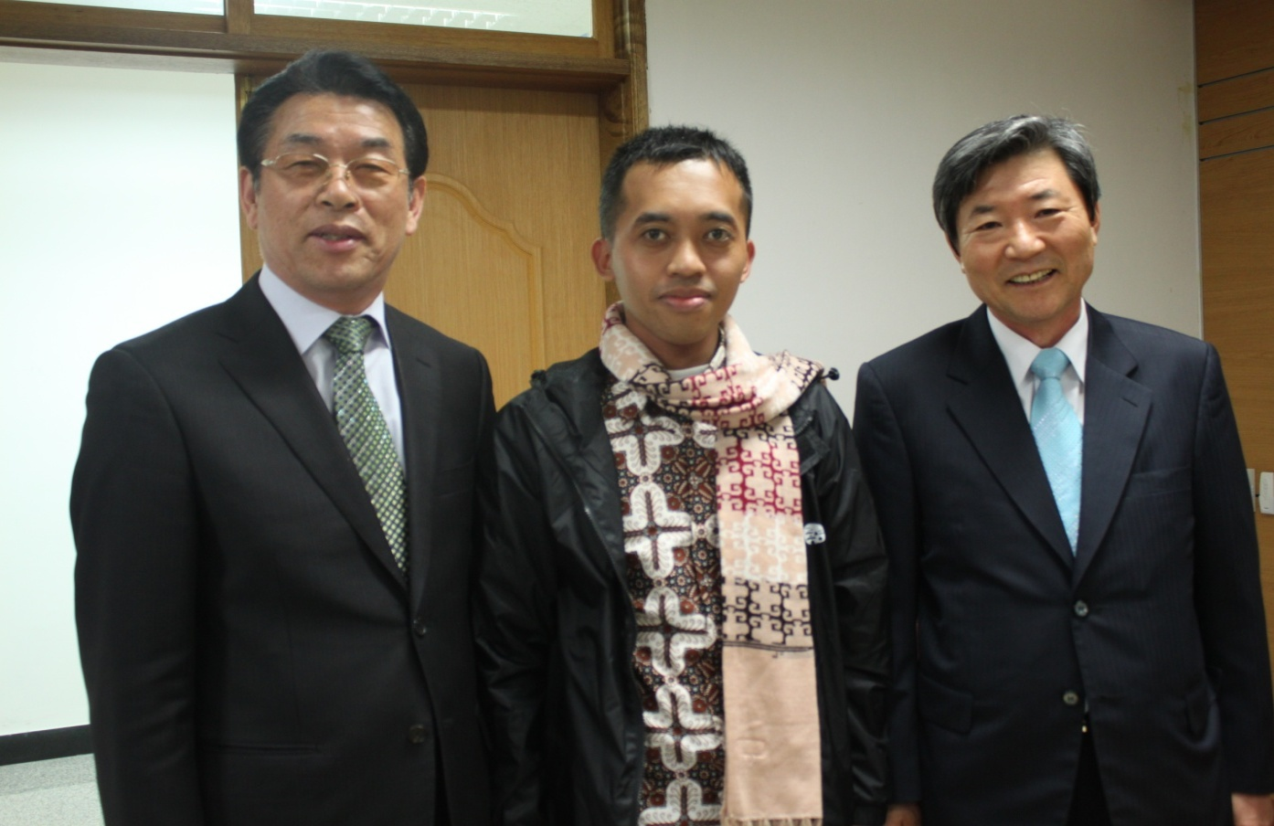
Office of education (March 2012)
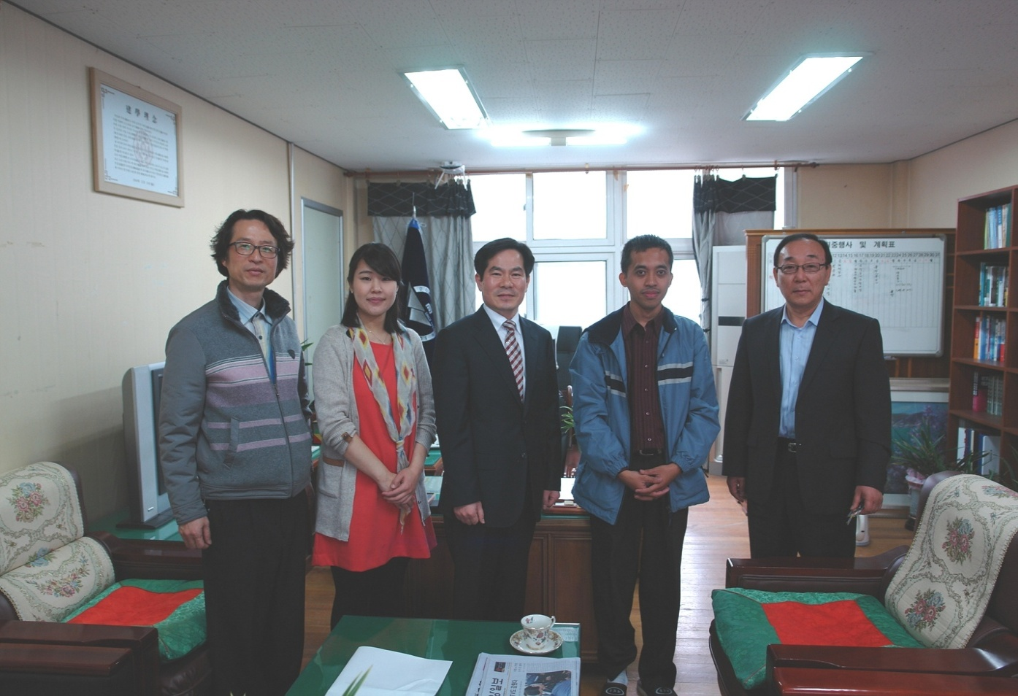
Dongwon high school: April 2012
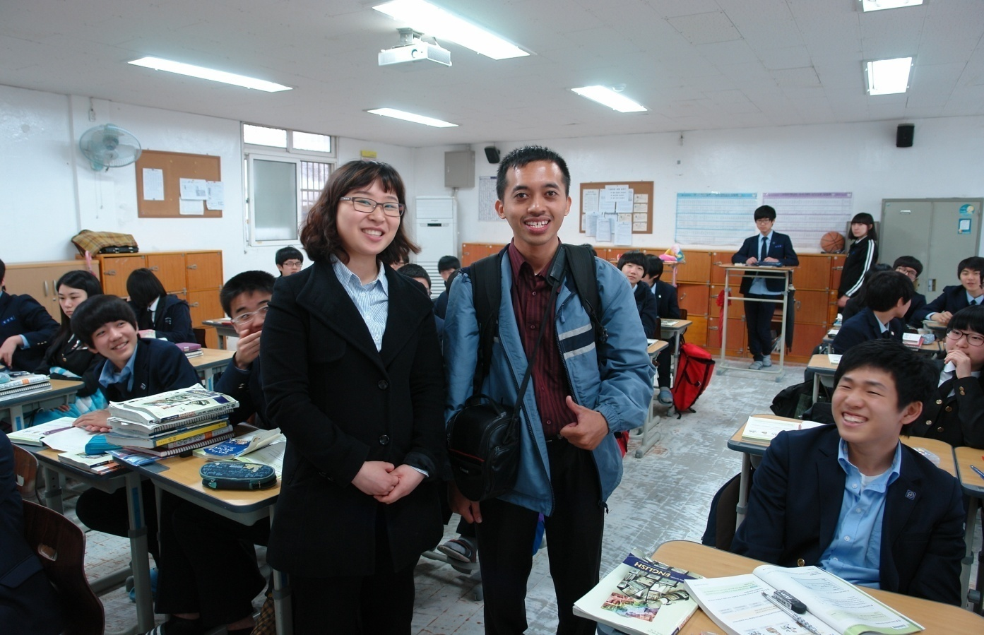
Dongwon high school: classroom visit (April 2012)
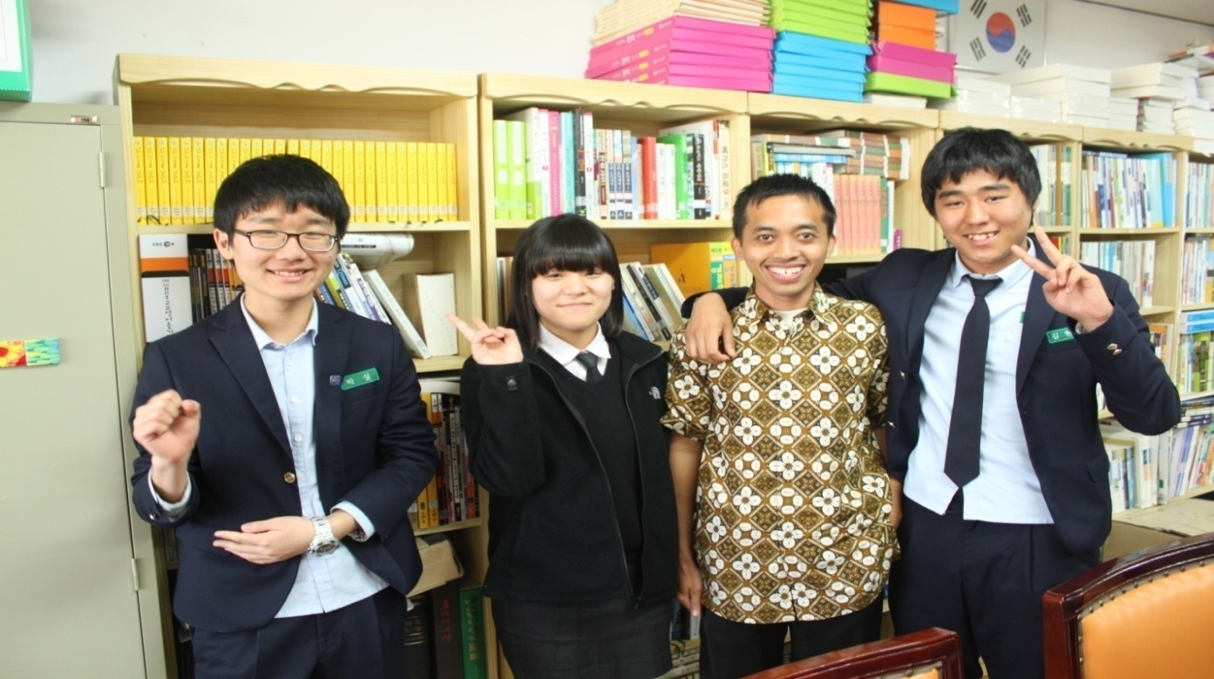
Dongwon High school: Interview with student (17 April 2012)
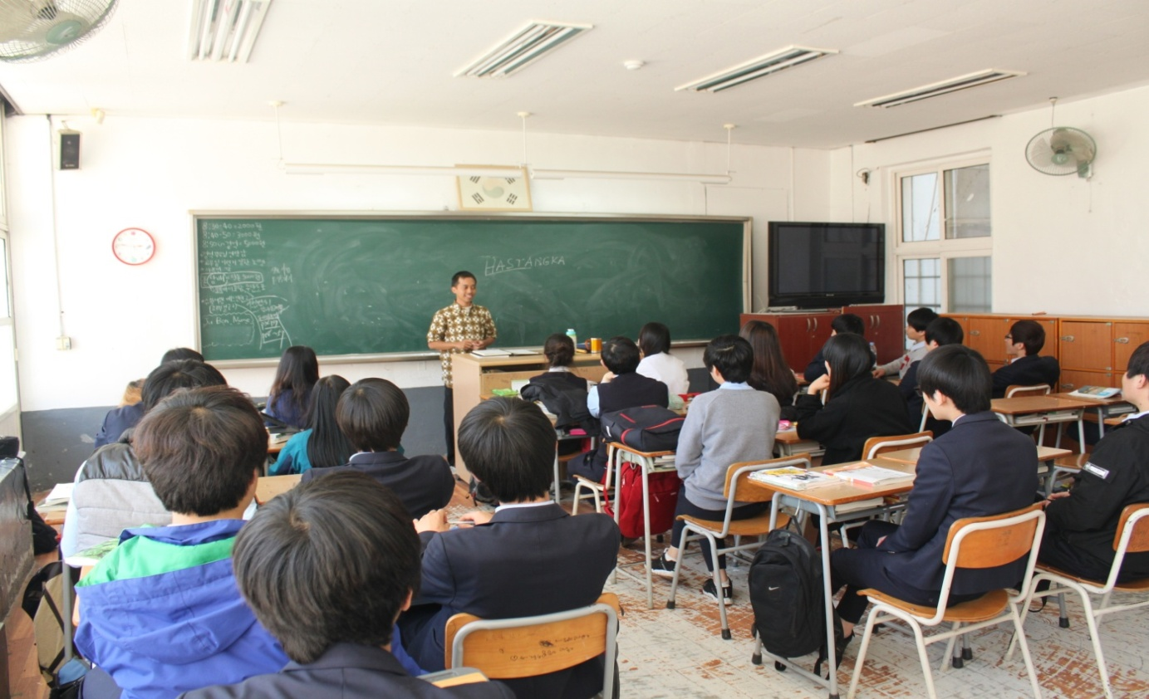
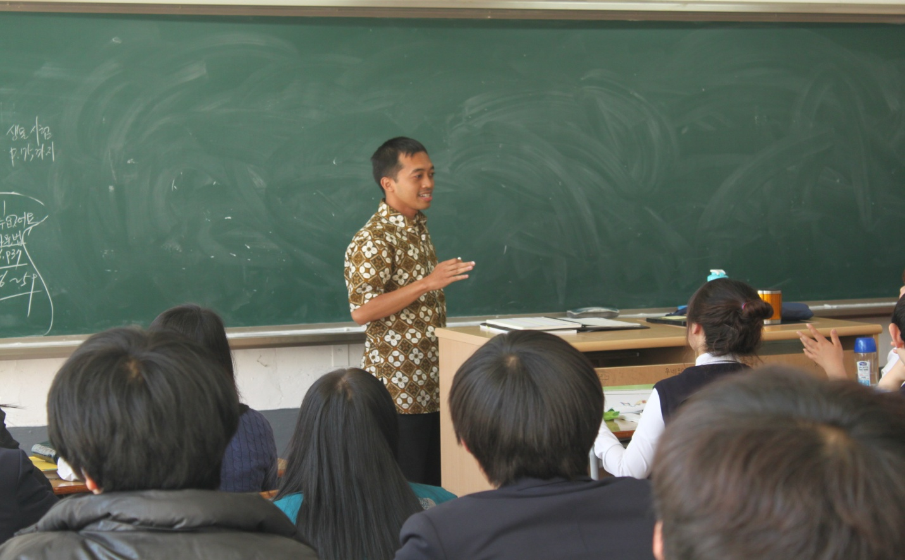
Dongwon high school: Introduction (19 April 2012)
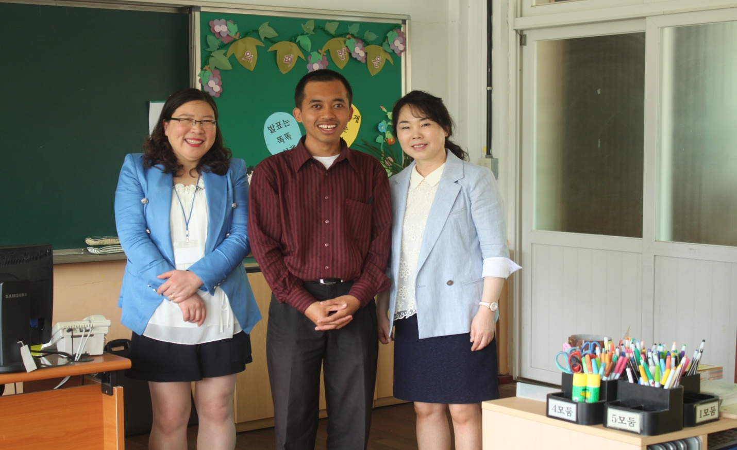
Inpyeong elementary school: 16 May 2012
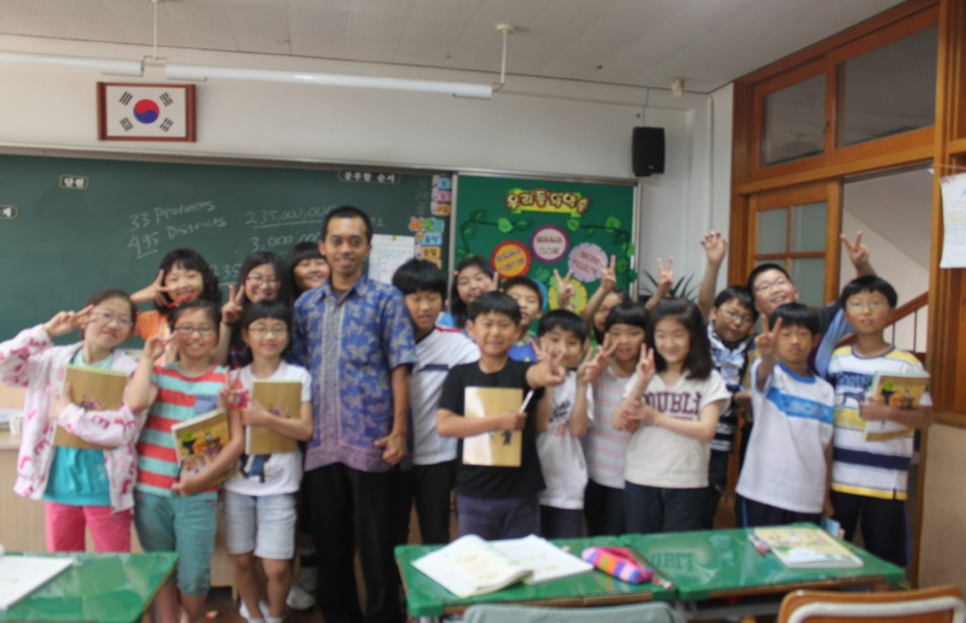
Inpyeong elementary school: fourth grade student 30 May 2012
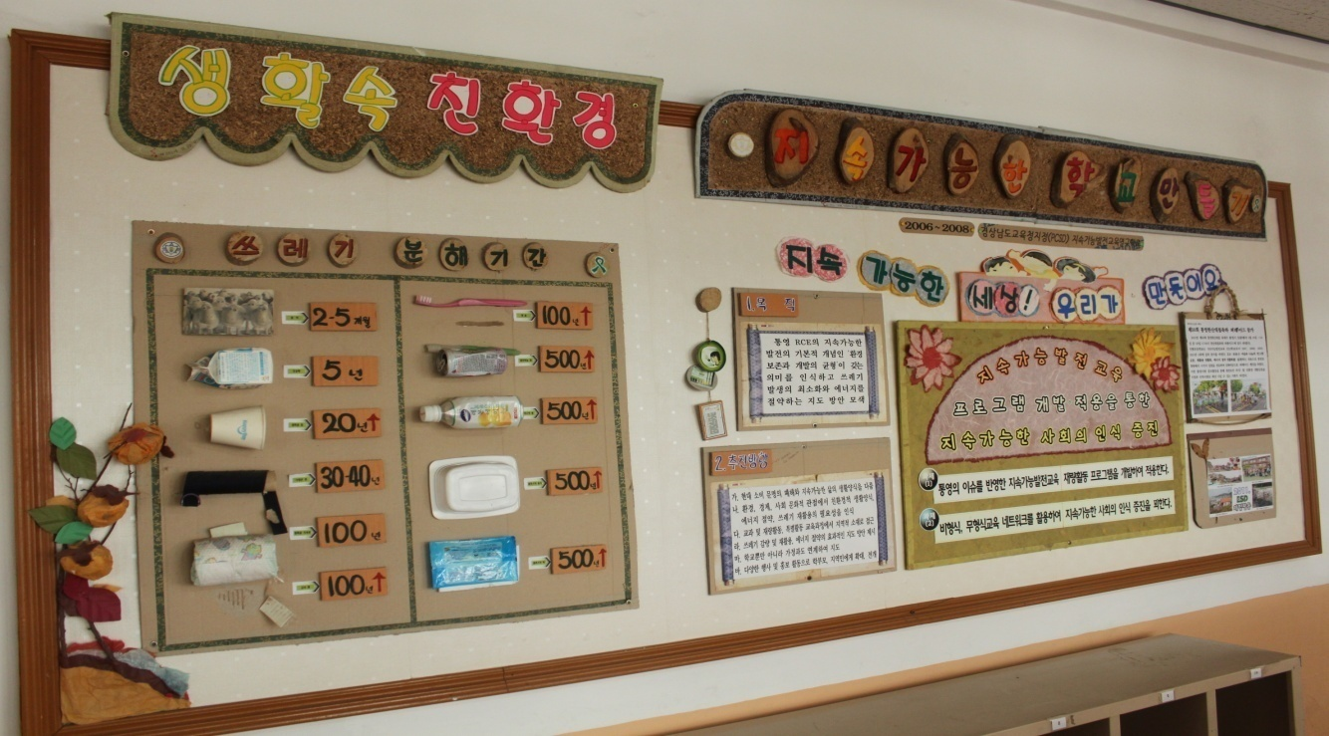
ESD board in Inpyeong elementary school
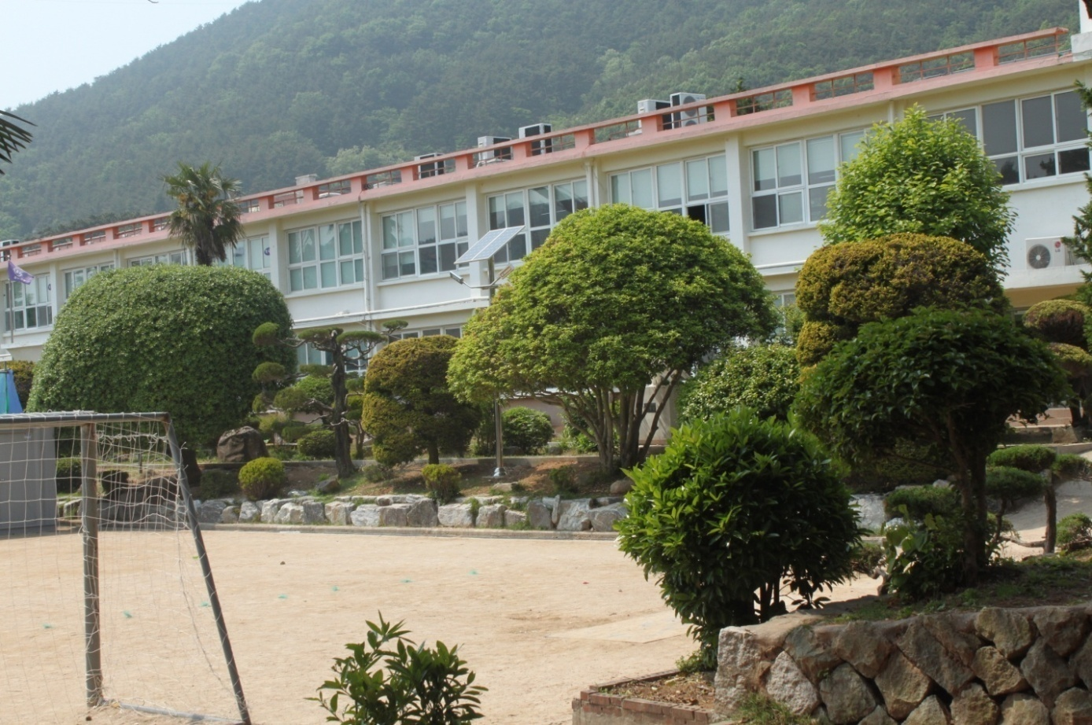
Yongnam elementary school
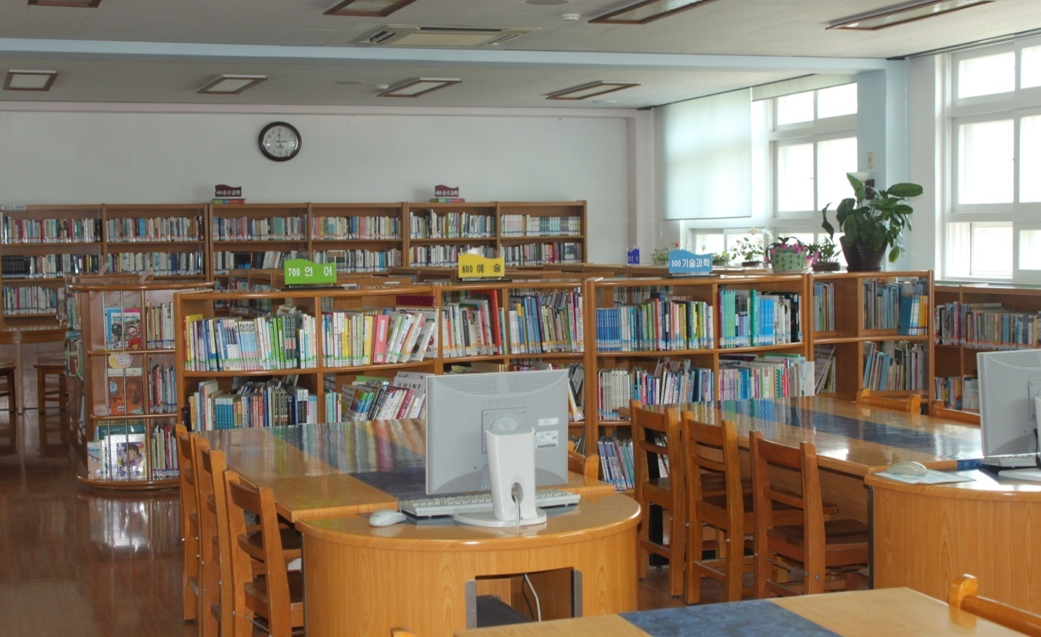
Yongnam elementary school library
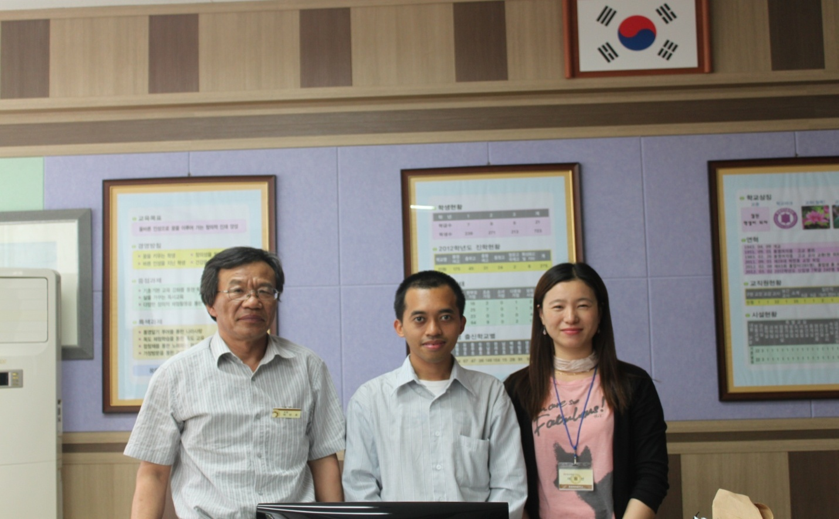
Tongyeong girl’s middle school: Headmaster, Hastangka, Mrs.Lee hoe-soen (24 May2012)
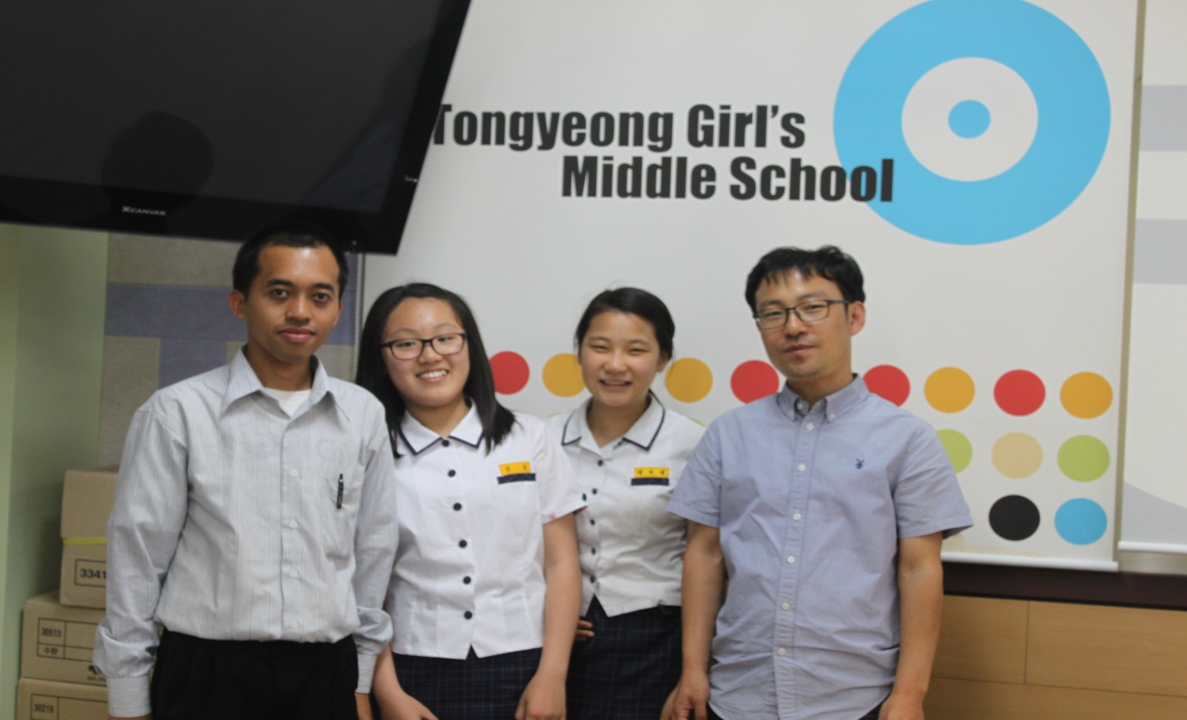
Tongyeong girl’s Middle school Library (24 May 2012)
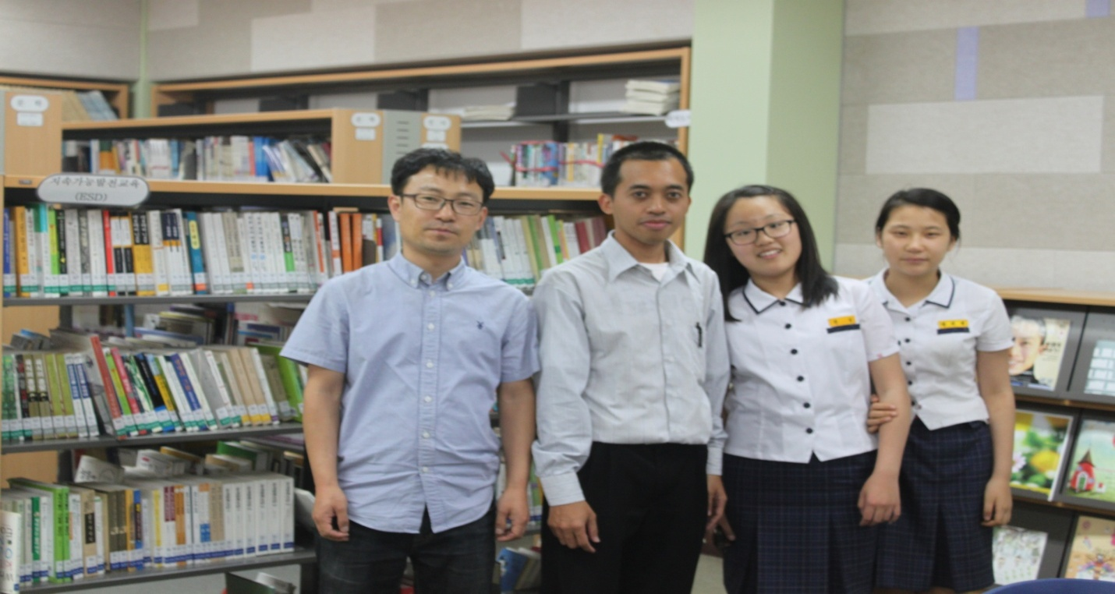
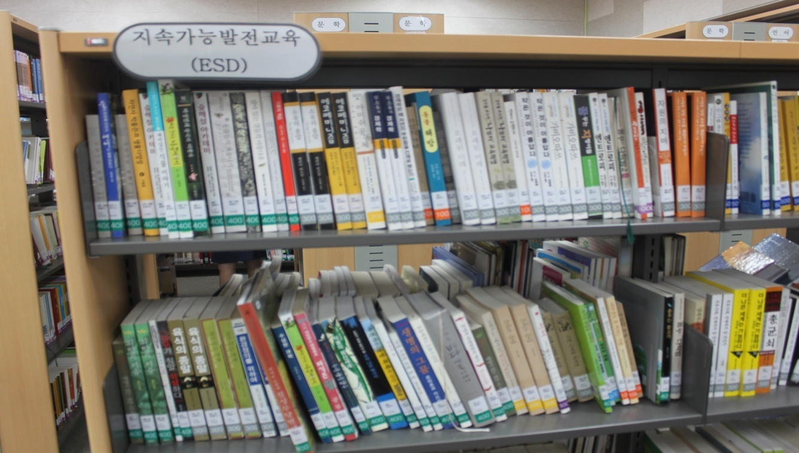
ESD books in Tongyeong girl’s middle school
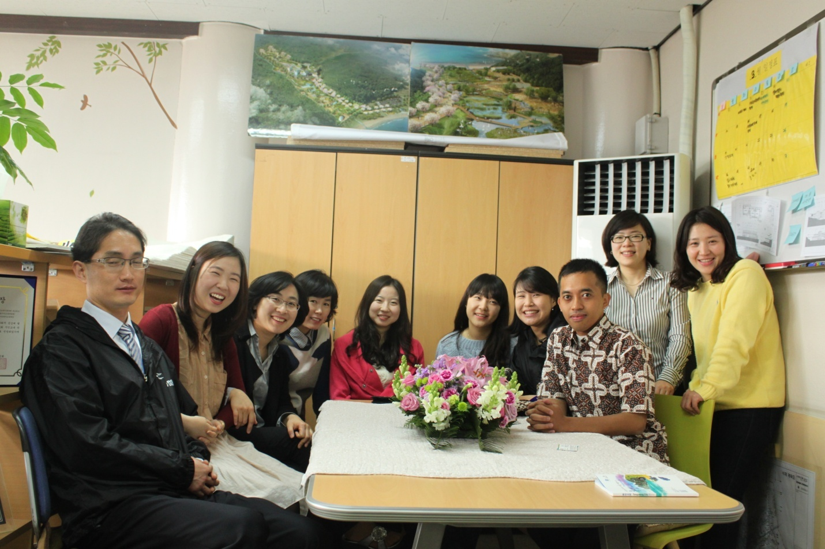
RCE Tongyeong staffs (March 2012)
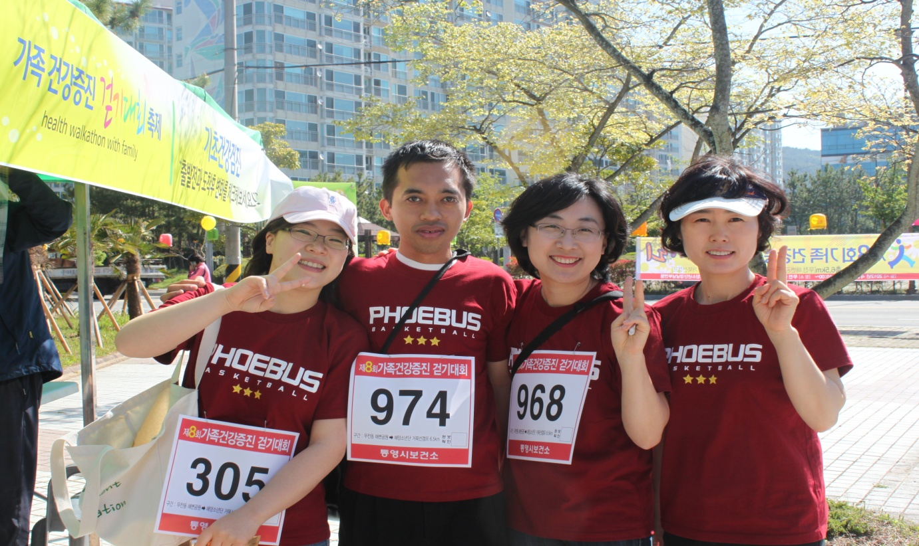
Health promoting program (April 2012)

I interview some Korean parents when I asked them about their hope for their children. They have same answers when their children grow up they want their children can get a good university and better job. A good university they defined as a university which can access to good job opportunity and better job mean as a good salary (interview noted on 14 April 2012, 01:00 pm).
There is no denying that the earth, as we know it, is in danger. The entire planet is suffering from environmental devastation, including climate change, every conceivable type of pollution, ecological destruction and the depletion of natural resources. The results are mind-numbing. There is widespread flooding and droughts, typhoons and tsunamis, heat waves and a wide range of other natural disasters (see http://www.koreatimes.co.kr/www/news/nation/2012/05/370_104284.html) accessed on 22 of May, 2012 10:30 pm.
As shown at the World Conference on Education for Sustainable Development held in Bonn, Germany, with four objectives:(1) to highlight the essential contribution of ESD to all of education and to achieve quality of education,(2) to promote international exchange on ESD,(3)to carry out a stock-taking of DESD implementation and (4) to develop strategies for the way a head (see UNESCO 2009,see also Andrade,2011,p.142).
Between 1990 and 2005, more than 1,000 authors from 304 institutions in 23 countries have penned (some jointly) journal articles in English about Education for Sustainable Development (ESD) (see Paden and Chhokar, 2007,p.73).
See “Earth Charter”, Journal of Education for sustainable development,14 Sep 2010, p.317.
The ESD principles could be translated and interpreted based on the needs of the country. It could be in form socialization, promotion, actualization, contextualization based on the sustainable development framework. For example, ESD in Australia; green environment, zero carbon campaign and taxing for carbon. ESD in Indonesia: biodiversity conservation, cultural preservation, Go green campaign, green school, edu-polis campus campaign, green campus, community empowerment. In Okayama, Japan emphasis on environmental programs, green company campaign, environmental management programs, in addition, Okayama ESD goals is to create a sustainable society where people learn, think and act together through interaction and cooperation among people in ESD sharing both inside and outside of the region (see RCE Tongyeong Proclamation Workshop, ESD and a part of Tongyeong RCE, March 29-30, 2006).
RCE has four programs: 1).governance,2)collaboration,3)research and development,4)transformative education (see www.ias.unu.edu/efsd).
Today, it has already 89 RCEs acknowledged by UNU-IAS, update in November 2011 (see www.ias.unu.edu/efsd).
The RCE Tongyeong has a great vision and mission to promote sustainable development. The vision: an environmentally, economically, and socially sustainable city which cultivates pride in its citizens. The Mission: Promoting Sustainable Development of Tongyeong through Education (See, Byun, Won Jung, 2011, p.88). The goal of this RCE is to establish a foundation for an eco-city where its people are conscious of the significance of their everyday activities for a sustainable society.
The Ministry of Education of Korea designed Tongyeong city as life-long learning city in 2007 (see Sampreethi Aipanjiguly,Yoko Mochizuki,Zinaida Fadeeva(ed).2010,p.1). Tongyeong city is situated at the tip of Goseong cape in the heart of the Hallyeo National Marine Park, which spread over the southwest coast of the Korean peninsula. Surrounded by 10,580 ha of clear blue sea on three sides, its coastlines and 192 islands create a tourist attraction and Korea’s finest fishing grounds. The number of population of this city is around 140,191 update in January 2012 (see Byun Won Jung, 2011, p.84; see Baseline report-RCE Tongyeong; see also Byun Won Jung, 2012, p.35; see also http://www.rce.or.kr/english;see also http://eng.tongyeong.go.kr/01/02_02.asp/).
According to common opinion of Tongyeong society and student said that the icon or characteristics of this city are Lee Sun Sin General, Tongyeong International Music Festival, Dongpirang, seafood (fresh sea food),famous writers and composers, and beautiful scenery,(this information taken from survey due during 9-20 April 2012). Meanwhile, an international student from Philippines who take her research for PhD level also stressed that Tongyeong city is friendly place to visit, life is simple here, and has beautiful natural view (I interview the student on 11 April, 2012 03:00 pm at Gyeongsang College). In addition, many people hope for Tongyeong city as a homeland of artists, and the resting of tourists.
See http://eng.tongyeong.go.kr/01/04_02.asp accessed 5 April 2012.
Based on UN Rio Summit in 1992 which emphasis on 4 core values on ESD to be inserted in education system they are; (1) improving basic education.(2)reorienting existing education,(3) developing public understanding and awareness, (4) training.
There are three essential meaning of ESD. Firstly, education that enables people to fore see, face up to and solve the problems that threaten life on our planet. Secondly, education that disseminates the values and principles that are the basis of sustainable development (intergenerational equity, gender parity, social tolerance, poverty reduction, environmental protection and restoration, natural resource conservation, and just and peaceful societies). Thirdly, education that highlights the complexity and interdependence of three spheres, the environment, society-broadly defined to include culture-and economy (see Matsuura, Koichiro, 2005, p.5).
Environmental issues could associates widely as social environment, cultural environment, family environment, political environment, and economy environment.
According to Korean National Commission for UNESCO states that Sustainable development is a vision of development that encompasses populations, animal and plant species, ecosystems, natural resources and integrates concerns such as the fight against poverty, gender equality, human rights, education for all, health, human security, intercultural dialogue, etc (see http://www.unesco.or.kr/eng/front/programmes/programmes_01.asp accessed on 23 April 2012 6:30 pm).
Responding to this issue, Korean Peninsula realized that climate change is becoming a real threat in this country.
Ban Ki-moon, UN Secretary-General also stressed that if our growing population is going to survive on this planet, we need smart designs that maximize resources, minimize waste and serve people and communities(see http://waterinthegreeneconomyinpractice.wordpress.com/2011/10/03/the-green-economy-and-eunkyung-park/, accessed 8 June 2012, 02:15 am).
Sustainable development could be defined as a development path along which the maximization of human well being for today’s generation does not lead to declines in future well being (see Hilman and Primanovenda, 2011, p.167).
According to Podger et.al (2010) noted that values are generally considered to be intangible and therefore unable to be weighted, measured or counted directly (p.299).
Published by UNESCO in Paris France.
Education for Sustainable Development (ESD) is a paradigm shift in education and goes beyond the traditional premise of education by providing individuals and communities, children and adult alike, with the savoir-faire to tackle the complexities of tomorrow today (see ESD: an Expert review of processes and Learning, UNESCO, 2011 132, Paris-France). However “learning” in ESD occurs in wide varieties of social contexts, It includes what happens in the formal education system but also extends into daily and professional life (UNESCO 2004 in ESD: an Expert review of processes and Learning UNESCO, 2011, p.20). ESD also mean as a dynamic concept that encompasses a new vision of education that seeks to empower people of all ages to assume responsibility for creating and enjoying a sustainable future (see http://www.ias.unu.edu/sub_page.aspx?catID=108&ddlID=182, accessed 8 June 2012 2:00 pm).
See the laws number 20 years 2003 about national education system. This law regulates the system of education in Indonesia which consists of curriculum. See also the laws number 14 years 2005 about teacher and lecturer.
All school both private and government mandate to use national curriculum.
This curriculum is use from kindergarten to high school level.
It is referred to the government regulation number 47 of 2008 on Compulsory education.
In Elementary school level from 1st to 6th grades, there are 8 primary compulsory lessons. They are religion, citizenship Education, Physical Education, Indonesian language, Mathematic, Natural Science, Social Science, Cultural Art, and Life skills and 2 compulsory local contents such as English and mother tongue.
In Middle School there are 11 primary subjects consists of religion, citizenship Education, Physical Education, Information and Technology, Indonesian language, English, Mathematics, Natural Science (Physic and Biology), History, Social Science (Geography and Economic), Cultural Art, and Life skills and local contents (mother tongue).
In High School there are 13 Primary subjects in this high school consist of religion, citizenship Education, Physical Education, Information and Technology, Indonesian language, English, Mother tongue, Foreign languages, Mathematic, Natural Science (Physic, Biology, and Chemistry), History, Social Science( Geography, Sociology, and Economic).
The UN defined ESD as a learning process (or approach to teaching) based on the ideals and principles that underlie sustainability and is concerned with all levels and types of learning to provide quality education and foster sustainable human development – learning to know, learning to be, learning to live together, learning to do and learning to transform oneself and society. UN also stated that this definition is not static but dynamic.
The term of suffering means war, clean water scarcity, energy crisis, food scarcity, hunger, economic crisis, and environmental destruction, etc.
See Mid-Decade review of United Nations Decade of Education for Sustainable Development, 2005-2014., General; August 2010. A/65/279. This document prepared by the director general of the United Nations to give information about the progress, obstacles, and recommendations in implementing the Decade Education for Sustainable Development. According to UNESCO Sustainable Development (SD) define as a vision of education that seeks to empower people to assume responsibility for creating a sustainable future.
Based on official website of Ministry of Education, on Information section –curriculum part, I do not find about model of ESD, study of ESD, and ESD itself. In this website on curriculum section information, I only found learning model of lesson sources, Kurikulum Tingkat Satuan Pendidikan model, Curriculum policy study, professional technical support, character education, and school curricular development. It means, ESD is not the main concern of education system in Indonesia. My thesis is that ESD is a minor and additional paradigm in Indonesian education system. The main concern education in Indonesia during 5 years is about the importance of character education.
My study found that there are two main problems why the socialization of ESD very limited and minimum standard in Indonesian schools because the main sources of knowledge about ESD in English language and there many head of office of education in districts, teachers, and school headmaster cannot read text in English. Secondly, the budget allocation on ESD promotion in each districts office of education is different and various.
In 2009, Indonesia’s office of education through Ministry of Education Republic of Indonesia developed national strategic of ESD practices, ESD models in extracurricular activities, ESD models in intra-curricular. In 2010, Indonesia’s office of education developed ESD learning sources, guideline of integration ESD values in learning activities. On 15-18 April 2010 Ministry of education through Pusat Pengembangan dan Pemberdayaan Pendidik dan Tenaga Kependidikan (PPPPTK) held Workshop on lesson development for ESD, this workshop located in PPPTK Bahasa, Jakarta. The result of the workshop are guidance on ESD in Indonesian and English teaching (1 exemplar), Guidance on ESD in Indonesian language for fourth grade, fifth grade, and sixth grade elementary school level ( 6 exemplars);for first grade, second grade, and third grade (3 exemplars), guidance on english lesson ESD based (3 exemplars), map on EfSD in English lesson and Indonesian lesson (1 exemplar).
Ibid, p.5.
Since ESD become government agenda, ESD is just merely labeling campaign on education and particular project for office of education and teachers especially government official in Education office/department. Dissemination report result on study, research, and workshop related on ESD are rarely to hear.
ESD is based on values of justice, equity, tolerance, sufficiency and responsibility. It promotes gender equality, social cohesion and poverty reduction and emphasizes care, Integrity and honesty, as articulated in the Earth Charter. ESD emphasizes creative and critical approaches, long-term thinking, innovation and empowerment for dealing with uncertainty, and for solving complex problems. ESD highlights the interdependence of environment, economy, society, and cultural diversity from local to global levels, and takes account of past, present and future.
ESD programs consist of Environmental awareness, combat illiteracy, cultural preservation, women empowerment, community empowerment, and curriculum development. This year, Gadjah Mada university offer ESD grant for village development based ESD. Since 2009, Gadjah Mada University through Community and research services has been developed community services (KKN-PPM) based on ESD in number of regions in Indonesia. The programs consist of economy development, illiterate eradication, and environmental education both soft and hard skills. It proved bring a great positive impact for the improvement of quality of life in rural and inland society.
Yogyakarta’s Special Region = Daerah Istimewa Yogyakarta. According to Yogyakarta statistical agency (2011) number of population of Yogyakarta region is 3.452.390. It is consist of 338.775 in Kulonprogo district; 910.572 in Bantul district; 674.408 in Gunung Kidul district; 1.090.567 in Sleman district, and 388,088 in Yogyakarta city.
Private institutions are company, private organization and mass organization. Mayor of Yogyakarta city has been released a decree number 6 years 2010 about private provision of green space.
In 2011 RCE Yogyakarta received and reviewed seventeen proposals on ESD from nine faculties. The topic of proposals were varied, for example on biodiversity, conservation and forest management, community based-herbal plantation, sustainable laboratory practice, house waste management, children teeth health, coastal plantation using natural ameliorant, green philosophy implementation on basic philosophy courses, environmental etiquettes, adaptation and mitigation on climate change, green village, sustainable housing management, ESD based bio-science program, botanical garden, herbal plantation, research for community.
Research and Community services = Lembaga Penelitian dan Pengabdian Kepada Masyarakat (LPPM)- Gadjah Mada University.
Yogyakarta Special region consist of 4 districts and 1 city. They are Sleman, Kulonprogo, Gunung Kidul, Bantul and Yogyakarta city. in Yogyakarta, there are around 116 private universities(institute, College, University) and 4 public Universities (Gadjah Mada university, Yogyakarta state University, UIN Sunan Kalijaga, and Indonesian Institute of Art).See http://www.suaramerdeka.com/v1/index.php/read/news/2012/04/01/114128/Empat-dari-116-PTS-Yogyakarta-Tidak-Aktif accessed on 29 May 2012 2:30 pm.
RA means Raudhatul Athfal (Kindergarten or pre-school level)
MI means Madrasah Ibtidaiyah (Elementary school level).
MTs means Madrasah Tsanawiyah (Junior high school level).
MA means Madrasah Aliyah (High school level).
In elementary school, the class starts at 07.00 am -12.30 pm(official time).
In Junior high school, the class starts at 07.00 am -2.00 pm (official time) for extra time they usually have to come early at 06.00 am in the morning. The extracurricular begin from 02.00 pm to drop.
In High school, the class starts at 07.00 am- 2.00 pm (official time) for extra time they usually have to come early at 06.00 am in the morning. The extracurricular begin from 02.00 pm to drop.
Vocational education means practical education for specifics skills such as secretary, tourism, mechanical engineering, and cooking.
The Ministry of Education declared the need of character education in school because responding critical issues in society and in the country such as identity crisis among students, corruption, civil crime, demonstration, madness, bullying, drug abuse, and immorality action (rape, sexual abuse). Those issues become phenomenal issues that happened in every region in Indonesian provinces and it caused frustration among parents, educators, and society. Democratic euphoria also causes unstable society and environment. Based on that case, the Ministry of Education recommended every school in Indonesia should teach character education/moral values in the schools. Character education become the main campaign in education, many advertisements such as street banner has been took place in front of district educational office to promote character education in schools since 2010. In contrast, the district of educational office and Indonesia’s Ministry of education do not have any appropriate instrument to evaluate character education paradigm in the school. There are four main national issues faced by Indonesian education, Firstly, anti-corruption education. Secondly, sex education. Thirdly, multiculturalism education, and fourthly, character-education. Now day, we have to face ESD programs/paradigms.
All schools in Yogyakarta should have local contents or extracurricular related with cultural preservation such as batik writing, gamelan traditional music, or mother tongue language, Javanese language education.
The different between character education and education for sustainable development are character education responses to national and local issues and Education for Sustainable development responses to global issues.
Sekolah Dasar(SD) = Elementary school.
Many schools in Yogyakarta region has special characteristic on ESD program. Mostly, they develop their program in the extracurricular activities through student community service in the school such as scouts, cultural performance, charity, social services, and environmental awareness.
Indonesia national education has a vision to develop the capacity and build a character, civilized, dignity of the student in the frame of Indonesia basic constitutions 1945, paragraph 4 to educate all citizen in order to become faithful human, obey to the God, have a good personality, health, knowledgeable, competence, creative, self-reliance, and become good democratic and responsible citizen. See also on the laws number 20 years 2003 about National Education System.
Even though, Indonesia government has release school fee for public primary school to Junior high school. There are many schools still asks some money to the parents. Usually, public school gives reasons it is for administration, to support school’s activities, to give more facilities to the students, etc. When the first new academic year, there are many students must pay some money to the school with the reason to re-registration to go to the next level. The range of money around 150,000 rupiah to 1,000,000 rupiah, it depends on the school internal policy and where the school exists in the city or in the village area and the level of the school. The next reason why this alternative schools emerge in Yogyakarta and number of cities around in Indonesia Island because the issues in conventional school are too many regulations, and the schools only emphasis on cognitive side and inequality of access education for the poor. The complexity and overcrowded of Indonesian education and uncertain educational policy responded by many society and educators to find an alternative in education system.
The alternative schools that successful in educating the students usually get awards from many donors. The donor can come from local, national, and even international. It could be from individual and institution. So there are many alternative schools which successful in developing alternative teaching and learning. In this case it is not a new case about ESD programs but international program from various institutions. The International donors which usually has concern in environment, HIV/AIDS, public health, water sanitation program, gender, education, and economic in Indonesia are AusAID, USAID, World Bank, Australia-Indonesia Partnership (AIP), UNDP, ADB, Australia-Indonesia Institute (AII), Australia-Indonesia Basic Education Program, The Asia Foundation, JICA, KOICA, British council, and number of international NGOs such as (Relief Foundation, IOM, Save the Children, ChildFund Indonesia, American RedCross, Hivos, Tanoto Foundation, Djarum Super Foundation, Sampoerna Foundation, and etc). For example, this year 2012, USAID support Indonesia for marine conservation. This agency gives 800.000 dollar US for marine conservation in Indonesia until 2020 (see http://nasional.kompas.com/read/2012/05/16/19370219/AS.Dukung.Konservasi.Laut.Indonesia accessed 17 May 2012).
For example, One earth school founded by Anand Krishna based in Bali island, this school has a vision which emphasis on one earth, one sky, and one human kind and encourage the student to appreciate the environment (see http://www.oneearthschool.org/index.php?lg=en&ch=about), other examples SD Luqman Al hakim in Yogyakarta, SD Sanggar anak alam, Sekolah Alam, in Yogyakarta, etc.
According to Hilman & Primanovenda studied (2011, p.168) showed that the reality of education, especially in Indonesia mostly only emphasis on cognitive side and achievement.
There are many alternative schools grow and develop in urban and rural area usually initiated by religious institutions and individual who have concern in education. The vision and mission of school will depend on the vision and mission of committee in the Foundation. Most school especially basic education level has big concern in environment. Generally, they design their schools based on the environment condition. If the school near of agricultural land and green area they develops their school with green or eco school concepts. When their schools are existing in urban area, they develop their school on the framework of culture and sustainable life style. Sometimes, they design their school with the green school concepts and usually, they adopt these concepts from various sources. So, I would like to stress it cannot be claimed as ESD programs. My observation during 2010-2011 found that none of schools from primary schools to high schools both public and private in Yogyakarta states their vision explicitly for ESD or they inserted it in their vision statement and many school teachers do not know about ESD.
IT= Islam Terpadu-Integrated Islamic values school.
Tafakur alam taken from Arabic word or quran teaching in Muslim way of life it means to take cares the nature.
The main concern of this school for student are student can be able understand the Islamic teaching, embodied sholeh/obedience student. Embodied scientific character, embodied leader character, and to prepare the student continue to the next level.
BSNP-National Standard of Education Bureau.
In this process the school teaches to the student how to eat not too much and can share with other. They can get a lesson when they take a food they have to consider and think about other friend. They have to responsible with food they take and have to eat all, no waste on the plate because it is not good for future and unethical. This is a moral teaching on sustainable consumption. In addition, before they eat, the teacher teaches them to wash their hand first; they have to wait in eating until all their classmates get foods. After all students in a classroom get the food then, they can eat together.
When I visited to this school it was look like all students always at outside of the classroom. In this school it seems does not have an exact time where the time of lesson ends and when the lesson will begin. In fact, the student are understand and know when the time to enter to the classroom. Nature and school environment use as main learning media to teach them.
Family collection as means student brings books collection from their home and keeps it to the school during a week in order to share with other students.
This school has learning strategy such as student centered learning, developing child’s creativity, create good condition and challenging, developing multiple intelligent, provide various learning experiences and learning by doing.
This school has a basic assumption that children has a huge curiosity in knowing something and they still have natural sense to play also. It is important to create a fun condition for them. So that, the children can feels at home and enjoy to study.
The dancers from third grade student.
The buyer could be found from teacher, parent, and student itself. The purpose of this program is to emphasis on creativity and respect to our own work.
This school has extracurricular on cultural preservation such as traditional dance, traditional music practice, and batik writing.
The method of learning are exploration, questioning, experimentation, research, collect and report data, to deepening understanding through application of the concept, create and test the theory, the elaboration of the solution to the problems (see http://www.sekolahtumbuh.org/index.php?page=about&id=1 accessed 10 April 2012 2:30 pm).
See http://www.etic2012.org/.
The purpose of this convention is to build and share the latest EE/ESD theory, policy, and practice with the principle of togetherness, tolerance and participation. Throughout the conference participants will discuss the implications for Education for Sustainable Consumption (ESC) and ESD issues such as sustainable consumption, green economy, climate change and indigenous knowledge, as well as the latest strategies to enable young generation to see the planet as one interdependent environment. The program, which includes exhibitions, inquiry based field trip, group discussion and social activities such as cultural night and conference dinner, will provide an ideal opportunity to network with colleagues and strengthen school partnership (see http://www.etic2012.org accessed 10 May 2012 03:00 pm).
SD IT BIAS means Islam Terpadu Bina Anak Sholeh elementary school.
This small group classroom to make learning and teaching efficiently, in this school they have subject teacher not class teacher.
In this school and its branches has special characteristics, there is always number of trees in front of the school and surrounding it.
This number of student based on the data in 2010.
This school is very famous school and a proud if a parent can take their son/daughter to enter to this school. Number of student who graduated from this school can enter to the favorite school in Yogyakarta. This school also had an opportunity to do a comparative study in Australia. Student who gets higher score in examination and number of achievements, he/she will get a reward (fresh money and certificate) from the school.
This school is frequently sending their teacher in many training programs, workshops, and seminar.
According to Peraturan pemerintah No.74 tahun 2008 article 1 verse 1 defined teacher as professional educators with main duties to educate, to teach, to guide, to lead, to train, to value, to evaluate the learners in early childhood education formal education, primary, and secondary.
In order to be certified as a green school, a school needs to meet four standards: use toxic free materials, use resource sustainably, make a green schoolyards, and teach stewardship related environment (see Jin,Mi-sug,2011,p.74).
There are five aspects of safe schools;(1) disaster safe location –open space distance from thread point, easy access, near public facilities, water, electricity, and communication feasibility-(2) knowledge, attitude, and behavior – to increase knowledge and prepare appropriate attitude to reduce disaster risks-,(3) building structure-strong and solid, appropriateness meets local wisdom, quality materials-(4)class design and layout setting to reduce disaster risks, (5) facilities and services support.(see Safe school National conference report, Jakarta 20-21 December 2010, at Hotel Kartika Chandra, p.5-6). Organized by National Disaster Risk Management (BNPB) and Ministry of Education
On 22-25 October 2012, Yogyakarta to host for Asian Ministerial Conference on Disaster and Risk Reduction (AMCDRR)http://edukasi.kompas.com/read/2012/05/28/17490585/Program.Percontohan.Sekolah.Aman.di.5.Provinsi, accessed 28 May 2012, 11:30 pm. Beside green school there is also safe school programs.
Indonesia targeted MDGs programs in 2015 are completed, but many experts said that it is still face many problems and obstacles. As Suyono Hadinoto, Director for Population and national family planning said that the increase of population caused environmental pollution, water pollution, less productive land, forest degradation, illegal lodging.(see http://ugm.ac.id/index.php?page=rilis&artikel=4707, accessed 7 June 2012 09:25 pm).
The common problems are the relationship among teachers sometimes have tension because of project scramble within the school and position promotion, the relationship between teacher and student sometimes is not good enough and not conducive because the teacher discriminative in classroom, and the problems of student itself.
Regarding with climate change issues, SEAMEO has published teacher’s guidebook for integrating climate change in Southeast Asian schools (edited by Abdullah, 2010).
The fact that Korean education system and its national curriculum has contribute to the national economic development by supply qualified man power (see Kwak, Byong-Sun, “Comparison of Korean and Namibia School Curriculum with focus on Textbook provision”). In its national curriculum Korean has own definition related with well-educated person. It means as a person who is healthy, independent, and creative and has a moral. As Kwak Byong-Sun study showed that school curriculum comprises subject matter and extra-curricular activities and the subjects matter divided into compulsory and selective subjects. Meanwhile for eleventh and twelfth grade is differentiated program for individual and school based programs.
See http://asiasociety.org/education/learning-world/south-korean-education. In addition, the vision of Korean education is “Hongik Ingan” (Korean pronunciation), it means being beneficial to all people.
See http://english.mest.go.kr accessed 4 May 2012 2:30 pm.
The elementary school begins at 09.00 am until 04.00 pm.
Middle school begins at 08.00 am until 04.00 pm.
Korean, social studies, moral education, mathematics, science, technical and housekeeping, physical education, English, Art (included Music).
High school divided into two categories. They are academic and vocational (advanced technology). This school begins at 08.00 am until 06.00 pm. The period of study in Korean schools has more extra hours compare to other country such Indonesia which only short hour from 07.00 am-02.00 pm. The common reason why Korean school has more time to study is because many students want to go to a good university and pass the exam (taken from interview with one of Korean scholar from Korean Education major through email, Saturday, 14 April 2012 at 10:00 pm). In addition, the fundamental reason is only education that can change the nation into prosperity and welfare. Moreover, Korean people want to build every citizen experts in many fields (science, technology, and skillful labor) in the world (based on personal communication with High school teacher in Tongyeong city, 16 April 2012 02:00 pm). In contrast, the implication of this long period of study in school causes stress of students. According to the survey of Seoul Metropolitan government showed that 43% of student under intense/high stress and the source of stress are 58% of study, 16% of parents, 10% of looks, 8% of friends. Male student relief the stress through video games (48%) and female students use TV and movie (43%) (See Arirang breaking news, 4/29/12, 10:04 pm).
Here are the primary subjects: Korean, Social Studies, Science, Mathematics, English, Physical education, art (music), second foreign language, Chinese character, Technical and housekeeping.
For eleventh grade and twelfth, they have elective course. Every school has varies elective course based on student interests.
Korean National Commission for UNESCO (KNCU) was launched as a DESD national coordinating body in 2009. Meanwhile the KCNU itself was founded in 1954.
See Korean National Commission for UNESCO, 2011, “ESD in Korea Integrating Education for Sustainable Development into Educational Strategies and Policies”.
Green growth is strongly emphasis on climate change and energy crisis (see www.greengrowth.go.kr).
See PCGG on progress report2008-2009; p.14.
See http://www.gggi.org/event/2011/00/00/global-green-growth-summit-2012, accessed 10 May 2012.
It is based on the conference section on “policy and capacity building support for developing countries”. Global Green growth Summit 2012, 11 May 2012. Meanwhile according to ISAP 2011 also stressed that regarding with green economy should have the twin goals of poverty alleviation and quality of life. It should improve the daily life of poor people, not only in developing countries but also in developed countries (2011,p.16).
Korean government also developed guide book on environmental education for Korean Schools, published in 2002 by Ministry of Education. The content of the book about environmental education model school, best practices in Kindergarten, elementary school, Middle school, and high school (see www.me.go.kr). Furthermore, The Korean government has anticipated in responding ESD through publication of ESD guidebook for teacher in 2007. In 2008, there was a workshop on ESD for Korean teacher in cooperation with the Hanyang Cyber University Institute of ESD; In April and October, Government ministries had conferences to discuss the implementation of ESD in Korea. In 2011, ESD teacher training courses for primary and secondary educators in partnership with the Seoul Office of Education and the Seoul Education Training Institute (SETI). In addition, in 2000, Korean government established the presidential commission on sustainable development (PCSD) which has main focus to formulate a national sustainable development strategy integrating the environmental, economic and social dimension (see http://esdkorea.unesco.or.kr/en/main/timeline.htm; see also Jung, 2011,p.24).
The Korean government translated ESD vision into number of programs, grants, and projects.
Presidential Commission on Sustainable Development(PCSD)and in 2007 PCSD changed into Korean National Commission for sustainable development (KNCSD).
Gyeonngi Province, Gangwon Province, North Chungcheong Province, South Chungcheong Province, North Gyeongsang Province, South Gyeongsang Province, North Jeolla Province, South Jeolla Province, and Jeju Province.
See http://www.gne.go.kr/eng/basic/basic.jsp accessed 17 May 2012 5:10 pm.
The data is taken from Tongyeong Educational Office (2011).
Meanwhile other issues in the schools are emphasis on job, local society issues, and cultural and historical protection in Tongyeong city (based on the interview with high school teacher, 17 April 2012 3:00 pm).
In responding to marine litter problems in 2006 the Tongyeong safeguard held International coastal cleanup program and marine litter education in Tongyeong science museum(see Lee,J.M,Hong,S,W,Ko,SS.H,2008,p.118-120).
Students are less competitive, less information about university and access for any new academic activities in the capital city and lack of desire to develop their competitive skills and potentiality because minimum of facilities provided in this city.
According to Prof.Choi Kwang Soo noted that Tongyeong city economy driven by fishery industry, tourists, and ship building company. Nowadays, the economy in Tongyeong city has decreased caused by ship building company lack of order (personal communication with Prof. Choi Kwang Soo, 20 April 2012 02:00 pm). In addition there are many others terms for Tongyeong city such as the land of Sea, marine products, tourists city, Pearl of city, ship building, the Naples of east, and cultural city. Related to tourist city, according to CNN, a US cable news network on January 17,2012,suggested Top 9 photographic spots to visit in Gyeongnam (daraengi village,Namhae,Gyeonghwa station, jinhae,Upo Wetland,Changnyeong,Haein Temple, Hapcheon,Cheonwang Peak, Mt. Jiri,Yeojwa Stream,Jinhae,Terraced Paddy fields,Hamyang, Royal Azalea Festival, Mt.Hwangmae, and Chokseok Pavilion, Jinju). Tongyeong-city is not included here. It means that Tongyeong city is still need to improve its quality of public tourist attraction in Gyeongnam area (see http://english.gsnd.net accessed on 2 May 2012 02:50 pm).
My study found that there is no information or data provided that Tongyeong city will become city of student.
Police arrested two teenagers in the provincial city of Makpo may 29 for attempted murder of the elder boy’s parents to get insurance money (see http://www.koreatimes.co.kr/www/news/nation/2012/06/117_112087.html), accessed 1 June 2012 03:00 pm.
Citizens in Daegu are in panic following the suicide of the eighth students in six months on Saturday. They are the victim of school brutality and bullying (see http://www.koreatimes.co.kr/www/news/nation/2012/06/117_112444.html, accessed 5 June 2012 09:00 pm).
One of the biggest concerns for educators now is violence in schools. As shown on the news that in the wake of a series of suicides by students because they were so severely bullied, the ministry announced a package of measures to root out bullying, empowering principals to suspend violent pupils from schools and to institute an alert system for organized student gangs (quoted in http://www.koreatimes.co.kr/www/news/special/2012/05/181_110646.html, accessed 11 May 2012 4:35pm). Recently, Korean educational policymakers and the US government agreed to conduct joint study on bullying at schools. The purpose of this study is to collect and analysis data on violence (see http://www.koreatimes.co.kr/www/news/nation/2012/05/117_111435.html) accessed 22 of May 2012 10:45 pm.
As Lee Ju-ho, Minister of Education, Science, and Technology underline that the root of violence problem in school is the competition-oriented within school systems. Therefore, he said. “We are trying to diversify ways for students to enter college and help students develop character instead of only forcing them to study.”(see http://www.koreatimes.co.kr/www/news/special/2012/05/181_110646.html accessed 11 May 2012 01:30 pm).
Referring to Bonn declaration (2009) ESD is based on values of justice, equity, tolerance, sufficiency and responsibility. It promotes gender equality, social cohesion and poverty reduction and emphasis care, integrity and honesty, as articulate in the earth charter. ESD also emphasizes creative and critical approaches, long term-thinking, innovation and empowerment for dealing with uncertainty, and for solving for complex problems.
The main cause of sea pollution is fish feed (see Joong, 2008, p.43) and human activity from household trash.
That vision developed since Tongyeong RCE was designated as 8th RCE by United Nations University on October 2005, as settlement of Education for Sustainable Development (see www.gntye.go.kr).
Interview taken in 9 May 2012 at 10:00 am in Tongyeong office of education.
Office of education adopted ESD since 2007/8 as an office program under coordination of RCE Tongyeong.
Heekyung Kim also showed that to expand ESD within and outside of the school, this school has training programs for teachers, parents, and doing a research exhibition under theme ‘the Future of Our Town’, for this exhibition, the team came from students, a teacher, and parents. The activities of this research exhibition was to seek a important subject of Tongyeong city related with Sustainable development(seehttp://www.intlalliance.org/ialeimagazine/sustainabledevelopment/voxpopbestcasesaroundtheworld/,accessed 30 May 2012 2:25 pm).
Club activities is consisting of animation, drawing, English, basketball, soccer, Korean wrestling, art, cooking, paper craft, science, music, reading books. In club activities student can choose what kind of activity they like. This club activity conducted a hour per-week.
The data is taken from the interview on 16th of May 2012 at 11:00 am in Inpyeong elementary school.
16 May 2012 11:00 am in Inpyeong elementary school.
Mrs. Kim Jong Sook (a teacher in Inpyeong elementary school) notes that through ESD she wants their student are happy living in this planet.
A model of school for ESD is a kind of competitive status which given by the authority (RCE Tongyeong) and only school that meets with the ESD criteria can get status and predicate as a model school for ESD.
Data is taken from interview on 16 May 2012 at 2:30 pm in Yongnam elementary school.
See school pamphlet (2011).
Observation and sit in activity in Tongyeong girl’s middle school, 13 June 2012 at 09.00-11:45 am.
I interview with Lee Hoe-Seon, a teacher (24 of May 2012, 3:30 pm) in Tongyeong girl’s Middle school.
This program could be develop into deep root for example, campaign to eat healthy food for students and campaign for not to eat fast-food (for example, hamburger) which caused health problems, obesity, etc. as shown on APEC educational Ministerial meeting under theme: “Future Challenges and Educational Responses: Fostering global, Innovative, and cooperative Education“ in Gyeongju, South Korea,2012. Two Indonesian students and Korean students make a poster for no fast-food eating and anti-hamburger campaign in public places in Gyeongju. Because of hamburger made from cow industry which has potentiality undermine the environment (see http://edukasi.kompas.com/read/2012/05/28/18355122/Pelajar.Indonesia.Berprestasi.di.APEC) accessed 28 May 2012 11:45 pm. See also http://view.koreaherald.com/kh/view.php?ud=20120523000968&cpv=0.
Interview with Lee Hoe Soen, a teacher at Tongyeong girl’s middle school, on 24 May 2012 3:30 pm. She has been a teacher for 10 year.
The address of this school is at Dongwon High school 166 Jeongryang,Tongyeong,Gyeongsangnamdo,South Korea.
When I visited to this school on Tuesday, 10 April 2012 at 10.00 am, I met with Doheon Lim, an English teacher and the headmaster Mr.Chayeol Hwang, headmaster of this school discussed about the progress and achievement of this school related school based management system. He developed new paradigm school based management system for teacher and student. One of the visions of this school is to empowering student get success on his education and develops their creativity based on their interest and talents.
Interview 17 April 2012 02:00 pm.
I interview with students from Tongyeong boy’s middle school, Tongyeong girl’s high school and Tongyeong boy’s high school.
I interview with the teacher on 17 April 2012, 02:00 pm.
It is consisting of 410 first grade student; 368 second grade student; 381 third grade student. I visited and observed to this school on Tuesday, 10 April 2012 at 02.00 pm.
This activity is deal with academic activities such as doing experiments and discussion.
In reading book club student can read about ESD issues and its cases. Teacher can guide to the students to read about recent ESD issues and its status and RCE Tongyeong can supply some books related to ESD from newspaper, research journal, books both in soft and hard copies.
This club has concern to debate and discuss about political matters such as compulsory voting, military credit systems, and capital punishment. Meanwhile, diplomacy matters such as World War II time victims, sex slave and forced laborers during Japanese occupation. In this club could be developed to discuss and debate about ESD paradigm in school, how student responses on ESD and its implication. Through this politic and diplomacy club, student can develop some topics about ESD to discuses.
Tongyeong boy’s high school also has environmental club call as LUX.
Data is taken from personal communication with Kim deok-gil at College of Marine, GNU 7 June 2012 at 03:00 pm.
Interview with Seo Ji-Eun, she was graduated from Tongyeong girl’s high school in 2010 and one of participant at “Bridge to the World” program (10 June 2012, at 03:00 pm).
I interview teacher in separate place and did a small group discussion with number of University student in Tongyeong city (10 April 2012, 10:00 am). The teacher stressed on main issue on Korean Education today related with violence and based on the small group discussion with University student also stressed that violence in schools become a current issue now(15 April 2012, 05:00 pm).
I did some observation in some places in Tongyeong city area, showed that beside this city has a famous icon as The Land of Sea and the home of artists. There are many public places for children have built in this area and many children can access that public places safety and comfort such as in Junnim area. The protection of children rights through facilities provision for children is also important to be considered in this city. The need of amusement park for children is important too, so the children in this city can get their rights for playground (see United Nations General Assembly’s Special Session on Children in May 2002, on the obligation to “promote and protect the rights and wellbeing of all children and pledged to created “A world fit for children”). In addition, Yogyakarta region could be as sister city for Tongyeong city related with these issues; City of Tolerance and city fit for children. Yogyakarta icons called as city of tolerance and some villages has been developed become city fit for children.
The categorization of ESD principles also referred to the previous study on core ESD issues in Asia Pacific (see Working paper: Asia Pacific Regional Strategy for Education for Sustainable Development, second edition.2005.UNESCO Bangkok.p.4).
RCE Tongyeong also offered number of programs for school and it has already around 45 programs that offered by RCE Tongyeong to support school teachers to succeed ESD programs. It is consist of curricular development, training, workshop and etc (See Byun,Won J, 2011). Meanwhile, other concern on ESD within school is about cultural preservation and protection, and environmental preservation.
See press release on December 17, 2008,http://english.mest.go.kr/web/1708/en/board/enlist.do?bbsId=259&.
Green food zone is organized by Korean Food Drug Administration (KFDA) in cooperation with Gyeongnam. Food safety protected area (Green food zone) emphasis on healthy life style and healthy food to consume which are focuses on low high calories food, clean condition, clean restaurant, good sanitation, good temperature; no expired food products are sold.
I interview one of student at Tongyeong Jungang Middle school said that they have empty plate campaign in his school but almost students still leave their food(taken from, 13 April,2012 01:00 pm). It is the challenges of empty plate campaign within the school that many students still not care about why do we need save our food and change our behavior in eating. Awareness movements also need to develop more understanding among teenagers. In Tongyeong girl’s high school has developed training eco plate soup friendly in cooperated with Eco-campus club, College of Marine, Gyeongsang University in 2006.
See Primetime news, arirang 14 June 2012 10:10 pm. See also http://www.koreatimes.co.kr/www/news/opinon/2012/06/202_112743.html accessed on 17 June 2012 11:15 pm.
Interview with Kim Jin Hyun, a Tongyeong boy’s high school student (10 June 2012 at 02:00 pm).
Arirang mean the song of the mountain. This Korean traditional folk song has transformed from song of soil become song of history. This song has historical, cultural, and philosophical worth (see Arirang, 100 icons of Korea, 11 June 2012 at 11:00am)
See http://www.koreatimes.co.kr/www/news/nation/2012/02/117_105912.html accessed 30 April 2012. 11:55 pm.
The clean plate campaign is not just for schools but also it has involved Tongyeong people, public organization, and University students.RCE Tongyeong has important role to promote this program. Meanwhile, the challenges of this campaign there are many people still underestimate the value of food, mostly food waste produced by seafood restaurant (see Jung,Shin Yeong,et.al, 2008).
Each school especially in Middle school and high school in Tongyeong city has different policy related with volunteer hours and its programs.
Compare to teacher in Indonesia, teacher in Indonesia has time allocation face to face with students in classroom around 24 hour (minimum) 40 hours (maximum) per week. Teacher should work around 37,5 hours per-week (see government regulation number 74 years 2008 of Teachers, article 52 verse 2 and 3).Meanwhile, the rest of time usually use to develop teaching material, syllables, lesson plan, and teaching evaluation. Meanwhile, Korean Teacher has time allocation face to face with students around 20-23 hours per week and it depends on the grade.
Some schools such as in Tongyeong boy’s Middle school and Jungang middle school become a compulsory and credits in school programs. In Tongyeong Boy’s Middle school around 15 hours per year (personal communication with student 28 May 2012 at 02:00 pm) and in Junggang Middle school around 20 hours per year (personal communication with student, 28 May 2012).
I interview one of Tongyeong Boy’s High school students at third grade, he said that the most important for school is to deliver the student get higher marks and enter to the best University in Seoul. He said that “you have enemy to be conquered and you have to compete each other and your friend is your enemy and moreover other school student is your enemy”(3June 2012 at 05:00 pm).
In this club student can discuss, develop and do what kind of sustainable development issues they can capture and develop in their community.
The name of Yogyakarta’s governor is Sri Sultan Hemengkubuwono X and he also is the tenth of Yogyakarta palace king.
Through RCE Tongyeong program “Bridge to the world”. This program is very important to help the school develop innovative teaching and understanding different culture with the purposes to open student’s mindset about cultural diversity and life.
Korean education system and way of life assumed in isolate system and exclusive. Interconnection and interaction among Korean students and international students are rarely. There are not many Korean students could accesses global issues and world culture in the frame of education. But now, through ESD and number of programs on ESD in Tongyeong city, Schools and its stakeholders showed progress to think and responses about global issues.
Of course ESD has four major concerns. They are to promote and improve the quality of education, reorient the curricular, raise public awareness of the concept of sustainable development, Train the workforce, business and civil society.
Biodiversity, climate change, cultural diversity, indigenous knowledge, disaster risk reduction, poverty reduction, gender equality, health promoting, sustainable lifestyle, peace and human security, water and sustainable urbanization (see http://www.unesco.org/new/en/education/themes/leading-the-international-agenda/education-for-sustainable-development/ accessed 11 June 2012, 2:30pm).
See http://www.uncsd2012.org/rio20/7issues.html accessed 10 May 2012.
See http://www.thejakartapost.com/news/2012/06/17/issues-linger-rio-summit.html accessed 10:35 pm 17 June 2012. At the forum Korean government will introduce two of Korea’s most successful programs-the green card and green procurement program. Green cards developed in cooperation with private car issuer BC card. The green procurement program introduced in 2004, compels government agencies and public organizations to buy green products (see http://view.koreaherald.com/kh/view.php?ud=20120617000082&cpv=0, accessed 18 June 2012 at 05:30 pm).
See arirang news 20 June 2012 10:10 am. Kumi Naidoo, executive director of Greenpeace also said that Rio+20 has turned into an epic failure, it has failed on equity, it has failed on ecology, and it has failed on economy. French president, Francois Hollande also noted that he was not too excited about the summit (see http://www.thejakartapost.com/news/2012/06/21/big-un-environmental-summit-opens-rio.html, accessed 21 June 2012 11:45 am). Number of environmentalists also pessimism about the R+20 for environment commitment because no detail and timetable how progress can be achieved (http://www.arirang.co.kr/News/News_View.asp?nseq=132072, accessed 21 June 2012, 12:00 pm).
See Speech of Prof. Hubert Gijzen on the occasion of the Asia-Pacific RCE conference 2011 Implementation and Action programs of ESD In formal,non-formal,and informal education, 12-15 January 2011, Yogyakarta. As on DESD at glance reported that ESD is not an option but a priority and ESD is everyone’s business (see UN-DESD, ED/2005/PEQ/ESD/3).
According to Budiarto,et.al.(2011,p.173) has concluded in his study that green economics mean as system that focused on investing, producing, trading, distributing, and consuming which is not only environmentally friendly but also environmentally enhancing products and services.
See http://oia.ugm.ac.id/interface/?p=1311 accessed on 11 June 2012 02:45 pm.
As Prof. Choi Kwang soo stressed on strategy tools to transform ESD values such as sincerely, humility, and honestly. Ms. Nam (teacher in Yongnam elementary school) emphasis on sharing experiences and patience, Dohoen Lim( teacher in Dongwon high school) emphasis on loving and listening.
(1)Improving basic education,(2)reorienting existing education,(3) developing public understanding and awareness, (4)training.
RCE Tongyeong is a good example to provide services and assistance on ESD in Tongyeong city. Learning for the success story from RCE Tongyeong is a good way to improve and develop more fruitful programs for another/other RCEs. Since RCE Tongyeong has designed by UNU-IAS in 2005 multiple agenda and programs has been set up in Tongyeong city by RCE Tongyeong(for more info contact: rceorg@gmail.com). Ginkel (2006, p.220) also stressed that there are five RCEs functions that are expected to promote EfSD. They are (1) to promote exchange of EfSD information and experience,(2) to facilitate cooperation between different level of education,(3) to assist in developing and implementing SD programmes in all sectors of society,(4) to facilitate effective management of resources,(5) to raise awareness on importance of EfSD.
Learn from Asia-Pacific RCE Meeting in Yogyakarta, 12-15 January 2012, host by RCE Yogyakarta showed that dissemination of result of the meeting was not to reach to grassroots level, targets groups such as teachers, headmasters, educational policy makers/staffs (except head of office of education) in local and school based did not know about Asia-Pacific meeting and its result (20 papers and 25 posters). The question is how ESD values could be implemented in formal, non-formal, and informal education in local region, when the information itself was not up to the school?, in addition, the proceeding of the Asia-pacific conference 2012 is incomplete, how can people access the information comprehensively. secondly, learn from Environmental Teacher’s International convention 2012 held in Malang, East Java, Indonesia,8-14 April 2012, there were no documents or result available and can access for public. The website (http://www.etic2012.org) was empty with the result of the meeting. I try to make contact by phone with the coordinator (Stein Matakupan) twice to ask the recommendation and paper of the conference but until now they did not give me the documents (papers) and recommendation result to study. Learn from the Asia-Pacific RCE meeting will be held in Balikpapan, East Kalimantan, Indonesia on 16-18 July 2012, the RCE Balikpapan invited number of schools who has concern on environmental awareness, teachers, local educational policy makers, and even City council in Balikpapan to participated at this event. It seems that these conferences tend to be elitists and exclusive. RCEs are not belonging to university activities but RCEs could be organized by university stakeholders. In order to avoid exclusivities it needs to re-position the role of RCE’s in all level of education related to ESD promotion.
See http://www.unep.org/wed/, accessed 5 June 2012 12:15 am.
Alexander Otte from UNESCO gave critical noted on green economy concept. He said that “the green economy can only be achieved if it is supported by a green society. Green societies cannot be attained without a real paradigm shift, in the way the food-water-energy nexus is addressed, and in how people relate to the natural environment…we need to create a culture of cooperation that knows no boundaries,- no administrative, political or natural”(seehttp://waterinthegreeneconomyinpractice.wordpress.com/2011/10/11/a-snapshot-of-the-closing-session/#more-312, accessed 8 June 2012, 02:30 am).
See http://www.antaranews.com/berita/314274/presiden-ubah-model-pembangunan-ke-ekonomi-hijau, accessed 5 June 2012 12:20 am.
See http://www.koreatimes.co.kr/www/news/nation/2012/06/113_113232.html, accessed 17 June 2012 12:05 am.
Seehttp://www.thejakartaglobe.com/home/indonesia-pushes-for-sustainable-development-in-mining-palm-and-forestry-sectors/522640 accessed 8 June 2012 at 05:00 pm.
Under smart education strategy, Korean government plans to digitalize hardcopy textbooks, reference books, dictionaries, and other teaching materials for elementary school by 2014. The following year, all middle- and high-school students will take lessons using digital textbooks and online-based materials on computers, smartphones and other digital devices (see http://www.koreatimes.co.kr/www/news/special/2012/05/181_110643.html, accessed 18 June 2012 03:00 pm).
Peni (2011, p. 163) also emphasis that case based learning and problem based learning approaches is important to change mindset in sustainable development. Peni has concluded in her study that through contextual learning on ecological ideas could help people more understanding better on the meaning of sustainable development.

